A Level Computer Science Programming Project

Shortest Path Education Tool

Contents

Analysis 3

Problem Identification 3

Stakeholders 5

Stakeholder Interviews 5

Interviews 6

Existing Solutions 10

Proposed Solution 16

Design 21

Initial Decomposition 21

Structure of the solution 22

User Interface Design and Usability Features 27

Stakeholder Feedback 31

Required Solution Algorithms 32

Key variables 40

Key Data structures 41

Inputs and Outputs of the program 43

Validation 45

Usability Features Testing 46

Post Development Testing 47

Development 61

Stage 1 – Main UI Design and Functionality 61

Stage 2 – Displaying graphs 71

Stage 3 – Creating and editing graphs 82

Stage 4 – Additional UI functionality and stakeholder feedback 92

Stage 5 – Shortest Path Algorithm Implementation 109

Evaluation 128

Success Criteria Review 128

Post Development Testing 144

Stakeholder Testing 165

Further Development 169

Final Code 171

# Analysis

## Problem Identification

Shortest path algorithms are an integral part of graph theory, which have numerous real-world applications, such as computer networking and logistics. Therefore, it is a key area of mathematics that should be easily accessible and understood to as many people as possible. Understanding graph theory and its algorithms can be difficult from textbook resources; it is very time consuming and tedious to correctly perform them by hand. This means that shortest path algorithms are often difficult to understand and to learn about how they work.

### Why it is suitable for a computational method?

I propose to create an intuitive, interactive simulation of different shortest path algorithms to make it easier for students to learn about them visually, in real time. This can be achieved effectively through computational methods as the complexity of shortest path algorithms can be easily programmed and computed in a timely manner. This will greatly improve the learning experience for students by creating a more interactive and visual learning approach to this area of mathematics. This shall improve upon the existing written resources which lack visualisation and interactivity.

### Problem Recognition

The solution to this problem will involve creating an environment the user can interact with using keyboard and mouse peripherals to learn about how shortest path algorithms are completed. The software will allow the user to create nodes and edges to build customisable graphs that the user can edit at any time. The software will additionally allow the user to make other changes to the weighting and direction of edges. The solution will be able to visualise several different pathfinding algorithms to encompass the learning requirements of students and teachers. This will include:

* Dijkstra’s Algorithm
* A* Algorithm

This is so that this software is a useful and practical revision tool for teachers and students studying pathfinding algorithms in Mathematics and Computer Science subjects.

### Problem Decomposition

#### Solution Modules

The program can be decomposed into the following modules:

* Creating an interactive environment in which the user can move around.
* Allowing the user to create graphs in the environment by creating/deleting/editing nodes and edges.
* Apply algorithms to a user’s graph in a visualised format.
* Allow the user to load and save graphs from external files.
* Provide help information, when necessary, in the program to aid with understanding of graph theory and the usage of the software.

### Uses of computational thinking and methods

The interactive environment that I shall create for this solution shall make use of abstraction where only the nodes and edges are displayed, as solid circles and lines. This is to ensure that the environment removes all unnecessary information for the user to make it easier for them to clearly understand elements of graph theory. This shall also make it easier to develop as only essential information will be included. Abstractification will also ensure the software is less demanding on computer hardware, making the software accessible to a wider range of devices so that more users can make use of the software.

Algorithms being applied to a user’s graph will need to run efficiently and produce a list of steps it performs upon the graphs. This list can then be applied to the graph to visualise the steps the algorithm performed to traverse the graph and find the shortest path. These algorithms will need to make use of recursion and backtracking to traverse the different graphs because Dijkstra’s and A* Algorithms are complex to solve iteratively. Therefore, to ensure efficient, execution of the program and to produce easily maintainable and readable code, recursion will be the best programming paradigm to use.

Multithreading will also be used in this solution so that different areas of the program can run synchronously such as running a thread which will update the user’s screen and another that will perform algorithms upon the user’s graph. This shall fully utilise the user’s hardware to improve performance and the perception of multitasking. Running the entire program on a single thread could result in slowdowns and the software may not run as effectively on school computers during lessons. This would prevent the software from reaching its primary audience if it was not created to run across multiple threads.

Different data structures will also need to be implemented such as stacks to create a history of operations the user has performed so that they could undo actions if they so desire. This is so that if the user makes a mistake, they can easily correct it without having to recreate their graph. Data structures will also need to be implemented to represent the connections between nodes and edges efficiently so that they can be stored and loaded into the software.

## Stakeholders

This software shall be mostly aimed at students and teachers learning about different shortest path algorithms in Mathematics and Computer Science at sixth form. Therefore, it will need to be accessible to a broad age range of individuals from 16-year-old students to teachers. Existing software is visually very outdated and not particularly intuitive and more advanced software is not free to use. My software will aim to address these problems by making it easier to understand for people who are less experienced with technology and making it work effectively in a classroom setting.

Teachers will be able to make use of the software by projecting the solution on their smartboards. This will allow a classroom to view a particular graph the teacher has chosen. This will help to encourage collaborative discussion of different components of graphs and their associated algorithms. The teacher will be able to use the software to visualise shortest path algorithms and will be able to work through each step with their students. By performing these algorithms collaboratively, the teacher will be able to quickly gauge student understanding as well as respond to any questions students may have about areas of these algorithms. Additionally, the teacher should be able to manipulate the weighting of their graphs on the smartboard so that they can explain the impact this has on the calculated shortest paths.

Students will be able to use this software independently by being able to create their own graphs and exploring how they can use different algorithms to find the shortest route. This provides another revision resource to students and a faster and more visual approach to learning. Written explanation and colourful visualisations should be sufficient teaching tools so that a teacher is not required. For example, a student could use the software for revision, by replicating a graph from an exam question into the program. They can then run a pathfinding algorithm to explain to the student how to work through the exam question.

## Stakeholder Interviews

Interviews will be broken down into two main categories of teachers and students. Through these interviews I hope to ascertain the unique, individual needs to better design my software and to design a set of success criteria to fulfil these needs.

### Questions for teachers

1. Do you find shortest path algorithms a difficult topic for some children to understand?
2. Have you ever found it difficult to explain certain concepts for pathfinding?
3. Have you ever tried using software to aid your teaching on this topic?
4. If so, what weaknesses did these pieces of software have?
5. How would you like to interact with the software?

### Questions for students

1. How did you find learning about pathfinding algorithms?
2. How do you continue to revise this subject?
3. Have you ever used software to aid your revision on this topic?
4. If so, how effective was this at helping you learn concepts?
5. What areas of pathfinding algorithms do you find most difficult?
6. What would be your opinion on this software being used in lessons?

## Interviews

### Teacher Interview #1 – Mr Norris

**“Do you find shortest path algorithms a difficult topic for some children to understand?”**

“Graph theory and shortest path algorithms are very abstract compared to other areas of maths and so some children can struggle at first to understand the structures of graphs. Shortest path algorithms can be quite complex as they increase in size which can be overwhelming for some children to understand. These algorithms are also very poorly explained in the textbooks and don’t provide much interaction to learn from.”

**“Have you ever found it difficult to explain certain concepts for pathfinding?”**

“Shortest path algorithms can be difficult to explain to some children as they can be very time consuming to explain and to draw out diagrams to help explain how they work. It can be especially difficult to explain to children how altering graphs can change the outcomes of algorithms.”

**“Have you ever tried using software to aid your teaching on this topic?”**

“I do not currently use interactive software to help with my teaching as what I have found in the past have been too difficult for myself to understand and have caused slowdowns in lessons. I often try and let the students watch videos about maths. Although these videos are not very engaging and do not allow much interaction with the students and me. “

**“If so, what weaknesses did these pieces of software have?”**

“The fundamental issues with other software I have used was that it was outdated and slow. It was not very intuitive for my students nor myself to use and had too many options that made it seemed overly complicated.”

**“How would you like to interact with the software?”**

“It would be good if I were able to use the software on the board to demonstrate certain concepts while getting feedback from my students. This would allow me to better gauge their understanding more quickly.”

### Teacher Interview #2 – Miss Baker

**“Do you find shortest path algorithms a difficult topic for some children to understand?”**

“Compared to some areas of mathematics, Graph Theory can be more straightforward than other areas such as Pure Maths or Statistics. However, students do often struggle to effectively revise graph theory such as the shortest path algorithms because of the many different key terms and algorithmic steps they must learn, many of which are non-transferrable to other parts of the course.”

**“Have you ever found it difficult to explain certain concepts for pathfinding?”**

“Some areas of graph theory such as the A* pathfinding algorithm and its use of heuristic distances can be difficult concepts to explain to students and ensure they have a thorough understanding of.”

**“Have you ever tried using software to aid your teaching?”**

“I have not tried using software, but I am always interested in improving my teaching methods to work better with pupils. If I had an easier way to teach this topic it would be greatly appreciated.”

**“How would you like to interact with the software?”**

“I would like to be able to use the software where each student tries to model and explain the different graph theory algorithms themselves. This way I can check up on each student individually to see what they are struggling with and help walk them through anything they are unsure about with the aid of the software.”

### Teacher Interview Summary and Analysis

From my interviews with these teachers, I have gathered that they would love to have access to a method of teaching shortest path algorithms which would be more engaging for the class. Both teachers agreed that this could be achieved with more class collaboration and interactivity in lessons. Mr Norris suggested using the software on a smart board in front of his class. For this to work I would need to make sure that the software could be used with a touchscreen as the use of other peripherals would not be an option on a smart board. It would be important to keep it as simple as possible to ensure teachers would not encounter technical issues and that the UI was accommodating to any features the users would want to use. Existing software which Mr Norris had used was described as slow and confusing. I will avoid these errors in my design by ensuring the UI is intuitive and clean and that multithreading is used to reduce slowdowns in the program.

Both teachers referred to graph theory as being quite abstract and non-transferrable to other areas of mathematics and computer science. Combined with limited effective resources to revise this topic, students may struggle to revise efficiently in this topic. Therefore, the software would need to be able to thoroughly explain concepts and algorithms of graph theory to be a useful revision resource for students.

### Student Interview #1 – David Bronson

**“How did you find learning about pathfinding algorithms?”**

“Pathfinding and graph theory was quite different to anything I had seen before in maths and so it was a little bit overwhelming at first. It did take me a while to get my head around these ideas because we only looked at examples from the textbook which were very convoluted and wordy. These didn’t show how to perform the algorithms very clearly.”

**“How do you continue to revise this subject?”**

“I mostly spend my time practicing performing the algorithms. However, it can be quite difficult and time consuming to find new questions and perform the algorithms by hand.”

**“Have you ever used software to aid your revision on this topic?”**

“Apart from just using software to watch videos, the main tool I would use would be Desmos for other areas of maths because it allows me to visualise different equations clearly. However, I do not use any software to help me revise graph theory because the only tools I have found have been old and not particularly easy to use.”

**“If so, how effective was this at helping you learn concepts?”**

“Desmos was helpful at visualising different equations for pure maths. This was because it allowed me to change different variables and manipulate the graphs in real time. This made it a lot easier to see what affected what and helped me with my understanding.”

**“What areas of pathfinding algorithms did you find most difficult?”**

“Understanding additional heuristic costs was difficult at first in the A* pathfinding algorithm. The textbooks did not clearly show how all of these costs were combined to determine which was the next best node to explore, for example. “

**“What would be your opinion on this software being used in lessons?”**

“I think using a piece of software like this could have really helped me learn graph theory faster. It would have also helped make the lessons more engaging instead of just watching someone else do the algorithm in a textbook or on a video.”

### Student Interview #2 – Jenny Watson

**“How did you find learning about pathfinding algorithms?”**

“Graph theory was quite confusing at first. Although online videos about the subject helped at showing me how to perform the travelling salesman and shortest path algorithms. Lessons themselves were boring though as it mostly involved just reading textbooks.”

**“How do you continue to revise this topic?”**

“I often do not spend too long on revision of this part of maths. This is mostly because of other areas of maths which are more demanding for revision. When I do revise this part of maths, I would mostly just rewatch videos on the different algorithms. However, this revision is never very engaging in my opinion and can often take a long time to explain certain elements.”

**“Have you ever used software to aid your revision of maths?”**

“I have only ever used software to help me find practice questions for exams. I have mostly been unable to find useful tools such as this as any I have seen have been too confusing to use.”

**“What areas of pathfinding algorithms did you find most difficult?”**

“I have always found Dijkstra’s Algorithm quite confusing as it is easy to make mistakes on and is quite long and tedious to practice by hand. “

**“What is your opinion on this software being used in lessons?”**

“I think using a program like this might be an interesting alternative to learning about this subject. Being able to practice things virtually might also help save on the amount of paper I use for revision.”

### Student Interview Summary and Analysis

By interviewing these two students I have gathered that they have struggled to engage effectively in lessons due to learning approaches consisting of watching videos or reading textbooks on the subject. Practice questions can also be quite tedious as they require lots of paper and drawing. This means that students do not spend enough time practicing the concepts of graph theory and instead find themselves drawing diagrams or reading written algorithms. They both agreed that software to allow them to experiment and learn about this subject would be a much more interesting alternative to study.

However, existing software which has attempted to achieve these goals have been difficult to use or have been very outdated. This confusion led to the software being ineffective and not worthwhile using. To overcome these potential pitfalls, I will ensure that the layout of my program is straightforward and guides students through graph theory at the right pace.

Students mentioned that they would like to see route inspection and the covering of key terms as outlined by the teachers as well. They additionally would be interested in the travelling salesman problem being covered as these were topics, they found difficult to learn about in class alone.

## Existing Solutions

### Visual Go

[VisualGo](https://visualgo.net/en) is a website application made by the National University of Singapore to help explain numerous mathematical concepts which involve graphical structures including graph theory. When a user first enters the site, they are presented with many pre-set options that they can choose from. Many of these are not pathfinding algorithms and so I shall focus on those which are:

#### Homepage

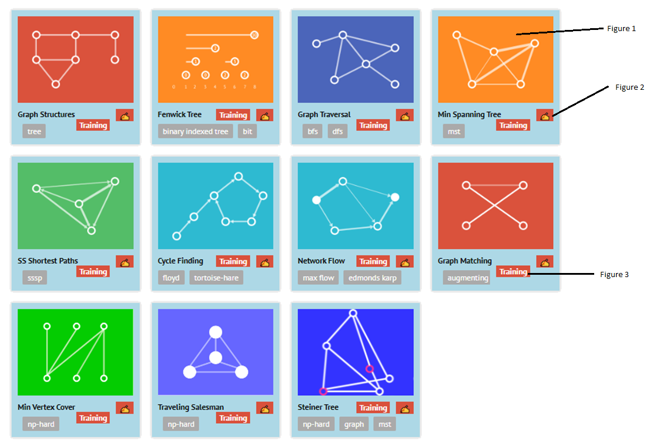

The user can press on each of the following images, outlined in Figure 1, to be taken to a dedicated environment for each topic. This is a useful, visual way for the user to select each topic with a simple, yet intuitive UI which is brightly coloured and simple to make it more appealing and easier to use for users. By having each topic in a separate environment, the solution would be more modular and may be easier to maintain and add new topics to since each algorithm could be developed separately. However, it is very compartmentalised and does not allow the user to apply multiple algorithms in a single environment and would not allow the user to experiment with different pathfinding algorithms on the same graph. This layout also assumes that the users already have a pre-existing knowledge of the content and could be quite daunting to new learners.

Figure 2 allows the user to view written notes on each specific topic. Figure 3 provides the user with example code written in C++ of how the algorithm would be programmed.

When the user chooses a particular topic, an environment is created for the chosen topic, in my case this will be the Shortest Paths topic. The program will automatically generate a graph when the user begins.

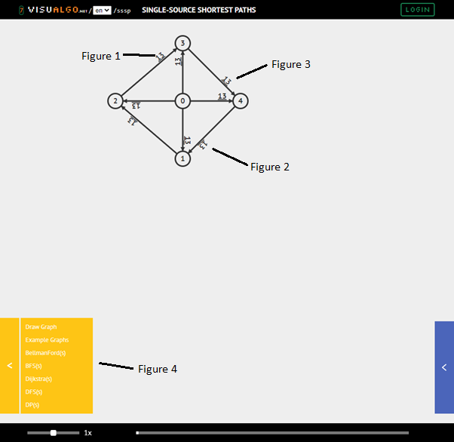

#### Graph Layout

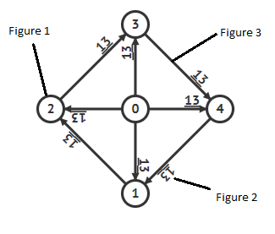This graph demonstrates that each node has been labelled a number from 0 to 4 as shown in Figure 1. This helps to distinguish each node uniquely. However, I believe that for my solution, alphabetical labels as they would be more easily distinguishable from other numbers such as the weights of edges shown in Figure 2. Figure 3 also demonstrates that the program considers directed graphs where edges can either flow in one or two directions. For my own solution I would also want to introduce more colour into the graphs to make it easier to distinguish between some elements as well as ensure all weights for edges are easily readable as in figure 2, the weight is upside down. However, the overall layout of the graph would be an ideal fit for my own solution as it provides all information I would want to show to the user.

#### Graph Editing

To edit a graph the user will select the option from the drop-down menu shown in Figure 4 where they are greeted by a popup window that looks like the following:

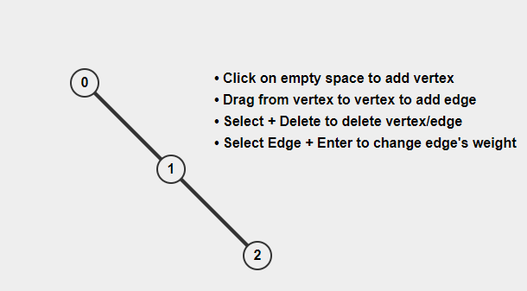

The design of the graph editor has simple functionality which is useful as it is very quick and straightforward to produce certain graphs. However, the graph editor is confined to a small window which could limit size of graphs that users are able to create. Additionally, once nodes and edges were made, it was difficult to edit them as they could not be moved around once added and there was no way to undo/redo changes. The only way items could be changed was by individually selecting them and deleting them/changing their value, quickly becoming more time consuming and frustrating than necessary.

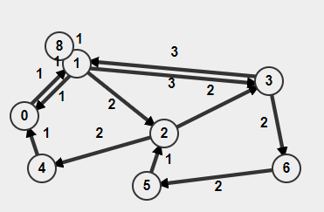As you can see, the graph editor can quickly become very cluttered, with information, nodes and edges overlapping one another. This is not only unpleasant to look at but also makes the learning experience harder for the student.

Overall, from this graph editor, I would want my solution to feature an editor which: is more intuitive to the user by making changes easier through a properties window that allows the user to easily see all properties about a node/edge/etc.; allows them to undo/redo changes using a stack data structure; automatically repels nodes from one another so that they are all clearly visible to the user. These features will ensure that my editor is fast and easy to use to help reduce confusion or frustration when playing around with the graphs to encourage students and teachers to explore different graph configurations.

#### Running Algorithms

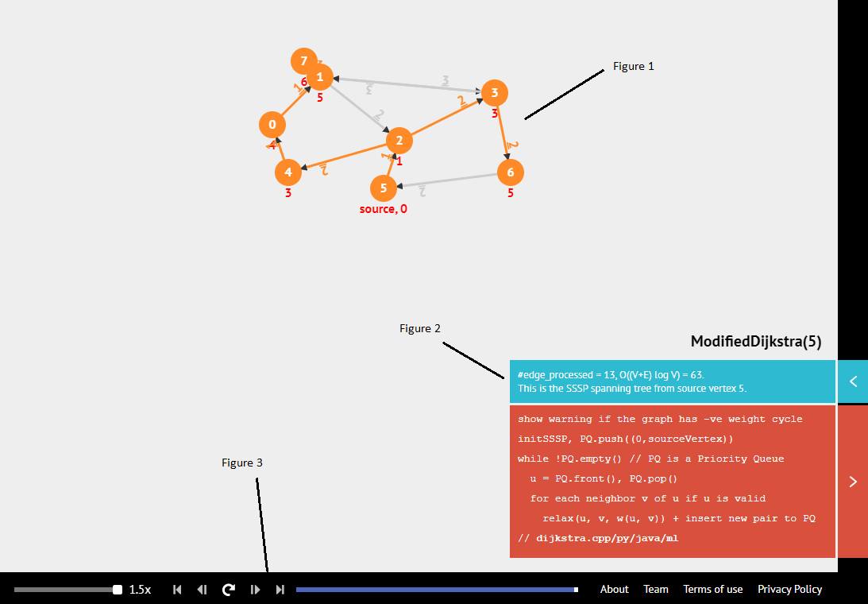

In this image, I test how the program can visualise Dijkstra’s algorithm. As shown in figure 1, the graph will dynamically update as the algorithm progresses through each step. This combined with the media controls shown in Figure 3 allow the user to traverse each step individually so that they can visualise each step the algorithm is performing. The description of the algorithm shown in Figure 2 has good potential to be especially useful at explaining what is happening in each step to the user. However, these descriptions are often quite difficult to interpret. e.g.

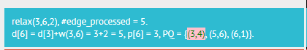

Therefore, I think this structure for visualising each graph would be very well suited to my problem as elements encourage users to explore and understand the algorithms visually. However, I think figure 2 could be implemented to better describe each step to improve student understanding. Figure 1 could be clearer as some information (such as the numbers in red) has little context to describe what it is used for. It would also be useful if Figure 1, could be more easily edited so that the user can view what changes variables have on the output.

### D3GT

[D3GT](https://d3gt.com/index.html) is another web application which has a stronger focus on teaching graph theory. At present, it lacks content which explains and visualises algorithms such as pathfinding, finding minimum spanning trees, root inspection etc. However, the approach to visualisation of graphs in this solution should be noted.

#### Program Layout

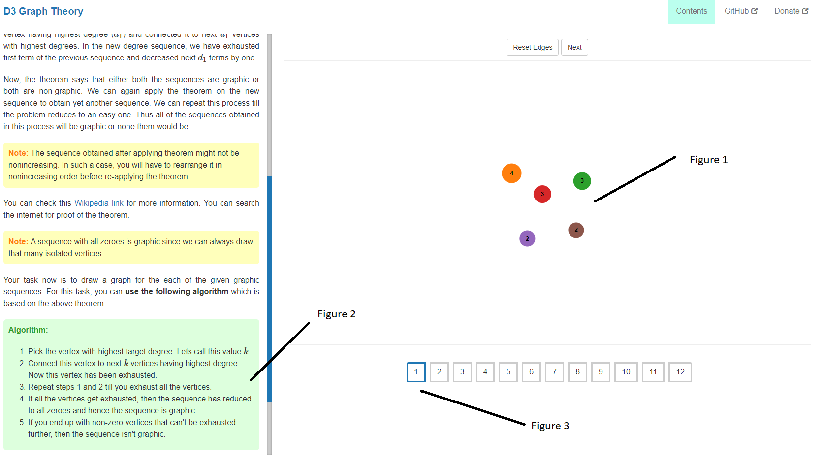

As shown in Figure 1, the program will present the user with a premade environment in which they may need to use it to learn about a certain concept or apply an algorithm themselves. This is a different approach to learning about graph theory which would be easier to implement into my program as I would not need to implement a programmed solution to each algorithm. This is also a practical approach to learning about the algorithms as the user must think about how they apply a given algorithm which is explained in Figure 2. Figure 3 highlights how the user will be tested numerous times to perform the algorithm on different graphs. This helps to ground knowledge for students through repetition to ensure they retain how they perform the algorithms for longer. Figure 2 comprehensively explains each algorithm, however, as this is not combined with any visual solution to the algorithm, it can be difficult to interpret the steps and ensure the user follows them all correctly. Therefore, it is still beneficial to develop solutions to algorithms in my program as visualisation can help to speed up the learning process and it can be time consuming and confusing to learn based on written information alone.

#### Graph Layout

The graph layout is very abstract in this solution. This does make it very intuitive to the user as the graphs are quite simple to understand However, areas of this design lack detail which would be required in my solution. For example, in Figure 1, there is no way to distinguish nodes from one another other than the colour. In my solution, I would want to label each node so that the user can identify each node whilst the program performs any of the algorithms and that they can easily follow along. From Figure 2 and Figure 3, several limitations of this graph layout are highlighted as the software only supports omnidirectional edges and that the graph is confined to this small, limited space. Directed Graphs are another vital area of graph theory for students as directed edges can create vastly different outcomes from an algorithm. Figure 3 highlights this limitation on the environment which could limit the complexity and freedom of the user. Despite these limitations, Figure 4 shows some additional information about the graph, which is useful at teaching what different key terms in graph theory represent and would be an interesting concept to apply to my own solution where I create a window which can display a list of properties about each element.

#### Graph Editing

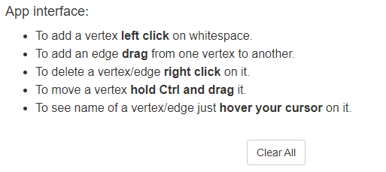The graph editing is much more simplistic than that of the editor found in Visual Go as it does not require an external window to the graphs. It maintains the simplistic point-click functionality to create and delete nodes. This means it is quite easy to create graphs and edit them for the user so they can spend less time structuring the graph and more time testing their graphs in different situations. This is combined by the ability to drag vertices as well as them being automatically spaced from one another which allows graphs to be dynamically manipulated to different isomers and helps improve the visibility of the graphs. However, this design also does not allow users to undo actions which could be frustrating and time consuming if they accidentally delete part of their graph.

## Proposed Solution

### Features Of the Proposed Solution

My solution will initially allow the user to create a new environment or load one from an external file. Once an option is selected, the application will create an interactive sandbox environment where the user can create their own graphs with keyboard and mouse peripherals. This is so that users can create their own models which could be based on a graph given in an example question.

However, the software will be flexible so that it is simple enough that it can be used with touchscreen input for basic functionality. This is so that the software can be used by teachers during lessons on smartboards, for example. The program will then allow the user to choose from different pathfinding algorithms to visualise each step in finding the shortest path in the user’s custom graphs.

The student shall be able to return to their sandbox environment at any time as well as pausing, stepping through and skipping through the steps involved for the algorithms to complete. This will allow the user to read an explanation to each step in the algorithm and learn about the algorithms at their own pace. This will also allow teachers to give further comments about what the algorithm is doing and engage with the class to check they understand the content.

### Limitations of my solution

Due to the complexity of graph theory, my program shall only cover the A* and Dijkstra’s pathfinding algorithms and shall assume some knowledge of graph theory itself and the structure of graphs themselves. The software shall be designed in a way that would mean that algorithms would be modular and future ones could easily be implemented in future development of the software.

The software will also be limited to being made as an executable application due to time limitations on learning how to create a more easily used web application which would more effectively meet the requirements of the stakeholders. This is because as it is an application, users would have to download and setup the software to use it which may be more time consuming and less user friendly to those who are less confident using software and may not be allowed on school computers.

The solution will also only allow for basic functionality of the program when the user uses a touchscreen. This is because there will be combinations of keystrokes and mouse presses that will require the additional use of a keyboard. This issue will be alleviated by adding additional UI for additional movement/editing options that would otherwise require a keyboard to access.

### Hardware Requirements

* A modern multicore Windows computer – the executable will be compiled to run for Windows machines specifically (other executables for MacOS/Linux/etc. could be made in future).
* It will need to have basic I/O such as a display and connections to keyboard/mouse peripherals.
* Memory and CPU requirements may also be demanding from the complex nature of the algorithms and visualising the graphs.

### Software Requirements

The final product shall be compiled into an executable and so the end-user will not have access to the source code, however, will also not require an installation of python or the libraries required to develop the software.

The non-compiled software will require:

* Windows/Linux/Mac Operating System
* Installation of Python 3.6 Interpreter or above
* Pygame 2.0 – This external library shall be used to create the interactive environment in which the user will create their graphs.
* Pygame GUI – This external library will be used to add greater functionality for developing the User Interface for the software.

### Stakeholder Requirements

#### Design

|  |  |
| --- | --- |
| **Feature** | **Explanation** |
| A simple and intuitive user interface. | This is so that the software is accessible to the range of stakeholders which will use it, who may have varying confidence and familiarity using software. This is also so that the software can operate effectively across different devices such as on touch screens and on smart boards and is an effective learning tool. |
| An option to view help information about how to use the software. | This is to ensure that the user is able to make the most of their experience by explaining and showing what different areas of the software do. |
| An abstract visualisation environment to edit the graphs in. | This is so that the user can build custom models to fit a particular shortest path problem for example which they can then use the software to manipulate. |
| Intuitive UI to allow the user to edit the graphs. | This needs to be easy to use that people who are inexperienced with the software can clearly edit their graphs to their desire. |
| Simple UI which displays properties about a selected element. | This is dual purpose as it allows the user to view properties about a certain element which would be useful for learning, but it also allows them to edit parts of the graph more precisely. |
| A dropdown menu for choosing from a selection of algorithms. | This is so that the user can easily choose which shortest path algorithm they would like to apply to their graph. |
| Media control functions (Pause/Start/Step) for progressing through the algorithms. | This is so that the user can revisit or pause on a particular step to have the algorithm explained to them so that they can improve their understanding about how it works. |

#### Functionality

|  |  |
| --- | --- |
| **Feature** | **Explanation** |
| The user should be able to load/save graphs from an external file. | This is so that the user can easily pick up where they left off with a graph without having to recreate it. This would be useful for teachers as it would allow them to create graphs they could revisit during lessons. |
| The user should be able to use mouse/keyboard/touchscreen/UI controls to edit the graphs. | This is so that manipulating the graphs is intuitive to users as they will be familiar using similar software with a mouse and keyboard. Interacting with the software should be simple enough that it can be done with the mouse alone so that it would also work effectively with touchscreens. |
| The user should be able to undo/redo changes they make in the environment. | This is so that if they make a destructive change by accident, they can easily restore their environment much faster than recreating the whole environment. |
| The algorithms should dynamically update the graph onscreen. | This is the main function of the program as it should be able to show what is happening to a graph while an algorithm is performed upon it. |
| The software will explain each step a chosen pathfinding algorithm performs. | This is so that combined with the visual aid of showing what is happening to the graphs. The software will also explain why this is happening to the graph to deepen the students understanding of the subject. |

### Success Criteria

|  |  |  |
| --- | --- | --- |
| **Criterion #** | **Criteria** | **Justification** |
|  | A simple and intuitive UI which allows the software to work effectively across different devices, some without access to keyboard input. | It is important that new users can quickly learn how to use the software by making good use of large clear buttons. This UI should grant full usability on a touchscreen so that it can be used effectively in a classroom environment. |
|  | An option for the user to create a new graph or load/save an existing one from/to an external file. | This would allow students to keep a record of the graphs they create and allow teachers to prepare a set of graphs to be used in future lessons. |
|  | Provide help information about how to use the software, how to create graphs and what different parts of the UI do. | This is so that more complex features of the program can be explained in detail so that all users are able to make the most out of their experience with the software. |
|  | The software should be able to display graphs in a virtual environment. This will display any graphs the user creates. | This is so that user can easily see the graphs they create and will be essential that graphs can be displayed effectively when visualising pathfinding algorithms. |
|  | The user should be able to move around in the environment and zoom in and out using keyboard and mouse input. | This helps to increase the scope in which users can create and view their graphs. This could allow teachers to focus on specific areas of a graph, for example. |
|  | A toolbar widget should also be included to provide functionality where keyboard input isn’t an option. | This allows the user to access all the interactive functionality in the environment by simply using a touchscreen. Icons should be used so the user can easily distinguish what each tool does. |
|  | The user being able to create/delete nodes and edges to form their own unique graphs. | This should allow users to create the structure of their graphs as quickly as possible. |
|  | The user should be able to undo/redo changes they make to their graph. | If a user makes a mistake or would like to revert to a previous state, they should be able to easily undo and redo each action they apply to the graph. |
|  | The user should be able to drag nodes to different positions. | This allows the user to manually move nodes so that their graph is easy to interpret. |
|  | Nodes will automatically try and space themselves to avoid overlapping. | This is so that nodes do not overlap each other and that nodes connected by an edge will maintain a fixed distance. This again aims to improve the readability of graphs created. |
|  | Allowing the user to select nodes/edges and view/edit their properties from a UI element. | This is so that the user can make aesthetic changes to their graph such as name/colour changes for better readability as well as allowing the user to adjust weights. Adjusting weights can be used to visualise how the algorithm will adjust its result of the shortest route. |
|  | Software should be effectively multithreaded so that it runs smoothly on different devices | This is so that the software is accessible on all hardware, including school computers. Better performance will give greater flexibility of what the user is able to develop in the program. |
|  | A set of parameters the user can choose from to perform a given shortest path algorithm. | This is so that the user can choose between A* and Dijkstra’s Algorithm as well as selecting start and end nodes. Modifying these parameters should be as simple and intuitive as possible. |
|  | The graph updating in the environment as the user’s selected pathfinding algorithm is performed. | This is so that users can visually follow each algorithms progression through the graph to determine the shortest path. It will also highlight what is being discussed in the written algorithm explanation. |
|  | Media controls for step, skip, exit buttons to go through the algorithms. | This is so that users can easily navigate between each step in an algorithm. Manual iteration encourages students to read through each part of the explanation and gives teachers the opportunity to give further explanation and assistance to students. |
|  | A UI window which will explain each step the algorithm performs. | This displays the explanation of what is happening in each step of the shortest path algorithms. This enables revision of how these algorithms work for students. |
|  | A navigation bar which allows the user to easily navigate between the properties, file options, help and algorithm parameters sections of the main window. | A navigation bar will link the four sections of the main window’s UI together so that users are able to easily navigate between each section by clicking its respective icon. |

# Design

## Initial Decomposition

The program will be developed using an iterative development process. This will involve breaking the overall problem I am aiming to solve into smaller solvable modules. These will iteratively produce prototypes that may be tested against an outlined set of test data and reviewed on how well it meets the needs set out by the stakeholders and success criteria. In this section, I will identify and explain each module and how they shall meet the requirements from my success criteria.

To ensure a responsive experience for the user, I will create the program to run across multiple threads. This is to better utilise the user’s computer hardware and reduce freezing and lagging when the user is interacting with the User Interface.

**Two threads will be used in my solution, and I have outlined these below:**

* Main Thread – This thread will handle any user input as well as for generating and displaying the UI. This will also be used to define any data structures and variables to be used in shared memory.
* Environment Simulation – This will handle any changes the user makes to the environment. Some of these computations can be quite taxing on the CPU and so have been separated to improve performance on the main thread.

**Additionally, a function will be used to generate a list of steps to perform a pathfinding algorithm on the user’s graph. This function will be run in an external thread to prevent potential slowdown.**

* Algorithm Step Generation – This will be a temporary thread which is created each time the user wants to run a specific algorithm on their graph. This is to ensure UI and pygame remain responsive which would be a problem for larger, more complex graphs.

Files will be created to contain the functions for each of the three threads. This to improve the readability of the solution and to make it easier to make changes and debug during the iterative development process.

To begin my decomposition, I will design a user interface that meets the success criteria effectively and to how I believe will best suit the needs of the stakeholders. Once I have established what the software will look like for the end user, I can decompose further into the problem and look at the algorithms that will make the software work.

## Structure of the solution

### Main Thread

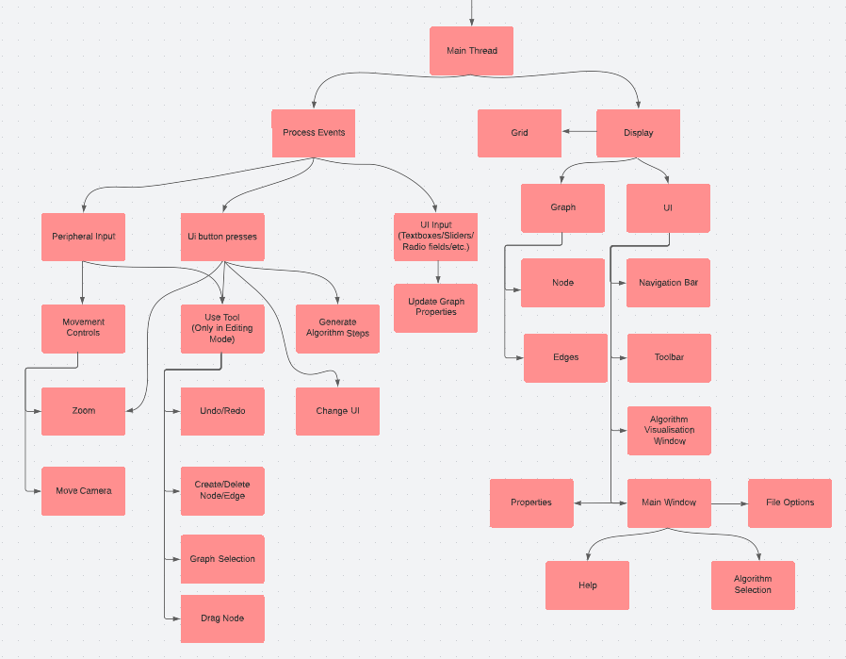

The main thread of the solution will be responsible for efficiently handling all user input and displaying the UI and graph environment to the pygame window. Creating this file will be the first step in the development of the project which is so that a framework is in place to display the graph and UI and can handle all events necessary for the program to work. This thread will overall satisfy points 1,2 and 4 by creating a UI which is simple and intuitive to learn for teachers and students alike whilst being flexible enough to allow for a good degree of freedom in how users create their graphs and use the software. It will additionally be responsible for saving/loading files for graphs that users wish to return to. The software will also connect to the other thread environment thread and manage communication between them so that the display and user input runs smoothly; this fulfils the 12th success point.

#### Event Processing of Inputs

Within the event processing section, all events in pygame’s event queue will be iteratively retrieved. This will be used to receive peripheral input from the user’s keyboard/mouse and will be used to track cursor position and move/zoom the camera in the environment. Peripheral input as well as UI buttons will be used to use tools that manipulate the graphs:

* **Undo/Redo** – This will be used to amend changes the user makes to their graph. This will be done by creating an undo and redo stack. Every time the user makes a change to the graph, the redo stack is cleared, and a new change is added to the undo stack. If the user decides to undo their last change, it will reverse the last change on the undo stack and append it to the redo stack.

**(8th point of the success criteria)**

* **Selection –** This would involve recording the screen position that the user pressed their cursor and converting this screen coordinate into a coordinate in the environment space. An event is sent to the Environment Simulation thread to select any node/edge that intersects the specified coordinate.

**(11th point of the success criteria)**

* **Create Node –** An event will then be added to a queue which is connected to the Environment Simulation Thread. This event will tell the thread to create a new node with specified parameters and position.

**(7th point of the success criteria)**

* **Create Edge –**A event will be sent to the environment simulation thread when the user starts and ends input each with the start and end coordinate of the user’s cursor. Under the correct circumstances that will be discussed in a later section an edge object will be created.

**(7th point of the success criteria)**

* **Delete Node/Edge –** This will select whichever node or edge the user’s cursor is hovering over and will then send an event to the environment simulator to delete the node. This will additionally delete any edges connected to this node.

**(7th point of the success criteria)**

* **Drag Node –** When input begins, a selection event will determine which node the user would like to move. While the input is sustained, the node will move towards the user’s cursor. This action will stop once the user releases their mouse.

**(9th point of the success criteria)**

UI buttons shall also be used to navigate different sections. By compartmentalising the UI into several smaller modules (outlined in the UI section above), it will not only be easier to program and design each individual module but will also ensure the UI is simple and doesn’t overwhelm the user; thus, satisfying the first and primary success criteria to keep the User Interface friendly and intuitive for its users. UI buttons shall include:

* **Navigation bar buttons –** These buttons will be used to switch between panels on the main window consisting of Properties, File Options, Help and Algorithm Selection. This will work by setting the “visible” attribute of a “UIPanel” object from the pygame_gui library. This will allow the program to switch between the UIPanel for properties and another for file options with a single variable.
* **Toolbar buttons –** In the toolbar, when a user presses a particular button, a variable to represent the selected tool - such as the create tool/selection/drag/move- will be updated. It will also be used to zoom, undo/redo changes and delete nodes. This is to allow for greater accessibility if the user does not have access to a keyboard and is limited to a single “mouse click” on a smart board/touch screen. This is so that the program works better in a classroom setting, satisfying the 1st and 6th points in the success criteria.
* **Visualise Algorithm Button –** This button will call the Algorithm Step Generation Function to generate an array of steps used to find the shorted path in the user’s graph. This will also open the Algorithm Explanation Window as well as disabling any editing features. This helps to meet the 13-16th success points. This function will only execute once all events have been processed by the environment simulation thread. This is to ensure that the most up-to-date graph is parsed into the function.
* **Simulation Control Buttons –** These buttons will be used to step through the user’s selected pathfinding algorithm. If the “next” button is pressed, the step will increment and be applied to the graph. The next appropriate step description will also be displayed. If the “skip” button is pressed all steps will be applied. Vice versa for the additional “back” and “to start” buttons. This will also include the quit button which should close the explanation window and reinstate graph editing functionality. This additionally fulfils the 15th success point.
* **Help Buttons –** The help buttons fulfil the 3rd success criterion and allow the user to read different sections about how to use the software by pressing “next” and “back” to view different sections, consisting of a paragraph and image where necessary.
* **Save/Load Buttons –** These buttons will allow the program to fulfil the 2nd success criteria. These will work using the asksaveasfilename and askopenasfilename functions from tk.filedialog. These will display the familiar “save as” and “open” which user’s will be more used to interacting with. These functions will return the file directories which the program can then store all necessary information about the graph using the pickle library.
* **Node Selection Buttons –** The user will need to supply to parameters before performing any pathfinding algorithm, a start and end node. Since the user may be at a smart board and unable to type the names of nodes, node selection should be achieved by first pressing the node selection button and then the next node that is clicked on will be set as the start/end node.

Additional UI Input will be handled using the pygame_gui module which provides support for textboxes, sliders, checkbox input and dropdown menus which will be used to update graph properties and for the user to select which pathfinding algorithm to apply from a dropdown menu. Any property UI changed will create a pygame event which can then be sent to the Environment simulation thread to apply the changes to the graph. By completing this the solution will be able to meet the 13th and 11th success points.

### Environment Simulation Thread

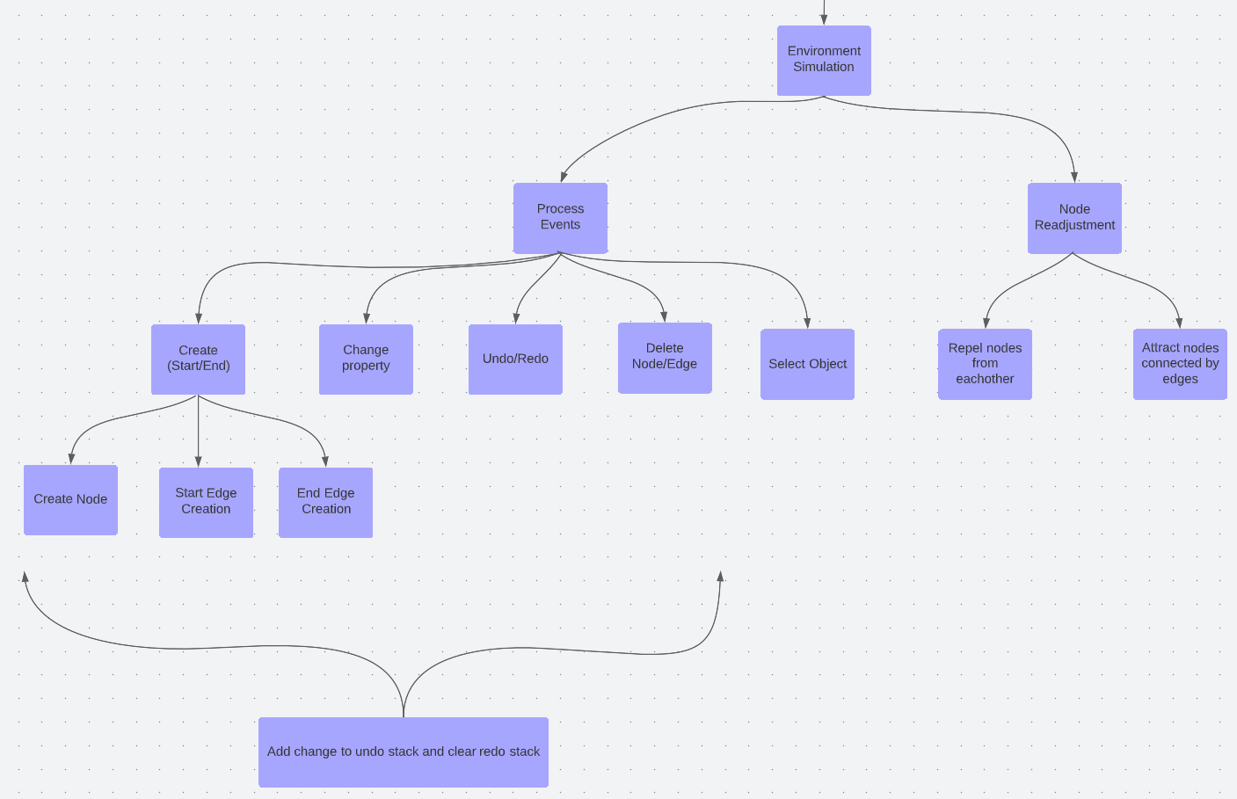

The environment simulation thread is a separate module which will run alongside the main thread which will complete the majority of computation to be applied to the graph, aside from algorithm step generation. This was separated from the main thread to prevent slowdowns and potential freezing of the UI window which would adversely affect the user’s ability to use the software, fulfilling the 1st and 12th success points.

One function of this thread will be node readjustment. This will be an n-body simulation that will assign velocities to each node and update each node’s position. This is to improve upon visibility for the user which aims to fulfil the 1st, 4th and 10th success criteria and is useful for when nodes may be overlapping each other, obscuring information about the nodes. Therefore, these nodes should move away from each other by applying repulsive velocities to each node. This will ensure that all information the user may need and the structure of the graph itself is easily readable. This feature will also attract nodes connected to an edge so that any edges in the graph are of a consistent length.

The other main feature of this thread is to apply the user’s input to the graph. Some of these operations are again quite computationally intensive and were separated from the main thread to uphold the 12th success point and ensure the UI runs smoothly for the user. These include:

**Selection Feature –** This feature is designed to complete the 11th success criterion by receiving an event to select whatever part of the graph intersects a specified coordinate. For selecting nodes, the thread will compare the distance between each node and the coordinate. If this distance is less than the radius of the node, they intersect. The selected object variable in shared memory will then be updated with this new node. In the case of edges, I will need to find if a point intersects a rectangular area. This will be achieved by using vector projection. This will be used to map a local coordinate to the normal of the edge. The projected coordinate can then be checked if it is within certain bounds – the length and width of the edge.

**Creation Feature –** This feature will work by the thread receiving two events from the main thread from when the user started/finished using the creation tool with 2 sets of coordinates indicating the start and end positions of the cursor. If the start position does not intersect a node, it will be assumed that the user wants to create a new node; in this case the finish creation event is ignored. The new node will be appended to the graph array in shared memory. If the start position intersects a node, this will indicate that the user wants to create a new edge. If the end position intersects another different node as well, an edge will be created between the two nodes. This edge will be added to the list of edges in each adjoining node. This fully satisfies the 7th success criteria into a single button press ensuring that interacting and creating graphs is as simple and intuitive as possible for the user.

**Delete Feature** – This event will simply remove the selected object from the graph array. If it is to delete a node, all connected edges will also be deleted. This should update the lists of connected edges in all associated nodes. This feature additionally fulfils the 7th success criteria.

**Undo/Redo Feature** – As previously mentioned for the 8th point in the success criteria, this will operate with the use of undo/redo stacks. Whenever a property about the graph is changed, any nodes/edges are created/destroyed, a record of this event will be added to the top of the undo stack. Then when an undo event is received, the record from the top of the stack is undone and added to the redo stack. This redo stack will be cleared whenever a new undo stack entry is made.

**Drag Node Feature –** This feature will work by using two events similarly to how edges were created with the creation feature. When the user begins input, the main thread sends an event to select a node and another event will also be sent alongside it to start dragging the selected node. When the input ends, an event will be sent to stop dragging nodes. If the selected item is a node, the distance between the node and the cursor position will be calculated, a force will then be calculated and applied to the node.

[This work belongs to Alex Dent](https://github.com/skalex05/Search-Algorithm-Education-Tool)

## User Interface Design and Usability Features

In order to create an environment which my user can effectively interact with, I have chosen to use the library, Pygame, to achieve this. This is because it allows for user input as well as displaying graphical elements which will be needed to display interactive graphs. However, Pygame does not support UI elements. Therefore, my solution will additionally need the pygame_gui library. This library adds support within Pygame for buttons, sliders, drop-down menus and other useful widgets that shall be used to improve the interactivity of my software and make it simpler and more intuitive to use for my stakeholders.

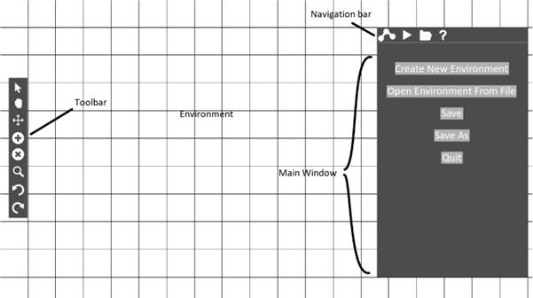

This window will be displayed when the user initially enters the program. It will by default open a new environment the user can immediately start creating graphs in if they choose to do so, with the assistance from the toolbar on the left-hand side. The window to the right will additionally allow the user to open/save an existing graph from an external file.

### Environment

The Environment is where the user will interact and create their graphs. It consists of simply a plain white background and a black grid. This is too ensuring the design remains simple for the user and so that the graphs are easily visible. The grid helps to provide further clarity and a sense of scale to the user’s graphs. This design aims to meet the 1st and 4th points of the success criteria by helping to create a simple UI and an environment the user can interact with.

### Navigation Bar

The navigation bar is to allow navigation between different UI elements in the software. This includes:

* Node/Edge/Graph Properties
* Algorithm Visualisation
* File Options
* Help

This bar consists of several corresponding icons, which when clicked, will navigate the user to one of the outlined sections. In the image above, the file options UI is displayed as default. This UI allows the user to create, save and open environments in the software and so satisfies the 2nd point of the success criteria. Additional UI windows for node/edge graph properties; algorithm visualisation; help satisfy the 11th,13th, and 3rd success criteria points respectively.

### Toolbar

The toolbar consists of the main input functionality of the software such as moving around in the environment and creating graphs, which can be done through keyboard input. However, so that this software could work on a smartboard in a classroom, visual buttons require only a single mouse button/ touch input to use the software. This helps meet the success criteria from points 5-9 as well as the 1st point by making features of the software easily accessible on the range of devices the software is designed to work for such as changing the perspective on the environment, editing graphs and undoing/redoing changes.

### Main Window

The main UI window is a focal part of the user interface for the user by allowing them to access a variety of sections from the navigation bar such as graph properties, algorithms, file options and help information. By containing all of this information within one UI element, I am meeting the first point of the success criteria by keeping the design simple and intuitive for the user as they have a central place to look for information about the software, as well as customising it to best suit their individual needs.

#### Graph Properties

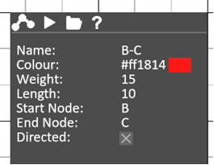In this image, I have designed the properties UI that will be used by the user to manipulate and personalise their graphs and so satisfies the 11th success point by allowing the user to edit properties about nodes and edges in their graph. It will consist of several input boxes where the user will be able to input numbers, text and hexadecimal colours. It will also need to use checkbox inputs and potentially sliders as well. The information in this field will be continually updated in alignment to whatever node/edge the user has selected.

#### Help

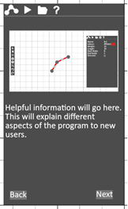This image demonstrates how new user will be able to access help about the program in order to meet the 3rd success criterion. An image with additional text will be used to show different elements of the program to aid their understanding. The image and text will be stored in an external file. A page index will indicate which image and text should be retrieved and displayed onto the UI.

#### Table Description automatically generated File Options

This UI will allow the user to open and save graphs into external files in order to achieve the 2nd success criterion. The save function, in addition to the Ctrl-S key bind, will provide a quicker path to save to an existing file whereas save as will display an additional file dialog where the user can select a particular directory to save to. The open button will display another file dialog to the user where they can select a valid graph file. A quit button is also included within this section so that the program can be closed if the user is in full screen mode. Before quitting the application, the user should be first prompted if they would like to save their graph before exit to prevent accidental loss of data.

#### Algorithm Visualisation Parameters

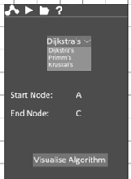This UI is to complete the 13th point in the success criteria by allowing the user to choose which algorithm they would like to visualise on their graph from a dropdown menu. Each algorithm may have varying parameters the user will need to specify to run each algorithm. This will include requiring the user to choose the start and end nodes by selecting them from the graph. When they have chosen an algorithm and entered all required parameters, they may press the “Visualise Algorithm” button, which will create a new UI window. This window will explain each relevant step in the algorithm accordingly.

### Graph

A graph is a collection of vertices, also known as nodes, which are connected together with edges in order to show relationships between them. The program will need to display these graphs as the user creates them as specified in the 4th point of the success criteria. These graphs are the inputs to the various algorithms the user will be able to perform in this software. Therefore, it is important that the program shows all necessary information to the user to make learning as intuitive as possible and so that the graphs are easy to interpret. This will include labels on the nodes so that the user can distinctly tell them apart when they are referenced in algorithm explanations. The program will also need to display the weights associated with different edges on the graph and the direction these relationships/edges flow. By providing all necessary information to the user as simply, cleanly, and abstractly as possible, I am additionally satisfying the 1st point of the success criteria to create a simple and intuitive UI.

### Algorithm Visualisation

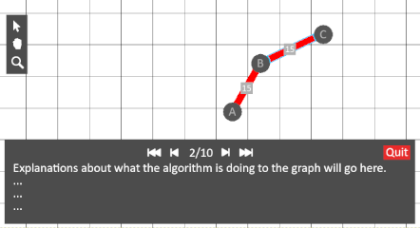When a user presses the aforementioned button, the above UI panel will be displayed. This is for the 15th and 16th points in the success criteria, which are to have a section of the UI which will explain each step-in a given algorithm as well as media control buttons (step, skip) to navigate each step in the algorithms. This is to ensure the user is able to understand why and what is happening in the algorithms to effectively learn about graph theory. This is additionally useful in a classroom environment so that teachers can provide further explanation and assistance to students with the visual aid. It should also be noted that when visualising pathfinding algorithms, graphs can’t be edited and so a simplified version of the toolbar should be displayed. This provides only basic functionality such as moving and zooming aimed at the classroom environment when the teacher would not have access to keyboard input while interacting on a smart board and may wish to move around in the environment or focus attention to a specific part of the graph.

## Stakeholder Feedback

So far, I have a good idea of how I expect the program to look and what features it will have based on my initial stakeholder feedback and from my research into existing solutions. I will now gain additional feedback on my proposed design to revise it into what I will later create in the development process. I sent the section of this document under ‘User Interface Design and Usability Features’ to the 4 stakeholders who were initially interviewed along with the following email:

**“Hello once again,**

**I have taken your feedback into consideration to help create a prototype design of what the user interface of the program will look like and how you will be able to interact with it. This design will allow you to create your own graphs with several options to edit them to meet your needs or replicate another graph you might have in class. There is also the option to run algorithms on these graphs to aid explanations in the classroom as well as accessing help information to make this software as easy to use as possible.**

**I would love to hear your feedback on these designs and what can be improved upon.**

**-Alex”**

### Teacher Response #1 – Mr Norris

“Hi Alex, I really like these designs. They seem very simple and straightforward to use. I am glad that this software will work well on my smartboard as I mostly aim to use it in front of my class. However, I do think the window on the right-hand side might take up too much space on my board.”

### Teacher Response #2 – Miss Baker

“The layout looks really nice, and think it has all the main features I would use. In particular, the help section as I can use this if I get stuck using the software at any time. However, it would be good if there were additional properties about the graph such as valency and if graphs are eulerian, etc.”

### Student Response #1 – David Bronson

“The designs look really cool in my opinion, although it’s a little confusing understanding what all the buttons do as they only have pictures. However, I am sure the help section would explain them if I was confused.”

### Student Response #2 – Jenny Watson

“This software looks like it will be a much more engaging way for me to revise. It also seems to be very straightforward and intuitive to use. I might not need to use all that this software offers as I just want to try out some of the different algorithms, but it is nice that it is there for those who would benefit from those features.”

### Response Analysis

From my follow up feedback from my stakeholders, I have learnt they are very happy with the overall design and usability features of the program. However, I shall try making some of the UI such as the main window a bit smaller so that it takes up less screen space in the environment. It was also suggested to have text cues for what the buttons do and so I shall try and implement this as tooltips; This will display text about a given button the user hovers over. It was also suggested to show additional properties about the graph in the UI as this would be helpful for teachers.

## Required Solution Algorithms

### Screen to Environment Position Algorithm

This algorithm will be used to take a screen coordinate such as the cursor position, measured in pixels from the top left corner of the screen, and convert it to a relative environment position. This function shall be used in conjunction with other algorithms such as the selection and creation algorithm. This algorithm will need to consider the scale of the environment as well as the camera’s position.

|  |
| --- |
| **FUNCTION ScreenToEnvironment ( screenPosition )**  **// Get variables from the environment object**  **screenSize = getScreenSize()**  **cameraPosition = getCameraPosition()**  **scale = getScale()**  **// Centre the environment position to the centre of the screen**  **envPos = screenPosition – screenSize / 2**  **// Divide the the environment position by the scale (A larger scale will mean that the screen window will display less of the environment)**  **envPos = envPos / scale**  **// The environment position should then be globalised from an offset to the camera’s position**  **// The Y-Axis is also inverted so that greater y values are logically further up the screen**  **envPos = ( cameraPosition.x + envPos.x,cameraPosition.y – envPos.y )**    **RETURN envPos** |

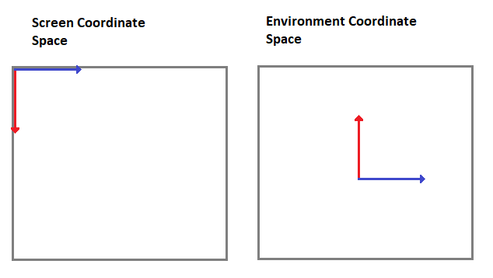**Example trace table**

|  |  |  |  |  |
| --- | --- | --- | --- | --- |
| Screen Position (px) | Screen Size (px) | Scale | Camera Position | Environment Position (units) |
| 0,0 | 500,500 | 1 | 0,0 | (-250,250) |
| 0,0 | 300,300 | 1 | 0,0 | (-150,150) |
| 0,0 | 500,500 | 2 | 0,0 | (-125.5,125) |
| 0,0 | 600,400 | 1 | (100,100) | (-200,300) |
| 50,100 | 600,400 | 1 | (100,100) | (-150,200) |

### Environment to Screen Position Algorithm

This algorithm is for the inverse function of the ScreenToEnvironment function and so the reverse of the trace table also applies.

|  |
| --- |
| **FUNCTION EnvironmentToScreen( envPosition )**  **// Get variables from the environment object**  **screenSize = getScreenSize()**  **cameraPosition = getCameraPosition()**  **scale = getScale()**  **// Invert the Y-axis and get the environment coordinate relative to the camera’s environment position**  **screenPos = ( envPosition.x – cameraPosition.x, cameraPosition.y - envPosition.y )**  **// Multiply the screenPos by the scale. This is to get the relative position in pixels from the centre of the screen**  **screenPos = screenPos * scale**    **// Get the the screenPos relative to the top left hand corner of the screen in pixels**  **screenPos = screenPos + screenSize / 2**  **RETURN screenPos** |

### Camera Movement Algorithm

This algorithm will be used to continuously update the position of the user’s camera position in the environment. This will enable them to look at different parts of the graph and move around in their environment freely and easily.

|  |
| --- |
| **FUNCTION MoveCamera ( mouseButton = “Centre-Mouse-Button” )**  **// Get necessary data and variables**  **mouseMovement = GetMouseMovement()**  **mouseInputs = getMousePressed()**  **cameraPosition = getCameraPosition()**  **scale = getScale()**  **// Check if the mouseInput is True for the selected input button**  **IF mouseInputs[ mouseButton ] == TRUE THEN**  **// Move The camera relative to the scale and mouse movement**  **cameraPosition = ( self.cameraPosition.x – mouseMovement.x / scale, self.cameraPosition.y + mouseMovement.y / scale )**  **ENDIF** |

### UI Selection

This function shall be used to improve the readability and maintainability of the solution. It will allow different UI elements in code to be more easily referenced in other sections of code that will require access and modification to the UI.

|  |
| --- |
| **// Will take a starting container and a path of other containers and the final object to return**  **FUNCTION GetUI(container, objectPath)**  **// Split apart the object path into each object**  **objects = objectPath.SPLIT(“//”)**  **// Search through each part of the path to find the final object**  **FOREACH object IN container.objects DO**  **matchingChildren = []**  **// Find the child that corresponds to the current object in the path**  **FOREACH child IN object.children DO**  **IF child == object THEN**  **matchingChildren.append (child)**  **ENDLOOP**  **//Ensure there is only one matching child**  **IF GetLength(matchingChildren) != 1 THEN**  **ThrowError()**  **ELSE**  **container = matchingChildren[0]**  **ENDIF**  **ENDLOOP**  **// Return the final child**  **RETURN container** |

### Graph Selection Algorithm

This algorithm will be used to select either nodes or edges in the environment. This will be important to satisfy the 11th success criteria so that the properties associated with these objects can be displayed. It will also be important in helping select the start and end nodes of the shortest path algorithms.

|  |
| --- |
| **FUNCTION Select ( position, sharedMemory )**  **// Get all nodes and edges connected to the graph**  **nodes = getNodes()**  **edges = getEdges()**    **// Check if position intersects each node**  **FOR node IN Node DO**  **// Calculate the distance between each node and the selected position**  **distance = Magnitude( position – node.position )**  **IF distance <= node.radius THEN**  **// Node intersects and so should be set as the selected node in shared memory**  **// This is so that the main thread can update property GUI etc.**  **node.selected = TRUE**  **sharedMemory[ “SELECTED” ] = node**  **RETURN**  **ENDIF**  **ENDLOOP**  **// If the position did not intersect a node, it will test if it intersects an edge**  **FOR edge IN edges DO**  **// Calculate a position relative to the edge’s plane**  **relativePos = position – edge.centre**  **relativePos = RotatePositionByNormal( relativePos, edge.normal )**  **// Check if the position falls within the bounds of the edge (length and width)**  **inBounds = PositionInBounds ( position, edge.length, edge.width )**  **IF inBounds == TRUE THEN**  **// Select this edge**  **edge.selected = TRUE**  **sharedMemory[ “SELECTED” ] = edge**  **RETURN**  **ENDIF** |

### Step Generation for A* Algorithm (Structure applies also to the Dijkstra’s function)

|  |
| --- |
| **FUNCTION AStar(startNode,endNode,sharedMemory)**  **// Get all nodes in the graph**  **nodes = getNodes()**  **// Calculate heuristic costs and reset explored variable and the weighted cost variable**  **FOREACH node IN nodes DO**  **node.hCost = Magnitude(node - endNode)**  **node.explored = FALSE**  **node.wCost = infinity**  **ENDLOOP**  **// Create an array containing all unexplored nodes that need to be explored.**    **unexplored = [startNode]**  **startNode.wCost = 0**    **//Create a Boolean and array which will contain the output of this algorithm: a list of steps the algorithm perfomed to complete the algorithm and wether the algorithm was successful at reaching the end node.**  **steps = []**  **endNodeReached = FALSE**  **// Choose the node with the lowest total cost while there are nodes to explore**  **WHILE NOT unexplored.empty() AND endNodeReached == FALSE DO**  **// Select the node with the lowest total cost**  **bestNode = unexplored[0]**  **FOREACH node IN unexplored DO**  **IF node.explored == FALSE AND node.fcost < bestNode.fcost THEN**  **bestNode = node**  **ENDIF**  **ENDLOOP**    **//Explore the selected node**  **bestNode.explored = TRUE**  **unexplored.remove(bestNode)**    **//Add a step to the algorithm each time a node is selected**  **// Parameters of this class will be defined in the datastructures section**  **step = Step()**  **steps.append(step)**  **// Check if the end node was reached**  **IF bestNode == endNode THEN**  **endNodeReached = TRUE**  **ELSE**  **// Add neighbouring nodes to the unexplored array, calculate the node’s weight cost and its new total cost**  **FOREACH node IN bestNode.connectedNodes DO**  **IF node.explored == FALSE AND node NOT IN unexplored THEN**  **unexplored.put(node)**  **calculatedWeight = bestNode.wCost + bestNode.getEdgeTo(node)**    **// If the new calculated weight is less than its previous weight cost, the wCost and fCost should be updated accordingly.**  **IF calculatedWeight < node.wCost THEN**  **node.wCost = calculatedWeight**  **node.fCost = node.wCost + node.hCost**  **ENDIF**  **// Add a step for each edge and weight that is checked and updated**  **step = Step()**  **steps.append(step)**  **ENDIF**  **ENDLOOP**  **ENDIF**  **ENDLOOP**  **// Upon completion of the algorithm, a tuple containing the array of generated steps and state of endNodeReached are put into shared memory so that they can be used by the main thread.**  **sharedMemory[“Step Generation”] = (endNodeReached, steps)** |

This algorithm will need to produce an array of steps that can be interpreted by the main thread to provide the learning aspect of the program, by demonstrating how to algorithmically find the shortest path. Suppose in a graph consisting of 4 nodes, the algorithm is asked to find the shortest path from node A to node D using Dijkstra’s and would be expected to produce the following:

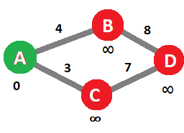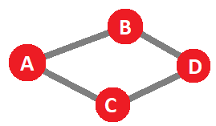In the first step, the start node should be marked green (indicating that the shortest route to this node has been found.)

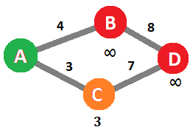In the second step, one of node A’s connected nodes (C) is selected and coloured orange. Its new weight of 3 is calculated and displayed on the graph.

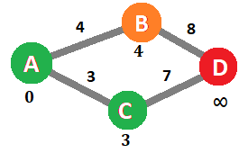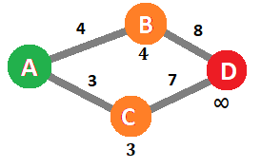In the third step, the other connected node to node A (B) is selected and coloured orange. Its new weight cost of 4 is calculated and displayed.

In the fourth step, all nodes labelled orange are compared and the node with the lowest total weight cost (C) is found. The algorithm therefore determines that it has found the shortest path to this node and so can label it green.

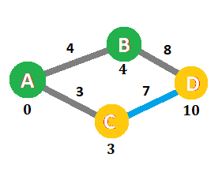This sequence of steps will continue by looking at all connected nodes of C and updating weights accordingly. This will be performed until the algorithm has found the lowest weight cost of D, the end node. The algorithm will have several more steps explaining how it will backtrack through the graph to show how the shortest path can be ascertained:

Starting from the end node, node D and C are compared. Since 10 – 7 = 3, the algorithm confirms that C-D is part of the shortest path.

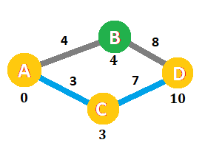Then again, starting at C, node C and A are compared. Since 3 – 3 = 0, the algorithm confirms that C-D is also part of the shortest path.

Therefore, the algorithm correctly displays A-C-D in gold and blue as the shortest path from A to D, with all necessary steps required to achieve this.

### Node Readjustment Algorithm

|  |
| --- |
| **FUNCTION ReadjustNodes (maxForce, optimalDistance, slope)**  **// nodes array is retrieved**  **nodes = GetNodes()**    **// Compare each node to every other node and apply any velocities where applicable**  **FOREACH node IN nodes DO**  **FOREACH node1 IN nodes DO**  **// Check the two nodes are not the same**  **IF node1 != node THEN**  **//Calculate the distance and direction between the nodes**  **distance = Magnitude (node1.position – node.position)**  **direction = (node1.position - node.position) / distance**    **// If nodes are connected by an edge they should be attracted together**  **IF node1 IN node.connectedNodes THEN**    **// Model the force applied so that nodes connected by edges are held together at a fixed length**  **edge = node. GetEdgeTo(node1)**  **force = maxForce * TANH ((distance – edge.length) / slope)**  **node.velocity += direction * force**  **//If nodes are not connected, repel them from each other if they are within some arbitrary distance from each other**  **ELSE IF distance <= optimalDistance**  **force = -maxForce * COS ((pi * distance / 2 * optimalDistance))**  **node.velocity += direction * force**  **ENDIF**  **ENDIF**  **ENDLOOP**  **ENDLOOP** |

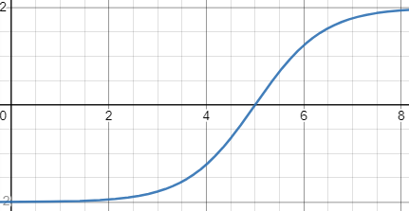The graph in blue is used to model the attractive forces between edges. The x-axis represents distance while the y-axis represents the force applied. If the distance is below an arbitrary optimal distance such as 5, the resultant force will be repulsive; if greater than, the force will be attractive. The graph in red is used to model the repulsive forces between unconnected nodes, within the bounds between 0 and the optimal distance 5. The closer the distance is to the optimal distance, the lower the resultant force, tending towards 0.

### Algorithm Testing

Several of these algorithms rely heavily on graphical inputs, such as graphs and mouse input and visual outputs such as graph manipulation. Therefore, testing these algorithms cannot be completed effectively with the use of trace tables in all cases and so I will need to provide further testing during the iterative development process to evidence how these algorithms work in the solution with screenshots. By testing these algorithms during development, it may be possible to make slight adjustments to them, such as better demonstrating the process in finding shortest paths. In this example, it would enable the software to better meet the first success criteria by ensuring how the algorithms are visualised is clear and intuitive to the user.

## Key variables

|  |  |  |
| --- | --- | --- |
| Variable Name | Data type | Justification |
| SharedMemory | Dictionary | A dictionary object is used so that data can be shared between the different threads. Data can easily be assigned, replaced or retrieved using keywords. Main uses of this ensures data is easily addressable and will reduce the possibility of bugs arising. This object is also immutable, meaning that the object itself will not be overwritten, disconnecting communication between threads. |
| SharedMemory [“Run”] | Boolean | This Boolean will be used to communicate to all threads that the program needs to close. It will be used during the main loop of each thread determine if it should continue running. |
| SharedMemory [“Step Generation”] | Array | This will be an array containing all steps to complete a particular algorithm. It will be set in the step generation thread and received by the main thread which will update the graph and UI accordingly. The data structure representing each step will be discussed below. |
| SharedMemory [“Graph”] | Array | This array object is used to contain all node data structures in the environment. This array will be used to find and modify information about nodes and associated edges as well as to display this information on the UI window. |
| SharedMemory [“SelectedTool”] | String | This string shall be used to identify which tool is currently selected. This will determine the appropriate function to perform when the user presses their left-click button |
| ScreenSize | pygame.Vector2 | This is a Vector2 which is used to respectively represent the width and height of the UI window. This variable will be used to create the pygame window as well as map coordinates between screen and environment space. |
| CameraPosition | pygame. Vector2 | This Vector2 object is used to represent the camera position in environment coordinate space. This variable is considered in converting between screen and environment space and enable the user to move around in the environment. |
| Scale | float | This float represents the linear scale of the camera in the UI window. This variable will be adjusted according to scroll wheel input. It will also be used to convert between screen/environment coordinates. |
| simulationEvents | multithreading.Queue | This queue data structure will be used to set and retrieve new events between threads. This data structure will be used to send requests to update data about the graph such as creating new nodes/ edges or adjusting their positions. |
| Undo Stack | Stack | This stack data structure will be used to represent all actions that can be undone from most to least recent. A new operation will be added to the stack each time a change is made to the graph. |
| Redo Stack | Stack | This stack data structure will be used to represent any actions that can be redone. Operations will be added to this stack each time an action is undone. It is also cleared each time a new change is made to the graph. |

## Key Data structures

### Operation Class

This class will be used to represent a two directional action. This class will be one of the main ways in which actions are communicated by indicating how they should be applied and removed. For example, creating a new node could be the “forward action” whilst deleting it would be the “backward action”. By putting this data into its own class, it will encourage simpler more modular code to be developed which will additionally be easier to interpret and maintain in the future.

The operation class will consist of two functions where each represents a forward/backward action. The forward action is what is originally applied to the graph and the backward action is what is required to undo that action. There will be several different classes for different operations each with unique forward and backward operations.

* CreateNode
* CreateEdge
* DeleteNode
* DeleteEdge
* ChangeProperty

### Step Class

The step class will be used to represent each entire step a shortest path algorithm performs on a graph. This class will consist of a text explanation of what the step has completed that will be updated onto the GUI. It will additionally consist of two arrays of permanent and temporary operations. These are all the changes that are to be completed such as updating weight costs, changing the colour/size of nodes etc. This feature ensures that there is as much visual clarity about what is happening in each step as possible. Temporary operations (such as selecting a node or changing its colour) are only applied during that specific step; They are undone once the user steps in either direction. Permanent operations (such as changing properties) are permanently applied to all future steps. They are only undone when the user goes to the previous step.

|  |
| --- |
| **Class Step:**  **Explanation = String**  **Temporary Operations = Array<Operation>**  **Permanent Operations = Array<Operation>** |

### Node Class

This class will represent a node in the user’s graph. This object will need to contain several properties regarding how it is displayed in the environment as well as how it is connected to other nodes.

|  |
| --- |
| **Class Node:**  **UniqueID = Int**  **Name = String**  **Colour = Hexadecimal**  **Position = Vector2**  **ConnectedEdges = Array<Edge>**  **Radius = float**  **Destroy()**  **Draw()** |

### Edge Class

This class will represent the connection between two distinct nodes in a graph. Similarly, this class will contain several properties for how it’s displayed as well as storing the nodes it connects together as well as the length and weighting of this connection.

|  |
| --- |
| **Class Edge:**  **UniqueID = Int**  **Colour = Hexadecimal**  **ConnectedNodes = Array<Node>**  **Weight = float**  **Length = float**  **Width = float**  **Destroy()**  **Draw()**  **OtherNode()** |

## Inputs and Outputs of the program

|  |  |  |
| --- | --- | --- |
| **Input** | **Processing** | **Output** |
| Toolbar widgets | Event processing will determine when the user presses a widget. | It will change the selected to tool corresponding to which tool was pressed. Undo / Redo buttons will undo/redo the last action. Scale buttons will adjust the camera’s scale in the environment. The delete button will delete the selected object. |
| Navigation bar widgets | An event will be triggered when a widget is pressed. The visible section of the main window will then be changed. | Navigate to the corresponding section (properties/  visualisation/file/help) and display this on the main UI window. |
| Save / Load file widgets | Event processing will determine when one of the widgets is pressed. A selected file will then either be “pickled” or “unpickled” to save/load the data respectively. | A popup window will be displayed allowing the user to navigate to the directory they would like to open from / save to. The graph will be loaded into the environment or saved to a file in the given directory. |
| Help widgets | When either the back/next button is pressed, an index will be updated corresponding to a page of information to display from an external file. | When one of the buttons is pressed, an image along with some text will explain a particular area of the program. |
| Change graph properties | This will send a request to the environment simulation thread to update a particular attribute about the selected node/edge. | When applicable, the property change should be applied to the UI display. E.g. changing the name/colour of a node should be shown onscreen. |
| Algorithm visualisation widgets | When the dropdown menu is changed, a variable corresponding to which algorithm should be executed will be updated. Variables for the start and end node of the pathfinding algorithms will be set as the next node the user selects. | The user is able to choose between algorithms from a dropdown menu and select which nodes the algorithm should start and finish from. |
| Algorithms visualise button | This particular button will disable all editing of the graph and then create a separate thread and run an algorithm similar to the example previously mentioned for Dijkstra’s algorithm. The UI for explaining and iterating over the algorithm steps will also be enabled and shall wait for the algorithm to return its generated array of steps. | When the user presses the visualisation button, they will be able to begin looking at the individual steps in performing a shortest path algorithm. |
| Move camera | While, the camera movement tool is active, the relative mouse movement will be added to the camera position. | As the user drags their cursor, the perspective in the environment will shift respectively. |
| Move node | While a node is selected, a velocity, relative to the distance between the node and mouse position, will be applied. This velocity will be applied alongside the node readjustment algorithm to smoothly move the selected node to the mouse position. | The user will select a node. when they move their mouse, the node will follow towards it over time. |
| Select node/ edge | When the input is detected, a request to select an item at the mouse position is sent to the environment simulation thread. This request is handled using the node selection algorithm. | When the user clicks on a node/edge, it will be highlighted in blue; this will show when an item is selected. Data about this object will be displayed in the Properties UI window. |
| Undo/Redo action | The top item in the undo stack is removed. The necessary actions are carried out to undo this step in the environment simulation thread. The inverse of this operation is added to the top of the redo stack. | The last action should be undone from the graph. This could include changing a property, creating/deleting a new node/edge. |
| Create node | A request to begin creation is sent to the environment thread. If the selected area is empty, a node is created at the selected position. | When the user clicks with the creation too selected, a new node will be created on their cursor. |
| Create edge | When input begins, the same aforementioned request is sent. Another event is sent when input ends is sent. If the start and end positions correspond to two different nodes, an edge is created between them. | The user is able to select one node and drag their cursor to another node. The program will then create a new edge between the two nodes. |

## Validation

### Buttons

Buttons are already set out by the pygame_gui module and should already be relatively robust. Whenever a button is pressed in the software, the button object will automatically add a new event to the pygame.event class. Each UI_BUTTON_PRESSED event will contain the UI button which was pressed and so each individual button can be handled appropriately. Button input will generally always be valid as in the majority of cases of this solution, they are independent of any other parameters. However, the “Visualise” button will only be valid if a valid start and end node have been set.

### Text fields

Text fields are another existing feature of the pygame_gui module meaning their rudimentary functions will already be robust and tested. However, data entered into these text boxes may require validation. For example, the names of nodes will be allowed to contain any alphanumeric characters whereas other textboxes representing numerical properties must be validated to ensure those fields do not contain non-numerical characters and if the value is valid within a given range. If a text box was attempted to be changed and the input is not valid, the text should just be overwritten with the last appropriate value.

### Sliders

Sliders will be used in conjunction to text fields, used to enter numerical properties. These are a useful feature in addition to text fields as it allows values to be adjusted quickly and easily without the use of a keyboard; ideal for teachers using the software on a smartboard who only have touch input available. These sliders will need to be validated by ensuring that the values entered into them are within a certain range. For example, when assigning the weight of an edge, it must be ensured that the weight is greater than 0 because algorithms such as Dijkstra’s and A* do not work with negative weights.

### Dropdown Menus

The dropdown menus are built in features of the pygame_gui library as well. These widgets shall be used by the user to select between the different shortest path algorithms they can perform on their graph. Since input options are already outlined by the software, any options should be considered valid. However, the software may need to ensure that one of these options are selected.

### Keyboard Input

Keyboard input is handled by the pygame module, and any inputs detected are recorded as events in the pygame.event class in a robust manner. This allows the software to iteratively look over each input and process it accordingly. Any invalid inputs will simply be ignored as only certain inputs will be checked in the event processing loop.

### Mouse Input

Mouse input will again be processed by the pygame module. Mouse position and the mouse button states can be called upon each frame from the pygame.mouse class. All inputs from these class retrievals are already validated by the pygame module and so can be expected to be valid and robust. Mouse position input however will require additional processing to get its relative position in the environment as so the ScreenToEnvironment algorithm will be used here.

## Usability Features Testing

This checklist shall ensure that all sections of the success criteria are met during the iterative development process:

* The user should be able to navigate between windows between the separate sections in the navigation window by pressing corresponding buttons.
* The user is able to open and load graphs by interacting with the open and save widgets. These should open another file dialog where they can select a directory.
* The user is able to change the name of nodes by typing into a text field. The new name should be displayed on the graph.
* The user should be able to adjust the weight and length of edges using sliders; these should only allow natural numbers.
* The user should be able to navigate through help information by using the “next” and “back” buttons.
* The user can move around and zoom in the environment.
* The user is able to create nodes and edges by clicking on areas of the graph and environment.
* The user is able to select nodes and edges. This updates information in the properties window as well.
* The user can delete nodes and edges. When a node is deleted, all of its connected edges should also be deleted.
* The user should be able to undo, and redo changes they make to the graph.
* Nodes will try and move away from each other if they get to close.
* Nodes connected by edges will try and stay at a constant distance from each other.
* The user can select between Dijkstra’s and A* algorithm from a dropdown menu and select the start and end nodes of the SPF algorithm by clicking on the nodes in the environment.
* The user should be able to generate and view a set of steps to complete the shortest path algorithm by pressing the “Visualise button”. This will only work if valid start and end nodes are set.
* The user should not be allowed to edit the graph while viewing the shortest path algorithm. This will be reenabled when they decide to quit the visualisation.
* The user can navigate between different steps in the visualisation of the shortest path algorithm. This will update information displayed on the graph and explain the algorithm’s process.

By fulfilling this checklist, I shall ensure that the solution fully meets the success criteria laid out in the Analysis section. Some attributes of this checklist may not be feasible or practical and so these will be discussed when appropriate during the iterative development process and any remedial action will be taken to ensure that this solution works best for its end-user.

## Post Development Testing

To ensure that the final solution works as designed, I shall devise a series of tests that I will perform once the development section is complete. This testing will fall under three main categories: UI; Environment Interactions and Shortest Path Visualisations.

### UI

In this section I shall focus on outlining the testing required to ensure all UI is functional and is able to appropriately handle any data it may be given.

#### Slider-Value Inputs

One UI component will allow users to set a particular integer property to arbitrary values of their choice using either a slider or text box. These two sub-components must change to match the other value.

**Slider Test**

|  |  |  |  |  |  |
| --- | --- | --- | --- | --- | --- |
| **Test Definition** | **Set slider to its lowest value** | **Set slider below its lowest value** | **Set slider to a value around the middle** | **Set slide to its maximum value** | **Set slider beyond its maximum value** |
| **Test Type** | Boundary | Invalid | Valid | Boundary | Invalid |
| **Expected Output** | The slider is set to its minimum value. The text box is updated to show the minimum value. | The slider is set to its minimum value. The text box is updated to show the minimum value. | The slider moves to the middle value. And the text box updates to show this. | The slider is set to its maximum value. The text box is updated to show the maximum value. | The slider is set to its maximum value. The text box is updated to show the maximum value. |

**Text-Box Test**

|  |  |  |  |
| --- | --- | --- | --- |
| **Test Definition** | **Enter the lowest allowed value** | **Enter a value below the lowest value** | **Enter a valid value within the given range** |
| **Test Type** | Boundary | Invalid | Valid |
| **Expected Output** | The slider is set to its minimum value. The text box displays the minimum value. | The slider is set to its minimum value. The text box displays the minimum value. | The slider moves to the middle value. And the text box updates to show this. |
| **Test Definition** | Enter non-numerical characters | Enter the highest allowed value | Enter a value above the highest allowed value |
| **Test Type** | Invalid | Boundary | Invalid |
| **Expected Output** | The user should not be allowed to type non-numerical characters in this textbox | The slider is set to its maximum value. The text box displays the maximum value. | The slider is set to its maximum value. The text box displays the maximum value. |

#### Colour Inputs

Some specific textboxes will allow the user to enter hexadecimal colours for node and edge properties. These textboxes should only allow characters 1-9 and a-f to be entered. They should also be case insensitive.

|  |  |  |  |
| --- | --- | --- | --- |
| **Test Definition** | **#123456** | **#789ABC** | **#def123** |
| **Test Type** | Valid | Valid | Valid |
| **Expected Output** | Colour is set | Colour is set | Colour is set |
| **Test Definition** | #12345 | #1234567 | #ghijkl |
| **Test Type** | Invalid | Invalid | Invalid |
| **Expected Output** | The input must consist of exactly 6 characters | The input must consist of exactly 6 characters | The textbox should not allow invalid characters to be typed |

#### Text Boxes

The text boxes themselves have already been tested by the developer that created the UI package. However, I have added additional parameters to these text boxes to ensure that any text that is entered does not exceed a maximum size.

|  |  |  |  |
| --- | --- | --- | --- |
| **Test Definition** | **Enter text below the character limit** | **Enter text until the character limit is reached** | **Attempt to add more characters beyond the limit** |
| **Test Type** | Valid | Boundary | Invalid |
| **Expected Output** | The text is allowed to be entered | The text is allowed to be entered | No more characters are allowed to be entered |

#### Buttons

The buttons themselves will have already been tested for robustness by the package developers. However, I shall ensure that each button has the correct response/responses when pressed:

**Toolbar Buttons**

**At this stage I will not test if the actual tool works. I will only test that each tool is correctly selected. I will print the result of sharedMemory[“SelectedTool”] for the first three. And printing corresponding text when each of the remaining buttons are pressed.**

|  |  |  |  |  |  |
| --- | --- | --- | --- | --- | --- |
| **Test Definition** | **Press “select tool”** | **Press “drag tool”** | **Press “create tool”** | **Press “delete tool”** | **Press “zoom in tool”** |
| **Expected Output** | “#Select” | “#Move_Camera” | “#Create” | “#Delete” | “#Zoom_In” |
| **Test Definition** | **Press “zoom out tool”** | **Press “undo tool”** | **Press “press redo tool”** | **Press “home tool”** | **Don’t press anything** |
| **Expected Output** | “#Zoom_Out” | “#Undo” | “#Redo” | “#Home” | Nothing should happen |

**Main Window UI Navigation**

This will look at how the buttons adjust the displayed UI in the main window. The expected UI that should be displayed should look like the UI displays designed at the beginning of this section.

|  |  |  |  |
| --- | --- | --- | --- |
| **Test Definition** | **Click on “Properties” with nothing selected** | **Click on “Properties” with a node selected** | **Click on “Properties” with an edge selected** |
| **Expected Output** | Properties are empty | Display node properties | Display edge properties |
| **Test Definition** | **Click on “File Options”** | **Click on “Help”** | **Press “Visualisation”** |
| **Expected Output** | Display all the buttons for file options | All Help UI is displayed. | Display all UI relating to visualisation |

**File Options Buttons**

This will only concern displaying the relevant UI for all of these interactions. Further tests will be completed later to verify that files are saved/opened correctly, etc.

|  |  |  |  |
| --- | --- | --- | --- |
| **Test Definition** | **Press “New” when graph changes are unsaved** | **Press “New” when graph changes are saved** | **Press “New” while visualising a graph** |
| **Test Type** | Invalid | Valid | Invalid |
| **Expected Output** | Prompt the user if they would like to save their file first | Open a new empty environment | Be prompted to first close the visualisation. |
| **Test Definition** | **Press “Save” when the graph has not been saved before** | **Press “Save” when the graph has been saved before** | **Press “Save ” while visualising a graph** |
| **Test Type** | Valid | Valid | Invalid |
| **Expected Output** | Open a file dialog box which allows the user to specify a file location | Automatically save the file. It should not open a file dialog. | Be prompted to first close the visualisation. |
| **Test Definition** | **Press “Save As” when the graph has not been saved before** | **Press “Save As” when the graph has been saved before** | **Press “Save As” while visualising a graph** |
| **Test Type** | Valid | Valid | Invalid |
| **Expected Output** | Open a file dialog box which allows the user to specify a file location | Open a file dialog box which allows the user to specify a file location | Be prompted to first close the visualisation. |
| **Test Definition** | **Press “Open” when the graph has unsaved changes** | **Press “Open” when the graph has been saved** | **Press “Open ” while visualising a graph** |
| **Test Type** | Invalid | Valid | Invalid |
| **Expected Output** | Prompt the user if they would like to save their file first | Open a file dialog box which allows the user to specify a file to open | Be prompted to first close the visualisation. |
| **Test Definition** | **Press “Quit” when graph changes are unsaved.** | **Press “Quit” when graph changes are saved** | **Press “Quit” while visualising a graph** |
| **Test Type** | Invalid | Valid | Valid |
| **Expected Output** | Prompt the user if they would like to save their file first | Quit the application | Quit the application |

**Help UI**

The help UI will contain two buttons which will allow the user to move between pages in the help documentation. The program must ensure that the user cannot exceed the last past and it cannot go below the first page.

|  |  |  |  |
| --- | --- | --- | --- |
| **Test Definition** | **Press “next” on the first page** | **Press “next” on the second to last page** | **Press “next” on the last page** |
| **Test Type** | Valid | Boundary | Invalid |
| **Expected Output** | Display the second page | Display the last page | Remain on the last page |
| **Test Definition** | **Press “back” on the last page** | **Press “back” on the second page** | **Press “back” on the first page** |
| **Test Type** | Valid | Boundary | Invalid |
| **Expected Output** | Display the second to last page | Display the first page | Remain on the first page |

**Visualisation Parameters**

For the algorithm selection, I will print the result of sharedMemory["SelectedSPA"]. For the “Select Start/End Node” buttons I shall print the result of sharedMemory[“SelectedTool”]. I will check that these tools work in future tests.

|  |  |  |  |  |
| --- | --- | --- | --- | --- |
| **Test Definition** | **Select “Dijkstra’s Algorithm”** | **Select “A* Algorithm”** | **Press “Select Start Node”** | **Press “Select End Node”** |
| **Expected Output** | "Dijkstra's Algorithm" | "A* Algorithm" | "#Start_Node_Input” | "#End_Node_Input" |

**Visualisation Start Button**

|  |  |  |  |
| --- | --- | --- | --- |
| **Test Definition** | **Press Start with no start node selected** | **Press Start with no end node selected** | **Press Start with start and end nodes but an algorithm has not been selected** |
| **Test Type** | Invalid | Invalid | Invalid |
| **Expected Output** | Prompt the user to select start/end node | Prompt the user to select start/end node | Prompt the user to select an algorithm |
| **Test Definition** | **Press Start with start and end nodes selected and Dijkstra’s algorithm selected.** | **Press Start with start and end nodes selected and A* algorithm selected.** | **Press Start where the start and end nodes are the same.** |
| **Test Type** | Valid | Valid | Invalid |
| **Expected Output** | Open the algorithm visualisation UI | Open the algorithm visualisation UI | Prompt the user to select unique start and end nodes. |

**Visualisation UI**

|  |  |  |  |
| --- | --- | --- | --- |
| **Test Definition** | **Press “next” on the first step** | **Press “next” on the second to last step** | **Press “next” on the last step** |
| **Test Type** | Valid | Boundary | Invalid |
| **Expected Output** | Display the second step | Display the last step | Remain on the last step |
| **Test Definition** | **Press “back” on the last step** | **Press “back” on the second step** | **Press “back” on the first step** |
| **Test Type** | Valid | Boundary | Invalid |
| **Expected Output** | Display the second to last step | Display the first step | Remain on the first step |
| **Test Definition** | **Press “skip” on the first step** | **Press “skip” on the second step** | **Press “skip” on the last step** |
| **Test Type** | Valid | Valid | Invalid |
| **Expected Output** | Display the last step | Display the last step | Remain on the last step |
| **Test Definition** | **Press “restart” on the last step** | **Press “restart” on the second to last step** | **Press “skip” on the first step** |
| **Test Type** | Valid | Valid | Invalid |
| **Expected Output** | Display the first step | Display the first step | Remain on the first step |
| **Test Definition** | **Press “Quit” in the Visualisation UI** |
| **Test Type** | Valid |
| **Expected Output** | Close the visualisation UI. |

### Environment Interactions

#### Camera Movement

|  |  |  |  |  |
| --- | --- | --- | --- | --- |
| **Test Definition** | **Click and drag the cursor upwards with the drag tool selected** | **Click and drag the cursor to the right with the drag tool selected** | **Click and drag the cursor to the left with the drag tool selected** | **Click and drag the cursor downwards with the drag tool selected** |
| **Test Type** | Valid | Valid | Valid | Valid |
| **Expected Output** | The camera should move downwards. | The camera should move to the left. | The camera should move to the right. | The camera should move upwards. |
| **Test Definition** | **Zoom in within the bounds** | **Zoom in when the maximum zoom has been reached** | **Zoom out within the bounds** | **Zoom out when the maximum zoom has been reached** |
| **Test Type** | Valid | Boundary | Valid | Boundary |
| **Expected Output** | The camera should zoom in slightly | The camera should not zoom in any further. | The camera should zoom out slightly | The camera should not zoom out any further. |

#### Selection Tool

**Main Tool**

This is the main functionality of the selection tool. It also tests that the properties UI will be updated accordingly as different items are selected.

|  |  |  |  |  |
| --- | --- | --- | --- | --- |
| **Test Definition** | **Select an empty area in the environment with nothing previously selected** | | **Select an empty area in the environment with a node currently selected** | **Select an empty area in the environment with an edge currently selected** |
| **Test Type** | Invalid | | Boundary | Boundary |
| **Expected Output** | Nothing should be selected. | | The currently selected node should remain the same. | The currently selected edge should remain the same. |
| **Test Definition** | | **Select the edge of a node with properties open** | **Select the centre of a node with properties open** | **Select the centre of a node with properties closed** |
| **Test Type** | | Boundary | Valid | Valid |
| **Expected Output** | | The node should be selected. The properties UI should be updated to show its properties. | The node should be selected. The properties UI should be updated to show its properties. | The node should be selected. The properties should not be displayed. |
| **Test Definition** | | **Select the edge of an edge with properties open** | **Select the centre of an edge with properties open** | **Select the centre of an edge with properties closed** |
| **Test Type** | | Boundary | Valid | Valid |
| **Expected Output** | | The edge should be selected. The properties UI should be updated to show its properties. | The edge should be selected. The properties UI should be updated to show its properties. | The edge should be selected. The properties should not be displayed. |

**Select Start/End Node**

The algorithm visualisation parameters require start and end nodes to be specified. These are done simply by clicking on these nodes with the “Select Start/End Node” tools.

|  |  |  |  |  |
| --- | --- | --- | --- | --- |
| **Test Definition** | **Select the edge of a node.** | **Select the centre of a node.** | **Select an edge.** | **Select an empty area of the environment.** |
| **Test Type** | Boundary | Valid | Invalid | Invalid |
| **Expected Output** | The node is selected and assigned as the start/end node. The node’s name is displayed in the algorithm visualisation parameters. The selected tool is set to the drag tool. | The node is selected and assigned as the start/end node. The node’s name is displayed in the algorithm visualisation parameters. The selected tool is set to the drag tool. | Nothing should be selected. The selected tool is set to the drag tool. | Nothing should be selected. The selected tool is set to the drag tool. |

#### Creation Tool

All of these tests will assume that the creation tool has been selected.

|  |  |  |  |  |
| --- | --- | --- | --- | --- |
| **Test Definition** | **Click on an empty area in the environment** | **Click on an edge in the environment** | **Click on a node** | **Click on part of the UI** |
| **Test Type** | Boundary | Invalid | Invalid | Invalid |
| **Expected Output** | A node should be created. | A node should not be created. | A node should not be created. | A node should not be created. |
| **Test Definition** | **Press and hold on a node and then release the cursor.** | **Press and hold on a node, drag the cursor to an empty area of the environment and then release the cursor.** | **Press and hold on a node, drag the cursor over another node in the environment and then release the cursor.** | **Press and hold on a node, drag the cursor over a node that already has an edge between the two and then release the cursor.** |
| **Test Type** | Invalid | Invalid | Valid | Invalid |
| **Expected Output** | An edge should not be created where the start and end nodes are the same. | An edge should not be created. A line should be drawn from the start node to the cursor while it is held. | An edge should not be created. A line should be drawn from the start node to the cursor while it is held. | A node should not be created. Only one edge can exist between two nodes. |

Once the creation of individual nodes and edges has been tested. I will test if the software is able to handle creating and displaying several different graphs. These graphs shall vary in size, by the number of nodes and edges they have, as well as varying edge weightings.

**The set of graphs I shall use to test my features:**

|  |  |  |
| --- | --- | --- |
| **Description** | **Design** | **Justification** |
| **An empty environment with no nodes** | N/A | This is a control test to ensure that the software operates correctly when no graph is present. Certain operations such as finding the shortest path should be considered invalid and handled appropriately. |
| **A graph consisting of a single node** |  | This test graph simply tests that an individual node can be displayed correctly in the environment. The shortest path should also consider this input invalid. |
| **A graph of 2 connected nodes** |  | This graph can be used to test the shortest path algorithms with the simplest possible valid inputs which should produce a trivial shortest path. |
| **A graph consisting of 4 unconnected nodes** |  | This test graph will demonstrate that disconnected nodes should have repulsive forces applied to each other in close proximity to prevent overlapping. It should also be registered by the pathfinding algorithms as a valid input with no possible path between any nodes. |
| **The K3 Graph** |  | This is a more complex graph which will be used to verify the shortest path can be found when multiple paths are presented to the algorithm. |
| **The K4 Graph** |  | Similar to the previous example, this is an increasingly complex demonstration of the forces applied to the nodes as well as for finding shortest paths in complex settings. |
| **A K4 Graph with a single unconnected node** |  | In this graph, it will be used to demonstrate that a valid graph may have shortest paths between some nodes while not others. |
| **A graph consisting of 100 nodes** |  | An arbitrarily large graph which will push the software to test how efficiently it can perform with higher amounts of computation in extreme circumstances. |

#### Delete Tool

|  |  |  |  |
| --- | --- | --- | --- |
| **Test Definition** | **Press Delete with nothing selected** | **Press Delete with a node selected** | **Press Delete with an edge selected** |
| **Test Type** | Invalid | Valid | Valid |
| **Expected Output** | Nothing should be deleted. | The node and all of its connected edges should be deleted. | The edge should be deleted. |

#### Changing Properties

All property changes should produce a visible change to the graph. However, to test that the names of edges are updated correctly. I shall output their Edge.name property.

**Node Properties**

|  |  |  |  |  |
| --- | --- | --- | --- | --- |
| **Test Definition** | **Change the name of a node to a unique name** | **Change the colour of a node from red to green** | **Change the name of a node to have the same name as another node** | **Change the colour of a node from red to orange** |
| **Test Type** | Valid | Valid | Valid | Valid |
| **Expected Output** | The name displayed on the node should be updated to the new name. | The node should change colour to green. | The name displayed on the node should be updated to the new name. The name clash should not affect the graph. | The node should change colour to orange. |

**Edge Properties**

|  |  |  |  |  |
| --- | --- | --- | --- | --- |
| **Test Definition** | **Change the name of an edge to a unique name** | **Change the colour of an edge from red to green** | **Change the name of an edge to have the same name as another node** | **Change the colour of an edge from red to orange** |
| **Test Type** | Valid | Valid | Valid | Valid |
| **Expected Output** | Edge.name should store the new name. | The edge changes colour to green. | Edge.name should store the new name. | The edge changes colour to orange. |
| **Test Definition** | **Set the weight of a node to 0** | **Set the weight of a node to 100** | **Set the weight of a node to 85** | **Attempt to set the weight of a node to -10** |
| **Test Type** | Boundary | Boundary | Valid | Invalid |
| **Expected Output** | The weight displayed on the edge should be updated to 0. | The weight displayed on the edge should be updated to 100. | The weight displayed on the edge should be updated to 85. | Only an integer from 0-100 should be valid. |
| **Test Definition** | **Set the length of a node to 5** | **Set the weight of a node to 25** | **Set the weight of a node to 15** | **Attempt to set the weight of a node to 0** |
| **Test Type** | Boundary | Boundary | Valid | Invalid |
| **Expected Output** | The length of the edge should decrease to 5 units. | The length of the edge should increase to 25 units. | The length of the edge should increase to 15 units. | Only an integer from 5-25 should be valid. |

#### Undo/Redo

|  |  |  |  |  |
| --- | --- | --- | --- | --- |
| **Test Definition** | **Create a node and then press undo** | **Create two nodes and then press undo twice** | **Create two nodes and then press undo once** | **Press undo when there is nothing left to undo** |
| **Expected Output** | The node should be removed from the environment | Both nodes should be removed from the environment. | Only the most recently created node should be created. | Nothing should be change to the environment. |
| **Test Definition** | **Create an edge and then press undo** | **Create two nodes and then an edge and press undo twice.** | **Create two edges and then press undo once** | **Create a K4 graph. Press undo once. Create a new node and then press undo twice.** |
| **Expected Output** | The edge should be removed from the environment | The edge and most recently made node should be removed from the environment. | The most recently created edge should be removed | The K4 graph should be missing two edges |
| **Test Definition** | **Create a K4 graph. Press undo once and then press redo once.** | **Create a K4 graph. Press redo once and then press undo once.** | **Create a K4 graph. Press undo once. Add a new node then press redo once.** | **Create a K4 graph and then press redo.** |
| **Expected Output** | The K4 graph should revert to its original state. | The K4 graph should be missing an edge. | The K4 graph should be missing an edge and there should be a node on its own. | The K4 graph should be missing two edges |
| **Test Definition** | **Delete a node with 4 connected edges. Then press undo.** | **Delete an edge and then press undo.** | **Delete all nodes in a K4 graph and then press undo four times to restore the graph.** | **Delete an edge and node and then press undo twice.** |
| **Expected Output** | The node and all 4 connected edges should be restored. | The edge should be restored. | The K4 graph should return to normal. | The node and edge should both be restored. |
| **Test Definition** | **Change the name of a node and then press undo and then redo.** | **Change the colour of an edge and then press undo and then redo.** | **Change the colour of a node and then press undo and then redo.** | **Change the weight of an edge and then press undo and then redo.** |
| **Expected Output** | The node’s name should change back to its original name and then change back to its new name. | The edge’s colour should change back to its original colour and then change back to its new colour. | The node’s colour should change back to its original colour and then change back to its new colour. | The node’s weight should revert back to its original weight and then change back to its new weight. |

#### Saving, Opening and Creating New Graphs

The file extension of files shall be given the arbitrary extension “.grav”

|  |  |  |  |  |
| --- | --- | --- | --- | --- |
| **Test Definition** | **Save a K4 graph called “k4.grav”**  **through “save”** | **Save a K4 graph called “k4.grav”**  **through “save as”** | **Save an empty environment to “empty.grav”** | **Open “k4.grav”** |
| **Test Type** | Valid | Valid | Valid | Valid |
| **Expected Output** | An K4 graph should be stored to the file. | An K4 graph should be stored to the file. | An empty graph should be stored to the file. | A K4 graph should be displayed in the environment. |
| **Test Definition** | **Open a corrupted .grav file** | **Create a new environment when the environment is already is empty** | **Create a new environment when there is a saved graph in the environment** | **Create a new environment when there is an unsaved graph in the environment** |
| **Test Type** | Invalid | Valid | Valid | Boundary |
| **Expected Output** | The user should be prompted that the file is corrupted and could not be loaded. | The camera should be repositioned to its original position. Nothing should change to the environment. | The camera should be repositioned to its original position. The environment should be cleared. | The user is prompted if they would like to first save their graph |

### Shortest Path Visualisations

|  |  |  |
| --- | --- | --- |
| **Graph To Test** | **Shortest Path Output** | **Visualisation Output** |
| Path from A to B | No path from A to B | A marked as explored.  No other nodes to explore and node B not reached.  Concludes no path |
| Path from A to B | A -- B  Total Weight: 10 | A marked as explored.  B is visited and given working weight of 10.  B the visited node with the lowest weight and so is marked as explored.  The destination has been reached with weight 10.  The algorithm backtracks through the graph to determine the route as A -- B. |
| Path from A to C | A -- C | A marked as explored.  B is visited and given working weight of 10.  C is visited and given working weight of 10.  C is the visited node with the lowest weight and so is marked as explored.  The destination has been reached with weight 10.  The algorithm backtracks through the graph to determine the route as A -- C. |
| Path from A to D | No path from A to D | A, B and C are explored. As no more nodes are left to be visited and since D has not been visited the algorithm concludes there is no path. |
| Path from A to B | A -- C -- B  Total weight: 20 | A marked as explored.  B is visited and given working weight of 30.  C is visited and given working weight of 10.  C is the visited node with the lowest weight and so is marked as explored.  B is visited again and given a working weight of 20.  B is explored.  The destination has been reached with weight 20.  The algorithm backtracks through the graph to determine the route as A – C -- B. |
| Path from A to E | A -- B -- C -- D --E  Total Weight : 50 | A marked as explored.  B is visited and given working weight of 10.  B is explored.  C is visited and given working weight of 10.  C is explored.  D is visited and given working weight of 10.  D is explored.  E is visited and given working weight of 10.  E is explored. |
| Path from A to B | A -- C -- D  Total Weight: 30 | A marked as explored.  C is visited and given working weight of 10.  B is visited and given working weight of 40.  C is visited and given working weight of 10.  C is explored.  D is visited again and given working weight of 20.  B is visited again and given a working weight of 30.  D is explored.  B is explored.  The algorithm backtracks through the graph to find the path. |
| Path from A to D | A -- C -- D or A -- B -- D  Total Weight: 20 | A is explored.  C is visited and given a working weight of 10.  B is visited and given a working weight of 10.  C is explored.  D is given a working weight of 20.  B is explored.  D is explored and the algorithm backtracks to find the shortest path. |

# Development

## Stage 1 – Main UI Design and Functionality

In the first stage of development, the focus will be on creating the overall structure of the main features of the UI and an interface which will process all inputs into the program. This stage shall aim to fulfil the 1st success criteria to create a simple, intuitive UI that clearly demonstrates what the software can do in an approachable manner so that it is accessible to a wide range of people and experience with computers. It will also begin to fulfil the success criteria for the 2nd, 3rd, 6th, 13th, 16th and 17th points by creating the foundational UI and functionality the user will interact with.

By the end of this stage the following will be completed:

* UI display
* Functioning navigation bar
* The user shall be able to select tools from the toolbar (tool functionality introduced later)
* Slider and text box validation

To begin development, a new file was created called main.py which will contain the main loop of the program. This file will handle all communication between threads as well as user input through the UI and peripherals.

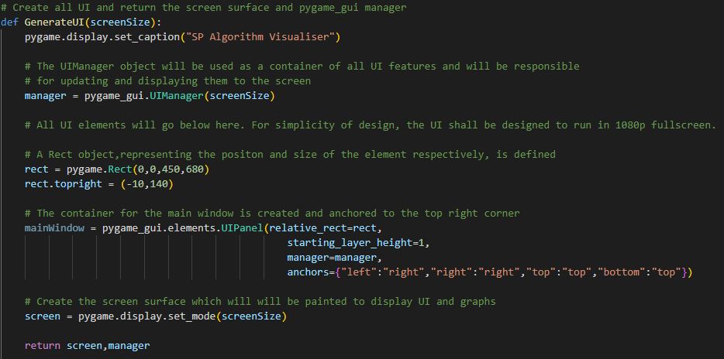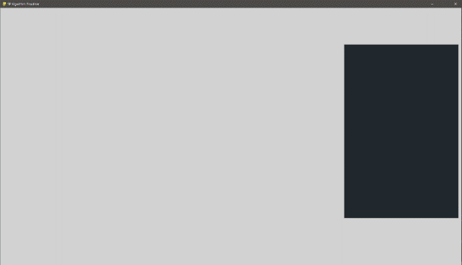A file called gui.py which will contain all functions which will define how the UI should be displayed on screen. By separating these functions into a separate file, I ensure that my solution is modular and so is more easily maintained since code is separated into more relevant categories. Therefore, it shall be easier to look for bugs and improve the code as the solution increases in size.

The GenerateUI function currently only displays a single rectangular panel. Many more UI elements will need to be created for the solution to have the required amount of functionality laid out in the success criteria. However, a considerable amount of space is required for this UIPanel element to be created. Realising this would quickly produce a lot of repetition within my code, which would make it harder to interpret and maintain, I have decided to improve upon the design and create a new function which will simplify the creation process of UI elements:

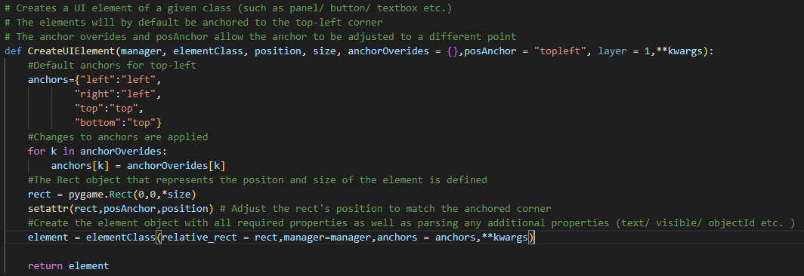

This remedial function will improve the program by reducing the repetition of creating and manipulating each Rect object which would be prone to mistakes. This function is designed to work for creating all pygame_gui elements and allows for any additional customisation to be added to the UI element through the “kwargs” parameter. This may be used to add text to labels or change the initial visibility of the UI element.



It now requires only a single line of code to create an element. Greatly reducing the repetition of code and helping to improve its readability. Most of the code repetition was caused by manipulating the positioning of the element with respect to anchors. These work by checking each side of the element and determining its position relative to a corner of a screen. E.g., for anchor in the top left:

* Left side of element – anchored to left side of screen
* Right side of element – anchored to left side of screen
* Top of element – anchored to the top of the screen
* Bottom of element – anchored to the top of the screen

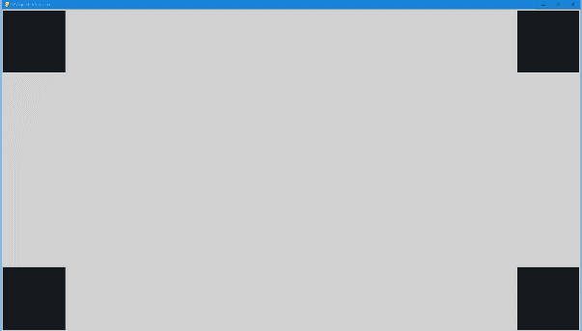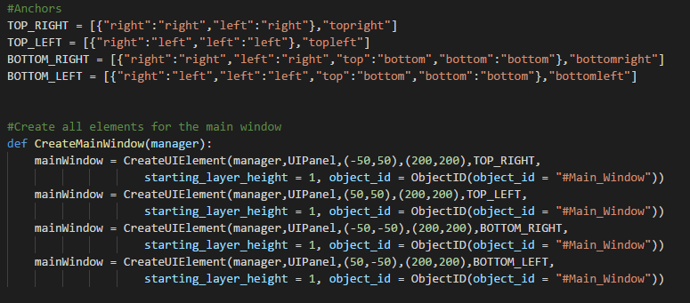Here is an example of how elements can be anchored to the different corners:

It should be noted that while testing these anchors, anchors were separated into variables to help reduce repetition of writing out anchors. This helps to make the CreateUIElement function easier to read and maintain and should also help to reduce the introduction of bugs in the UI.

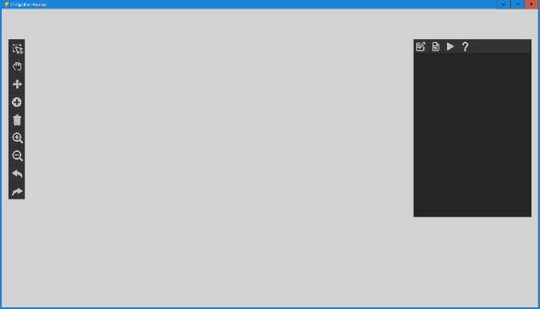Here, the implementation of anchors is shown. The toolbar has been anchored to the top left of the screen and given a specific offset and the main window has been anchored to the top right.

The UI is compartmentalised into individual subsections so that they could be designed individually. This will help improve the maintainability of the UI in the future because it is easier to locate specific elements of the UI. This was done by creating individual functions for each subsection which would create each section:

* Main window
  + Navigation Bar
  + Properties Section
  + Help Section
  + File Section
  + Algorithm Visualisation Section
* Toolbar (Editing and view-only)
* Algorithm Explanation

### UI Layout Development

#### Navigation Bar

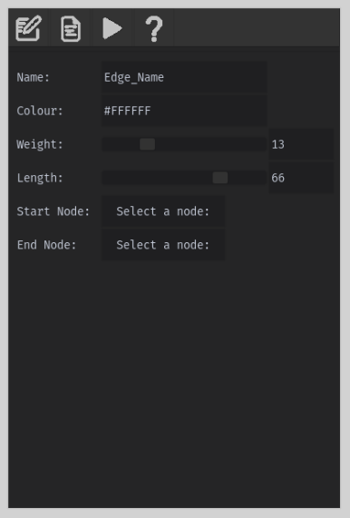The navigation bar was designed considering my initial and adjusted UI designs from stakeholder feedback as well as ensuring that it would meet the 17th success criteria to create an effective navigation bar which would connect all of the sections of the main window together. This has been created from 4 image buttons which help to clearly illustrate what each button will lead the user to in the main window UI.

#### Node Properties

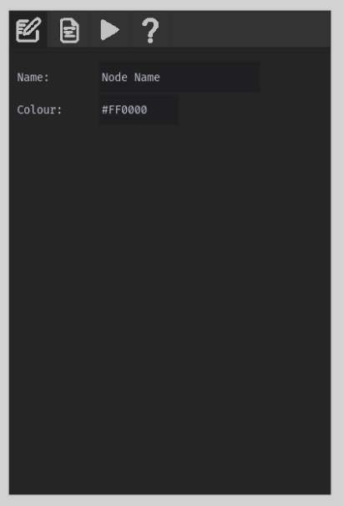The node properties section of the main window shall be displayed when the user selects a node; the UI functionality will be introduced after developing the selection tool so that the user can change the properties of nodes as specified in the 11th success criteria. The UI consists of 2 text box inputs where the user can enter a new name for a node as well as changing its colour. The colour input must be 7 characters long to be a valid hexadecimal colour and was specified by the following code:



**Tested Examples**

If a character is within string.hexdigits (1-10 , a-f , A - f) then it should be able to be typed into the text box. Only 7 characters should be able to be typed.

|  |  |  |  |
| --- | --- | --- | --- |
| Example | Expected Output | Output | Reason for invalidity |
| #ABCDEF | Valid | Valid |  |
| #123456 | Valid | Valid |  |
| #abcdef | Valid | Valid |  |
| #ghijkl | Invalid | Invalid | Contains characters not allowed in the defined set |
| Really long text | Invalid | Invalid | Contains characters not allowed in the defined set and is too long |
| #FFFFFFF | Invalid | Invalid | Input is too long |

#### Edge Properties

The edge properities section of the main window will additionally contribute the 11th success critiera and will be displayed when the user selects an edge in the environment. This section will have some additional properites which will allow the user to adjust weighting of edges as well as their physical length in the environment. The addition of sliders to controll these values was introduced to help meet the 1st success criteria so that the software works well without keyboard input such as if the user is using the software on a smart board.

#### File Options

The file options section consists of several buttons in the main window, where functionality will later be added so that the user can save/load/etc. graphs from files for example. These large clear buttons will ensure that the software meets the 2nd success criteria.

#### Help section

The help section layout has been designed so that it will be very easy for new users to find help as it is found in the main window under the tab of a large question mark. The help section will display different relevant images along with text-support to help explain different areas of the software to the user. They can move between these different sections with the “next” and “back” buttons respectively. This shall ensure that the 4th success criteria are met and so that the software can be effectively used by a broader audience of users with varying comfortabilities with computers. This section will be easy to always find.

#### Visualisation Section

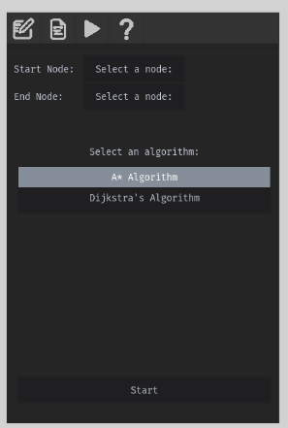This section will allow the user to enter several parameters required to run a shortest path algorithm of their choice. The select node buttons will allow the user to select which nodes they want directly from the graph. This improves accessibility for the program as the user would not have to type in the name of a node (which could have spelling-mistakes and a keyboard may not be readily accessible). Originally the user would select from a drop-down menu to choose an algorithm, but it was determined that using the UISelectionList class of pygame_gui was easier to read and implement as new buttons for different algorithms could easily be added in the future.

#### Toolbars

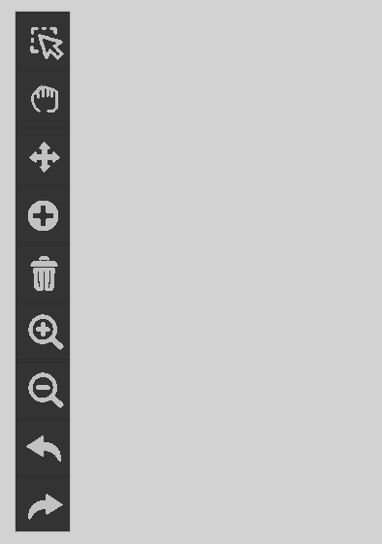Toolbars were to be designed to meet the 6th success criteria and would allow the user to choose from all available tools to be used on graphs. Two different tool bars needed to be created for two different environment states; edit-mode and read-only. Typically, the environment would be editable so that the user can freely adjust their graph. However, while the software is performing a shortest path algorithm, it is essential that the graph stays the same. This can partially be done by providing the user with a reduced set of tools in read-only mode. To overcome this problem, I created a single function which could take a list of objectIDs indicating which tools/buttons should be displayed on the toolbar. This adjusts the size of the toolbar accordingly. Each objectId would correspond with an id in the theme.json file which will lookup which image should be displayed.

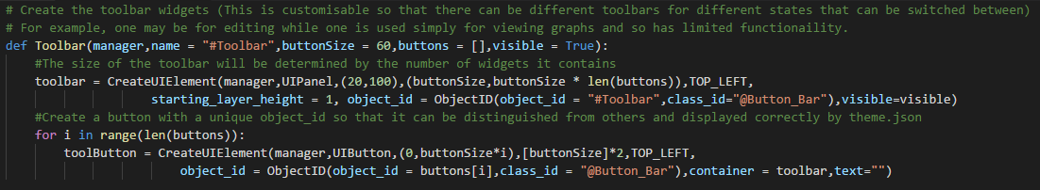2 Toolbar instances for the edit and read-only modes (left and right respectively in the picture above) were created.

**Example of object theming for the Redo button:**

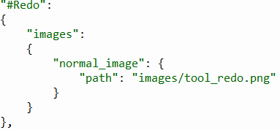

#### Shortest-Path Algorithm Explanation

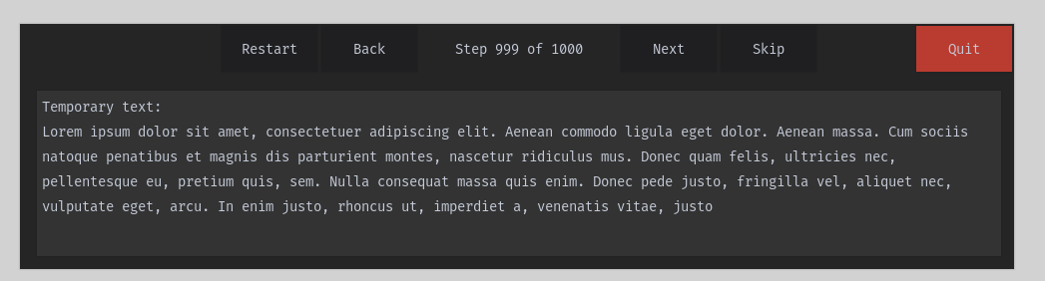This UI will be shown when shortest path algorithms will be performed as specified in the 15th and 16th success criteria. To uphold the 1st success criteria, some image buttons for media control were replaced for text buttons to improve readability of media control.

### Implementing the GetUI Function

To Improve the readability of code and to reduce code repetition, I created a function to easily reference different areas of the UI so that future functions have access to their data and our able to manipulate them:

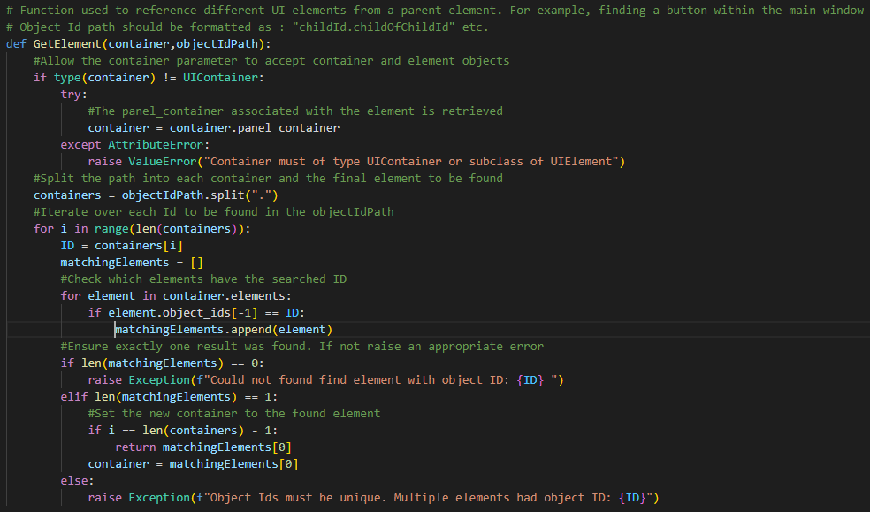

This function can then be used to get different UI elements in the software such as in this example which demonstrates the different ways in which the “Navigation Bar” element can be selected.

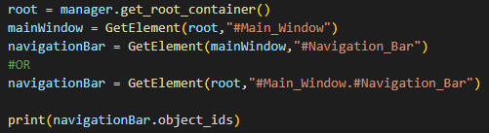

#### Testing

|  |  |  |  |
| --- | --- | --- | --- |
| **Test Input** | **Expected Output** | **Test Output** | **Success**  **/Failure** |
|  | Returns  Main Window Object |  | Success |
|  | Returns Navigation Bar |  | Failure |

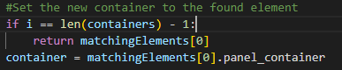Remedial action was then taken to resolve this issue. From revisiting the documentation, I researched how to correctly get the “panel_container” associated with an element. This container was where all information about child objects was stored.

|  |  |  |  |  |
| --- | --- | --- | --- | --- |
|  | Returns Navigation Bar |  | Success | |
|  | Invalid Id Error |  | | Success |
|  | Invalid Id |  | | Success |
|  | Invalid Id |  | | Success |
| With a duplicate instance of #Main_Window | Non-unique Id |  | | Success |

As shown when an invalid Id is entered, the program will raise an error as desired. This shall help with debugging if during development, an id was mistyped.

### Navigation bar functionality

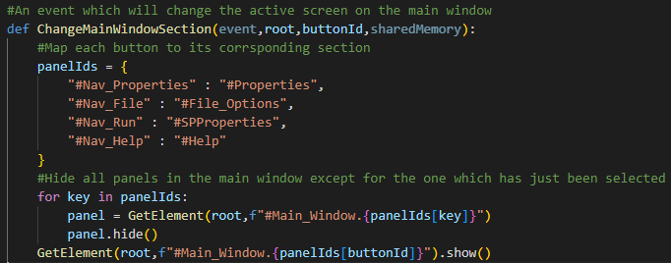The methodology for handling button events has been laid out and functionality has been added to the navigation window. This has satisfied the 17th point of the success criteria as different sections of the Main Window Ui can now be navigated between.

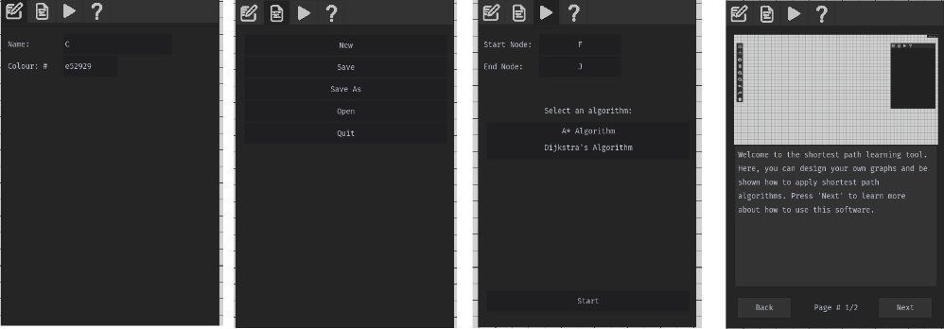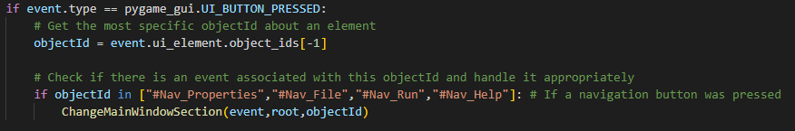The example below demonstrates how different sections can now be navigated between by clicking the button icons in the navigation bar at the top of the window.

### Toolbar functionality

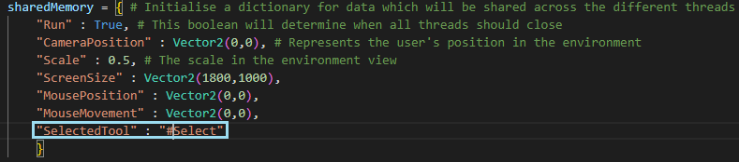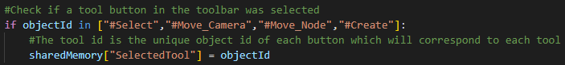The 6th success criteria to implement a toolbar has now been partially met as most tools now have added functionality. This has been achieved by creating a string variable in the sharedMemory dictionary for the selected tool.

### Sliders

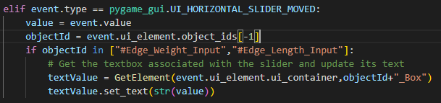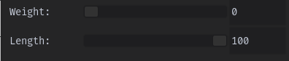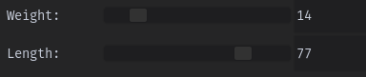Moving a slider should update the value displayed in the neighbouring textbox:

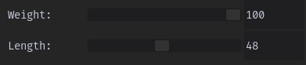Both sliders operate independently of each other and will only allow the value outputted to the textbox be between 0-100 in this example. This is because A* and Dijkstra shortest path algorithms do not work with negative weights. It fulfils the 1st point of the success criteria by allowing users to adjust values to their desires without the use of a keyboard. This will help allow this software to work better in a classroom environment.

Changing the number of the text value will also adjust the slider appropriately. If the typed value exceeds the bounds of the slider, the value will be clamped:



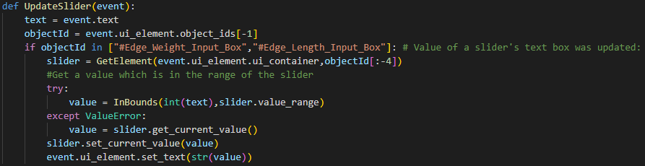

### Stage 1 Review

#### Overview

In this first stage, the priority has been to set up the overall structure of the solution under which more functionalities will be added. To ensure that future stages and maintenance is as easy as possible, the code has been set up in a modular format across several files so that individual functions can be adjusted more efficiently. It has also been to create the UI design of the entire solution; however, a large amount of the UI is missing functionality which will be added in later stages. Later adjustments may need to be made to better suit stakeholder requirements as well.

#### Met Criteria

|  |  |  |
| --- | --- | --- |
| Criterion # | How this area of the success criteria has been met | Level of Completion |
| 1 | The gui.py file has been created and contains all UI data for the solution in distinct modules, which can be addressed easily by the GetElement function. | Complete |
| 2 | UI has been created with all necessary buttons. However, these buttons do not have their attributed functions yet. | Partial Completion |
| 3 | UI for the help window has also been created but to ensure the help information is up-to-date, functionality will only be introduced at the end of development. | Partial Completion |
| 6 | The toolbar has been created and will change the selected tool when a button is pressed. Although the zoom in/out and undo/redo buttons are yet to be introduced. | Partial Completion |
| 11 | The properties panel has been added and receiving when a change to a property can now be handled correctly. However, these properties will not yet display/update information about a selected object. | Partial Completion |
| 13 | The UI to perform a shortest path algorithm is in place. This consists of a series of buttons for choosing start/end nodes, the chosen algorithm and execution button. Functionality for these buttons is still needed. | Partial Completion |
| 15 | The media control UI for the shortest path algorithms has been created. These buttons will not yet work as intended. | Partial Completion |
| 16 | The UI which will display explanations for each step in the pathfinding algorithms has been created however functionality is not yet introduced. | Partial Completion |
| 17 | The navigation bar has been added and functionality has been added which allows the user to easily move between different sections of the main window. | Complete |

#### Testing completed

A significant amount of this stage involved working with existing functions created in the pygame_gui module and so can be assumed to be robust.

UI testing consisted of ensuring that data entered into text boxes was valid. This was to ensure that certain text boxes only contained digit or hexadecimal characters as well as limiting the size of entered text.

Validity of slider values was also tested to ensure that they can only take values from a certain range and that any value entered in a slider’s associated text box also meets this criterion.

The GetUI function also required testing to ensure that when given different paths (child/nested/invalid), the correct UI element or appropriate error message is returned. Ensuring this function works correctly is crucial for many other functions referencing UI to work correctly.

#### Remedial action taken during development

The majority of development so far has aligned with the set-out development. However, some changes have been made so far to the design of the UI. The dropdown menu in the algorithm selection section has been replaced by a list of buttons for each algorithm. This was because a dropdown menu would have been more difficult to implement, and it was simpler for users to understand. Media buttons for the algorithm explanation window were altered to text buttons. This was because text would be easier to interpret than image buttons which could be more confusing to the user.

## Stage 2 – Displaying graphs

In this stage, the focus will be on meeting the 4th point of the success criteria – to display graphs in a virtual environment. To do this, functionality will need to be added to correctly render the environment’s grid as well as a graph’s nodes and edges. This will include any labels and information that also needs to be displayed to effectively represent the graph so that it can be easily interpreted by users.

### Screen To Environment Coordinate Function

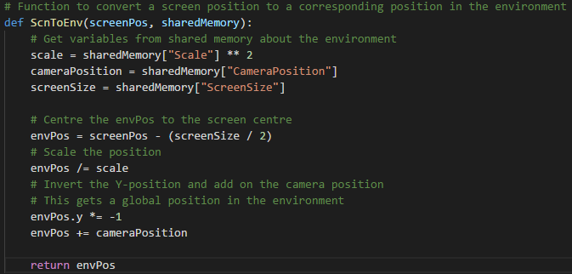This function will be important for translating mouse positions to a coordinate in the environment space. This will be significant when determining the positions of where the user clicks in the environment to correctly process each input.

**Test Table**

|  |  |  |  |  |  |  |
| --- | --- | --- | --- | --- | --- | --- |
| Screen Position (px) | Screen Size (px) | Scale | Camera Position | Expected Output | Output | Success / Failure |
| 0,0 | 500,500 | 1 | 0,0 | (-250,250) | (-250,250) | Success |
| 0,0 | 300,300 | 1 | 0,0 | (-150,150) | (-150,150) | Success |
| 0,0 | 500,500 | 2^2 | 0,0 | (-62.5,62.5) | (-62.5,62.5) | Success |
| 0,0 | 600,400 | 1 | (100,100) | (-200,300) | (-200,300) | Success |
| 50,100 | 600,400 | 1 | (100,100) | (-150,200) | (-150,200) | Success |

### Environment To Screen Coordinate Function

This inverse function will be important for getting the screen coordinates of nodes and edges in the environment so that they can be rendered in the correct position of the screen.

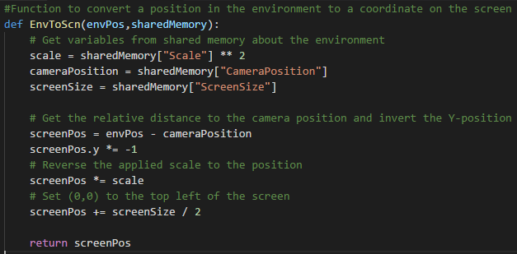

**Test Table**

|  |  |  |  |  |  |  |
| --- | --- | --- | --- | --- | --- | --- |
| Environment Position (px) | Screen Size (px) | Scale | Camera Position | Expected Output | Output | Success / Failure |
| (-250,250) | 500,500 | 1 | 0,0 | 0,0 | 0,0 | Success |
| (-150,150) | 300,300 | 1 | 0,0 | 0,0 | 0,0 | Success |
| (-62.5,62.5) | 500,500 | 2^2 | 0,0 | 0,0 | 0,0 | Success |
| (-200,300) | 600,400 | 1 | (100,100) | 0,0 | 0,0 | Success |
| (-150,200) | 600,400 | 1 | (100,100) | 50,100 | 50,100 | Success |

### Creating the grid

Using the previously implemented EnvToScn and ScnToEnv functions, I was able to create a function which would generate the gridlines to rendered in the environment:

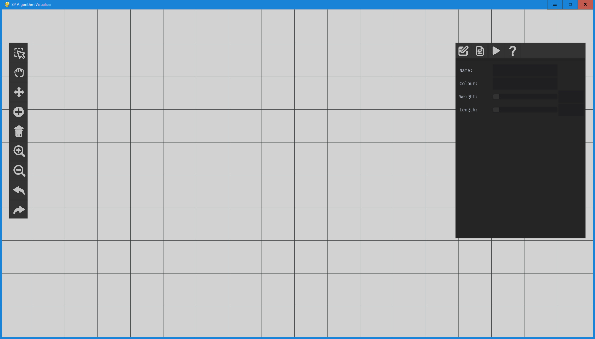

These gridlines should help satisfy the 1st and 4th success criteria by creating a better sense of scale and perspective for the environment which should make it easier for users to interact with it. This grid will move as they user moves the camera. This feature can now be introduced.

### Moving around in the environment

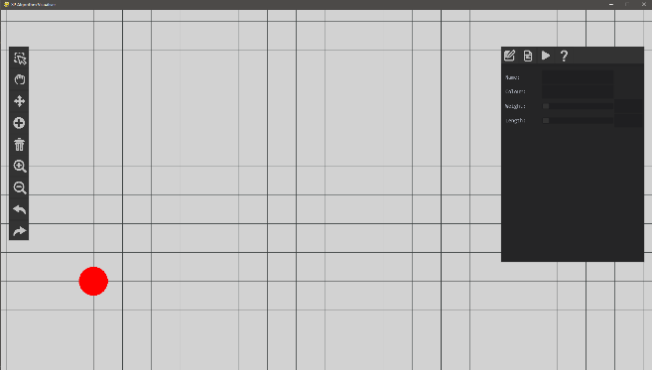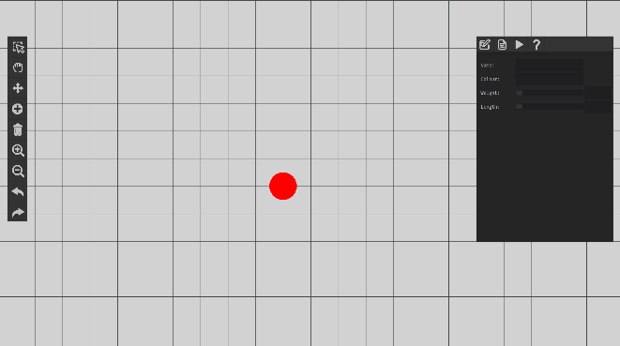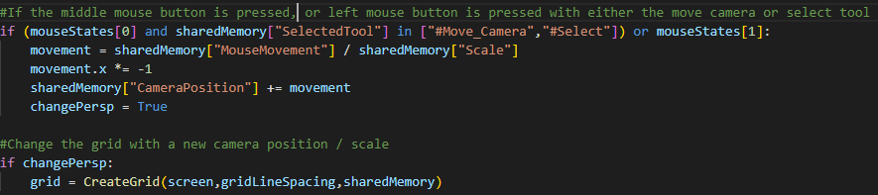Using the added toolbar functionality, the camera movement tool can now be implemented to satisfy the 5th point of the success criteria and will allow the user to move around in the application. This will mean that while holding the left/middle mouse button in the environment, the camera will move relative to the mouse movement. Moving the position in the environment and zooming in/out will have a relational change to the grid. In the example below, a point at coordinates (0,0) has been added to demonstrate how moving around in the environment alters the perspective.

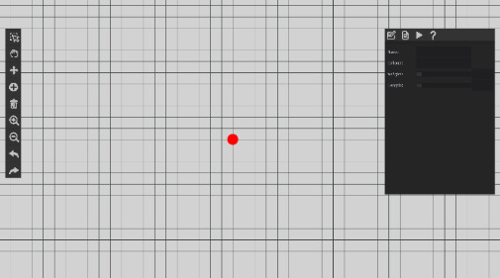Furthermore, the below example shows how the grid and objects within the environment can be scaled by moving the scroll wheel or pressing the zoom buttons in the toolbar:

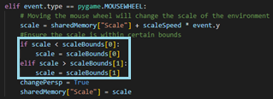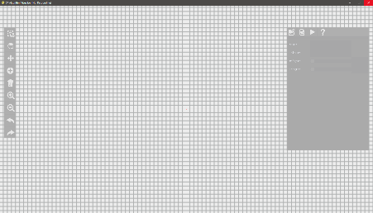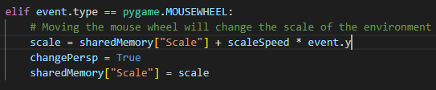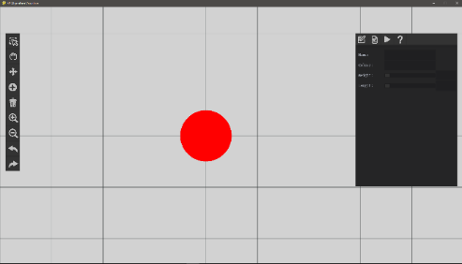While testing this feature, zooming too far out could result in the scale becoming <= 0. This caused the program to crash while trying to render the environment at these scales. I prevented this by introducing bounds to the scale. This would prevent the scale from exceeding a certain threshold:

### Checking if the user is hovering over UI

It was discovered during testing that moving a slider on the UI would cause the camera position to move. This may be unwanted by the user and frustrating if interacting with the UI could cause undesired changes to the environment. To prevent this, a function shall be created which will check if the user’s cursor overlaps any UI element. This will prevent unwanted changes being made to the environment.

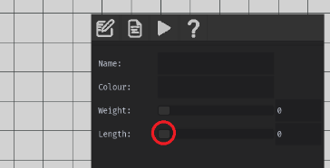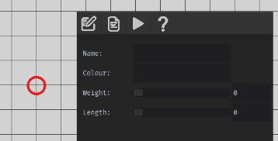This individual line will output the hover state of the main window for example:

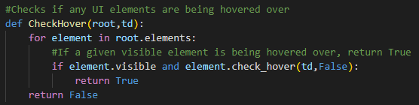False True

This function can then be used to check the state of all visible UI elements in the same way as it was shown above.

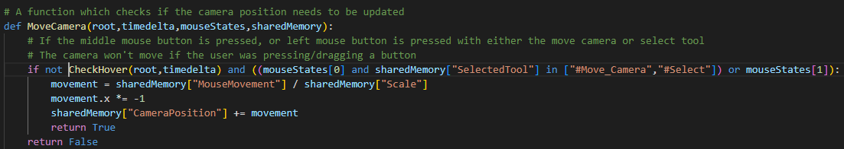The CheckHover function was then added as a condition for the MoveCamera function. This shall ensure that the camera cannot be moved while the user’s cursor is hovering over UI.

### Displaying Nodes

Using the data structure for a node created in the design section, an appropriate class was created in python:

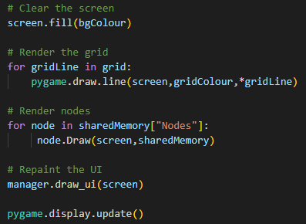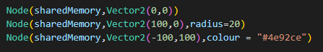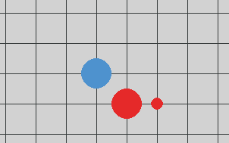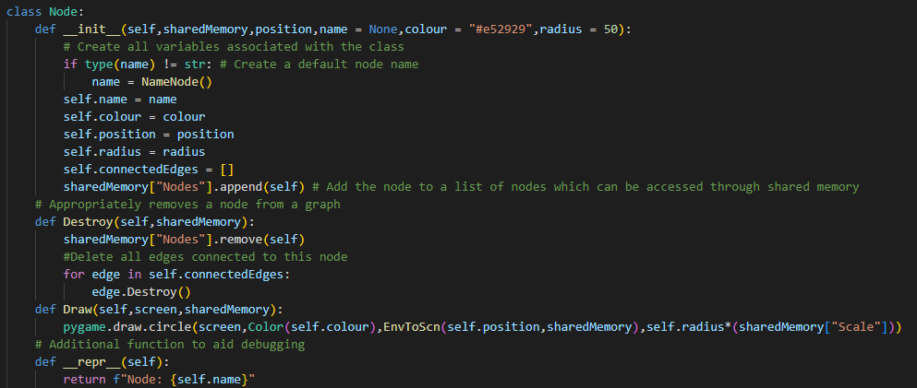This will contain all information about a particular node as well as a delete function which will correctly delete all edges associated with this node. It is also automatically added to the “Nodes” key in shared memory so that it can be referenced in the main thread as well as the environment thread which will be introduced later.

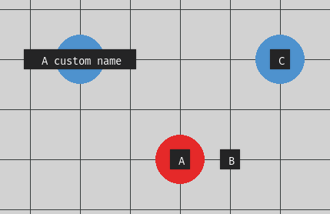In the example above, I have created several nodes with different properties. The for loop in the main python file will then draw these nodes correctly onto the environment. These nodes can have different sizes, colours, and positions for complete flexibility in how the user chooses to add them to the environment.

Labels have been created on top of these nodes which will be sized appropriately depending on the length of a node’s name. This will be very important for the user to uniquely distinguish between nodes.

### Displaying Edges

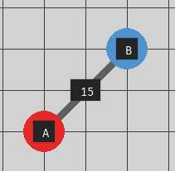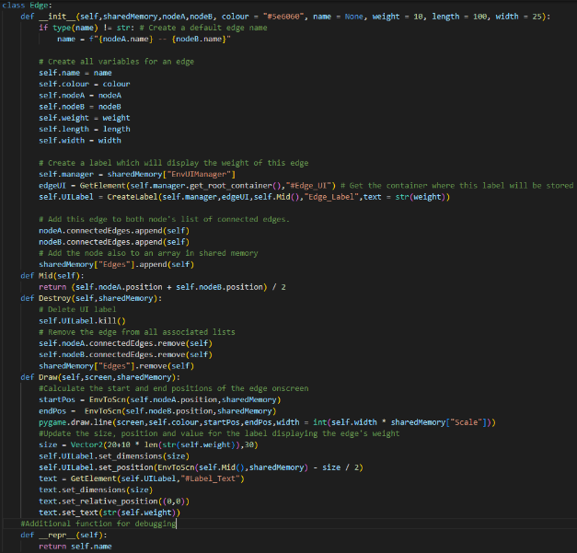The process and data structure for an edge was very similar to that of the Node class. Each node object would be associated with two unique nodes and when rendered, will draw a line between them. The weight of each edge is also displayed which will assist explanation later on with regards to pathfinding algorithms. A midpoint function was also created to calculate the midpoint more easily between the two positions of the nodes in a particular edge.

### A picture containing chart Description automatically generated Adjusting Nodes

If nodes become too close together, this can cause some information to be harder to read. This is detrimental for the user, particularly in a learning environment because information should be displayed as easily as possible.

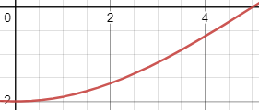Repulsive forces between unconnected nodes are applied according to the graph in red (x-axis is distance between nodes and y-axis is resultant force). The closer the distance is to the optimal distance, the lower the resultant force. It is important to note that this equation is only valid between 0 and the optimal distance.

**Node repulsion is calculated below:**

When testing this in the environment the following happened in the following scenarios:

|  |  |  |
| --- | --- | --- |
| Distance < Optimal Distance | Distance == Optimal Distance | Distance > Optimal Distance |
|  |  |  |
| Repulsion | No Change | No Change |

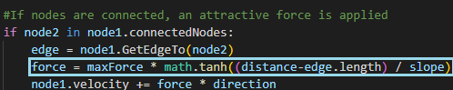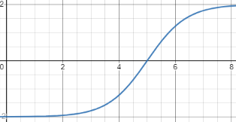Attractive forces also need to be calculated between nodes connected by edges. This is so that distances between connected nodes are constant. This distance was initially calculated by the following code and the force calculation was modelled from the graph in blue:

However, during testing, this force function did not produce the required results of letting the nodes settle at a fixed distance from each other. This was because at distances slightly above/below the desired distance, there was still a strong resultant force applied to the nodes causing them to bounce around the desired distance. To resolve this issue, I adapted the model to produce the following graph:

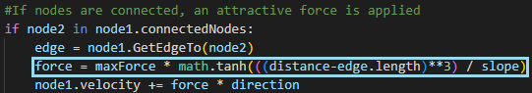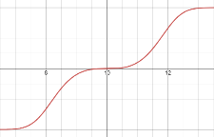In this graph, the resultant force is dampened as the distance approaches the desired distance (10 in this example). This shall reduce the bouncing motion which was observed. The code was then adapted accordingly:

This table shows how connected nodes rearranged themselves in the solution from different starting configurations:

|  |  |  |
| --- | --- | --- |
| Distance < Length | Distance == Length | Distance > Length |
|  |  |  |
| Repulsion | No Change | Attraction |

#### Multithreading remedial action

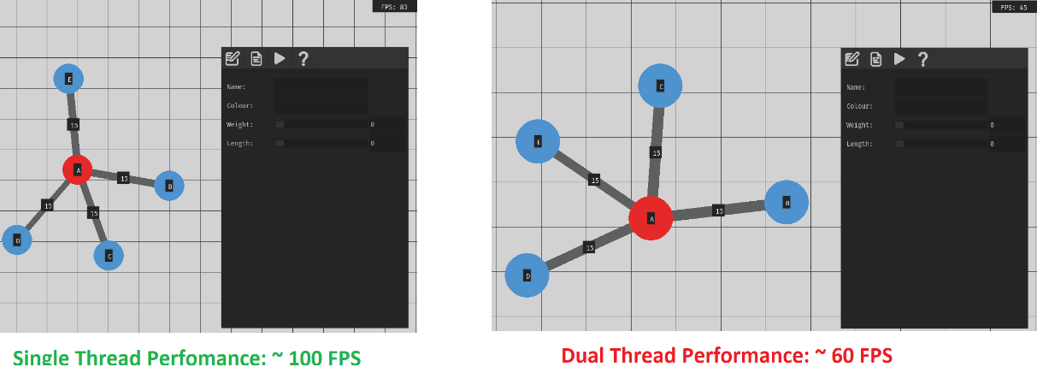My initial design wanted to incorporate multithreading for processing all movement and changes to the graph. However, through testing using multithreading in this way was actually detrimental to performance:

This was because the program was still running on a single core. By using 2 threads, the CPU time per thread is half of what is allowed on a single thread. If I wanted to improve performance like this, I would instead need to utilise multiprocessing. However, memory can only be effectively shared between a single process without significantly overcomplicating the solution. Therefore, changes to the environment will all be performed on the main thread.

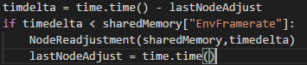

All adjustment to the nodes in the graph is now reduced to this small section of code. Since the node readjustment will become quadratically more complex as the size of the user’s graph increases, this code will only be run several times per second at a lower rate than what is rendered to the screen.

### Testing the robustness of displaying different graphs

The solution will need to be robust so that the software can effectively display a large variety of graphs that users may choose to create.

This set of test data will show a comprehensive list of different variations of graph the software may need to deal with.

|  |  |  |  |
| --- | --- | --- | --- |
| **Description** | **Design** | **Displayed result** | **Success/Failure** |
| **An empty environment with no nodes** | N/A |  | Success |
| **A graph consisting of a single node** |  |  | Success |
| **A graph of 2 connected nodes** |  |  | Success |
| **A graph consisting of 4 unconnected nodes** |  |  | Success |
| **The K3 Graph** |  |  | Success |
| **The K4 Graph** |  |  | Success |
| **A K4 Graph with a single unconnected node** |  |  | Success |
| **A graph consisting of 100 nodes** |  |  | Success |

From the test data, I can conclude that the solution is correctly able to display different configurations of graphs. However, there are further opportunities to improve performance at displaying these graphs. For example, rendering the graph containing 100 nodes required a substantial amount of time and reduced the framerate (to ~20 FPS) of the software. This made it harder to interact with and less responsive and therefore it would be important to optimise this.

To identify areas which would benefit most from optimisations I calculated the time taken to complete each function in the main loop:

|  |  |
| --- | --- |
| Function | Time taken (s) |
| Display Grid | ~0 |
| Display Edges | 0.024 |
| Display Nodes | 0.022 |
| Display UI | 0.001 |
| Total rendering time | 0.049 |
| Total Frametime (time taken for a cycle of the main loop) | 0.055 |

From these results, I discovered that the majority of processing time is being used to render the environment (89% of the time), particularly rendering the nodes and edges.

### Remedial optimisations

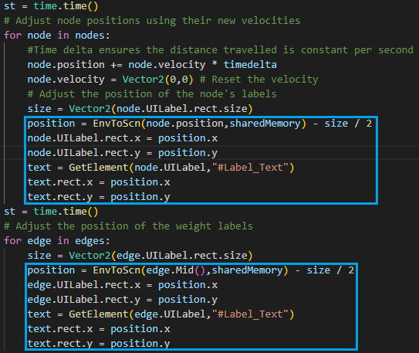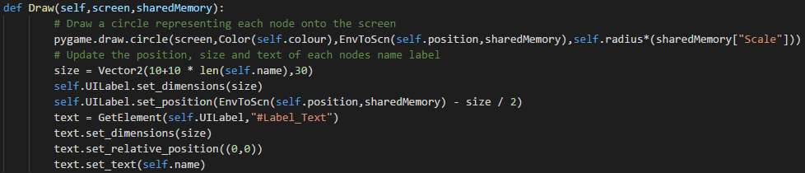The draw functions for the nodes and edges would update the dimensions of their text label each frame. However, since the label size is constant as the text inside is constant, this can be removed. Later on if the name/weight of a node/edge is changed, then the size of its label can be adjusted.

As shown to the right, the positions of these labels were now only updated when the position of a node was changed. This was able to improve performance to a stable and much more responsive 60-80 FPS which made the software much easier to navigate and use. Ensuring the software will run very well even with very large graphs consisting of a hundred or more nodes demonstrates the robustness of this stage in displaying the graphs.

### Stage 2 Review

#### Overview

In stage 2, the focus was to develop the code responsible for displaying the graphs on screen. It was important that the information displayed by the graph was easy to read and customisable so that the user can create a graph which best meets their needs. The graph and being able to move around in the environment have helped to create a better sense of scale between nodes as well as expanding the area in which graphs can encompass. Nodes and edges can have adjustable colours, names, weights, and lengths. These nodes will also rearrange themselves automatically so that the weighting and names on the graph are always easy to read.

#### Met Criteria

|  |  |  |
| --- | --- | --- |
| Criterion # | How this area of the success criteria has been met | Level of Completion |
| 4 | This has been met by creating code which will display and represent nodes and edges on the graph. Two classes were made from their data structures in the design section to contain all methods and variables about these edges and nodes. Labels are also displayed over the top of the nodes and edges representing node edges and edge weights. | Complete |
| 5 | By dragging the mouse while pressing the middle mouse button or the left mouse button with an appropriate tool selected, the camera position in the environment will move relative to the mouse movement. Using the scroll wheel as well as the zoom in/out buttons will adjust the scale in the environment making nodes appear smaller/larger. | Complete |
| 10 | Any nodes connected by an edge will now be adjusted so that they remain at a constant set distance from each other. Any unconnected nodes will be repelled by one another if they are within a certain proximity. This effectively ensures that the labels and context about the graph are always easily readable to the user. | Complete |
| 12 | Multithreading was initially intended to be used for adjusting the nodes for its computational complexity however separating this into a separate thread was shown to be detrimental to performance and so was not worth incorporating at this stage. | Not Complete |

#### Testing Completed

Several different testing methods were used in this stage. Test tables were initially used for the functions used converting between screen and environment coordinates. These test tables were specified in the design section to test any possible configuration of parameters to ensure that the outputted coordinates were correct.

However, the visual nature of graphs required a different method of testing. This was done by showing screenshots interacting with different elements of the solution to show the visual output of the solution. This was done to make sure that when moving around in the environment, the graph and grid are displayed correctly. A set of test data was also used to test a variety of different graphs to simulate what the user may make in the environment at a later stage.

#### Remedial action taken during development

Through visual testing, several adjustments were made upon the original solution. When moving around in the environment it was noticed that scales applied to the environment which were <= 0 caused the program to crash. This was resolved by assigning a set of bounds the scale variable was allowed to take. Additionally when moving around in the environment, scrolling, and moving sliders in the UI would also cause the camera position and scale to change which would be visually frustrating for the user. This was resolved by preventing the user from moving around in the environment while their cursor is hovering over UI.

When testing the node adjustment algorithm, it was also visually noticed that connected nodes were very jittery and did not hold a constant distance from each other. This was resolved by adjusting the equation used to calculate the attractive and repulsive forces between connected nodes; connected nodes are now correctly adjusted to be at a fixed distance from each other.

Performance was also an important consideration for this section because the software will need to be able to run on a variety of different hardware and operate effectively on school computers. The performance of the software across 2 threads was tested and was shown to be detrimental to performance. This required changes to the original design so that the solution would only use a single thread.

The test data of different graphs concluded that the solution was able to correctly display all varieties of graphs. However, larger graphs were detrimental to performance and so adjustments were made to how labels associated with the graphs were repositioned, which was found to have a very detrimental impact on performance.

## Stage 3 – Creating and editing graphs

The focus of this stage will be the complete implementation of the toolbar widget as specified by the 6th success criteria. This will involve adding functionality to each remaining button allowing the user: to create/delete edges and nodes; to undo/redo changes to the graph; to drag nodes to different positions; to select nodes/edges and edit their settings in the properties UI. By completing the following, I should be able to satisfy the 7th, 8th, 9th, and 11th success points respectively.

### Selecting nodes and edges

This will be a vital function for this section as several future functions will rely on selecting nodes and edges to manipulate them. This function can be decomposed into two subsections, checking if the position is inside a node and then checking if the position is inside an edge.

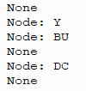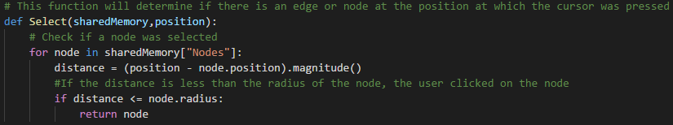

I tested this first subsection by first clicking an empty area which correctly outputted that no node was there. I then clicked the centre of node Y which also correctly returned node Y. I then clicked just inside the edge of node BU which returned BU correctly. Clicking just outside the edge of node DC returned none correctly.

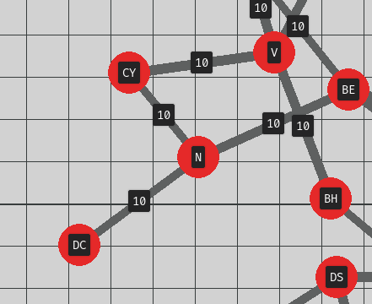To select an edge, the position will be manipulated to a local point so that a coordinate relative to the edge’s normal can be obtained. This will be used to test if the user is selecting an edge in any rotation. This will mean the collision area of the edge will be a rectangle with its centre at (0,0).

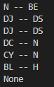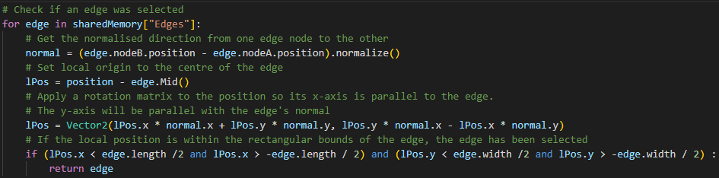To test the selection of edges, I selected the centre of the edge N – BE which was selected successfully. I then did this with several neighbouring nodes in various different locations which at first were all being selected as expected. However, I attempted to select the edge of the node N – BE, however “None” was returned indicating no edge was selected. From the graph diagram above, N – BE is slightly elongated beyond its fixed length of 300 units. This meant attempting to select a stretched edge beyond its fixed length would not work.

As remedial action to this I adjusted the boundaries which determined if the cursor position was inside of the edge to the following:

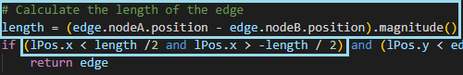

### Creating Nodes

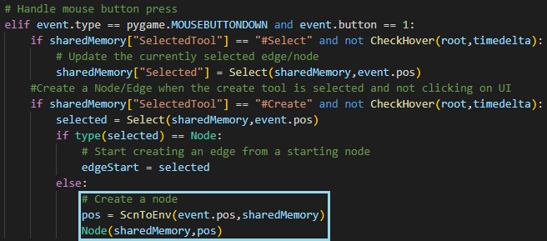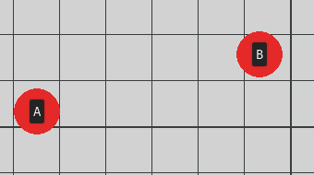Nodes and edges will be created very simply by checking if the “Create” tool is selected, the user clicks the left mouse button, and they are not currently hovering over any UI. To determine whether a node or edge should be created, it is determined what the user clicked on by the Select Function. If an existing node was selected, it is assumed the user wants to start to create an edge (discussed further later) and if anything else was selected, a node will be created:

The above image shows the code required to make a node appear on screen when the user clicks an empty space in the environment.

This feature was tested to the following conditions:

|  |  |  |  |  |  |
| --- | --- | --- | --- | --- | --- |
| Mouse button | Hovering Over UI | Tool Selected | Clicked On | Expected Output | Result |
| Left Click | No | Select | Nothing | Nothing Created | Nothing Created |
| Right Click | No | Select | Nothing | Nothing Created | Nothing Created |
| Left Click | Yes | Create | Nothing | Nothing Created | Nothing Created |
| Left Click | No | Create | Nothing | Create Node | Create Node |
| Left Click | No | Create | Edge | Create Node | Create Node |
| Left Click | No | Create | Node | Start Creating Edge | Start Creating Edge |
| Right Click | No | Create | Nothing | Nothing Created | Nothing Created |

### Creating Edges

Similarly, this was done for edges as well. When the user first clicks on a node, the node is recorded. When the user then releases their mouse, the cursors position is checked again and if another node has been selected, an edge is finally created.

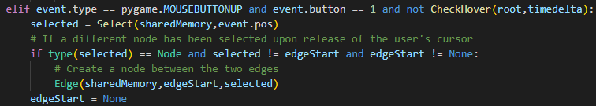

To help visualise the creation process of edges, a line is also drawn from the start node to the user’s cursor to indicate the desired start and end position of the node.



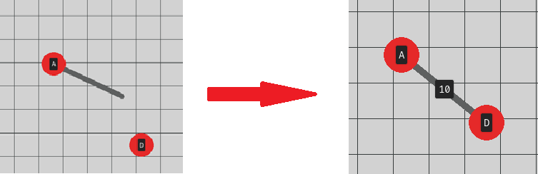

In the image above, I demonstrate how the program will show the starting node and where I want to make an edge on screen and how the edge is created between nodes A and D.

### Deleting Edges and Nodes

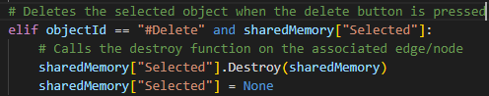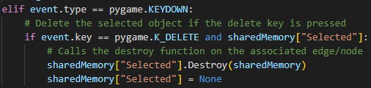Suppose the user accidentally forms an edge/node which they did not intend to make. In this case, there should be an appropriate way to delete these parts of the graph. It will be important to ensure that deletion is performed correctly to ensure that all data associated with the graph does not contain edges/nodes that should not exist. This has already been partially implemented in Stage 2 of development in the Edge and Node classes. However, this step will involve providing this functionality to the user.

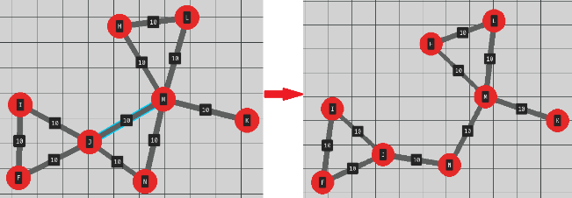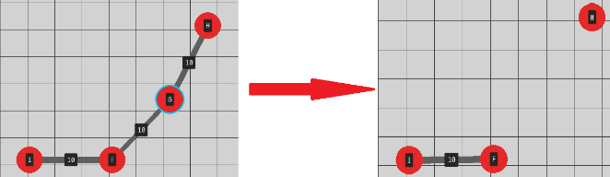These two sections allow the usage of the “delete” button on the tool bar and the Delete key to be used to delete the currently selected object:

The two examples above show how this feature was tested by deleting both edges and nodes. It should be noted that when deleting a node, all associated edges are also deleted.

### Dragging nodes

As described in the 9th success criteria, the user should be able to drag nodes to different positions. This is because whilst the automatic node readjustment algorithm does an excellent job at enhancing the readability of graphs, there may be some which are slightly more obscured. Therefore, it is a good idea to allow manual adjustment to these features to further improve readability and allow the user to customise their graph further into arrangements of their choice.

During development of this feature, testing this with a separate tool for dragging nodes slowed down the interactivity of the software since the user would have to alternate between the Select/Create/Drag tools. To improve this, the Drag and Select tools were combined so that when the user selects a node and holds their cursor on it, they will be able to drag it to their desired location. This therefore involved adjusting the toolbar UI as shown on the right:

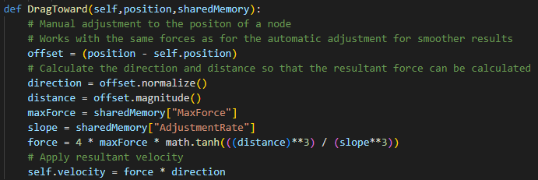A new function was added into the Node class to describe how a node would be dragged around in the environment. It was done using a similar formula to what was used to distributed connected nodes in the graph so that the node would smoothly move to points and interact with other nodes correctly.

### Recording changes to the graph and Undo/Redo functionality

The 8th success criteria indicate the solution should be designed so that the user can undo/redo changes they make to their graph. This is so that they accidentally make an unwanted change, they can very easily revert this change. Each adjustment made to the graph, such as adding a new node/edge or changing a property will have an associated “Operation” that will be stored in a stack. These will be referenced to determine what operation should be redone/undone.

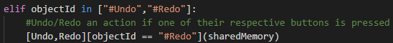The fundamentals for this feature are fairly straightforward, where functions are called for the respective undo and redo buttons as well as when Ctrl+Z and Ctrl+Y are pressed.

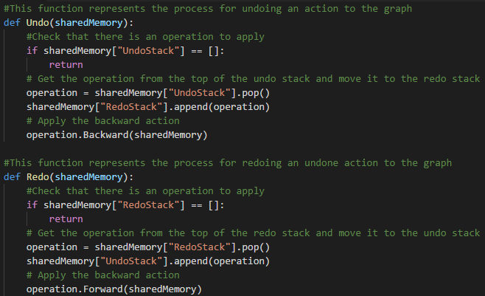

The following subsections will cover the implementation of recording the operations for creating/deleting nodes/edges:

#### Create Node Operation

This operation will have a forward action where a node is created into the environment according to a set of defined parameters and a backward action where this node is removed from the environment. During the backward action, the node which should be deleted may not be the original instance of the node. Therefore, a node with the corresponding ID should be found and destroyed.

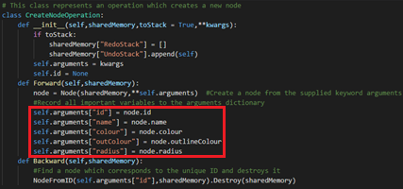

Instances of this class can then be created when the user creates a new node in the following method highlighted in blue. It should also be noted that when a node is created, its variables should be recorded so that if a node is instantiated in the future, it will have the same original properties.

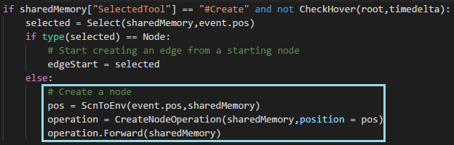

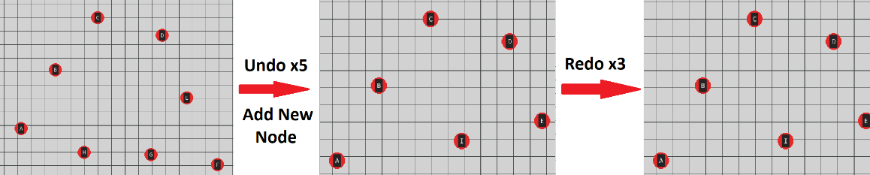**Testing Undoing and Redoing operations:**

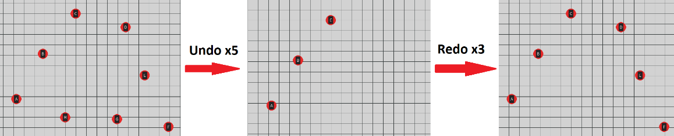Adding a new node to the graph correctly clears the redo stack and so nodes F, G and H will not be reperformed to the graph. This is because the new node I has overwritten those operations.

#### Create Edge Operation

This operation will similarly have a forward action where an edge is created into the scene and a backward action where it is appropriately removed from the environment. An edge will be comprised of two nodes, which may not be the original instance when the Forward function is called. Therefore, it will be important to correctly retrieve the edge’s nodes from unique ids.

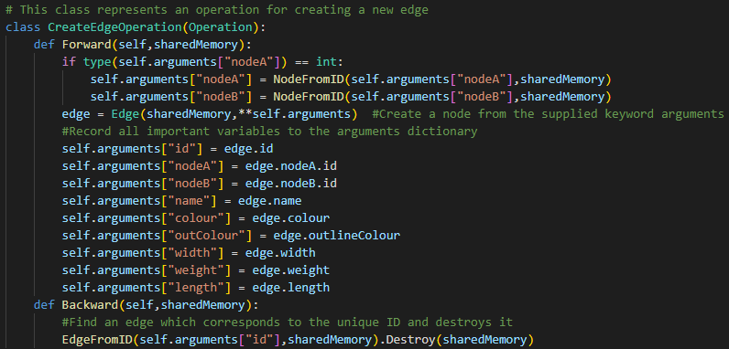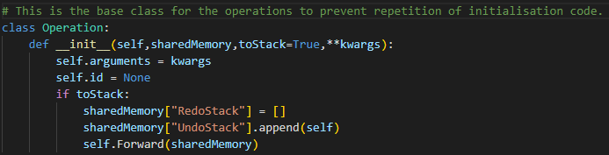To reduce repetition of code, a base class for these operations was created so that the subclasses could all be initialised in the same way:

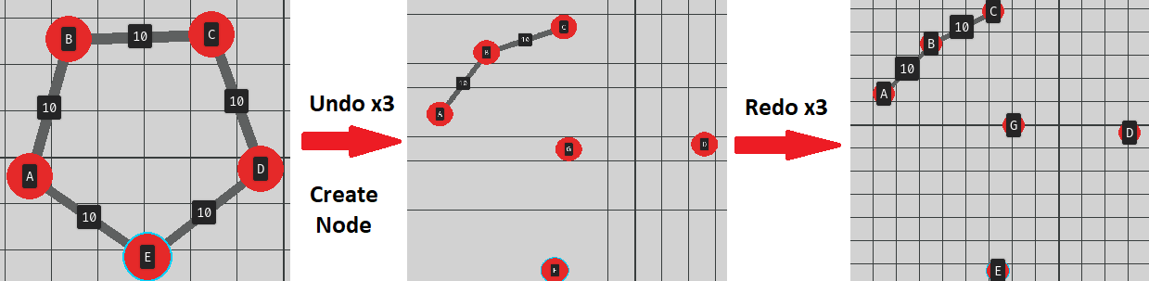The format for the CreateEdgeOperation subclass follows a very similar structure to the CreateEdgeOperation subclass. However, this class takes more attributes from the edge so that running the forward action creates the same edge each time. This also includes storing the ids of the connecting nodes so that a node with each respective id can be located and used to create the edge.

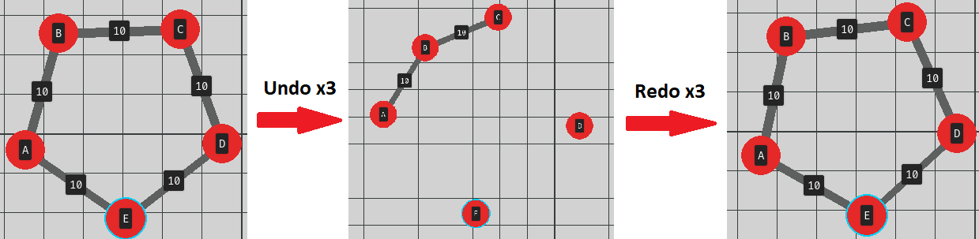Redoing and undoing changes will now also apply to creating edges. Making a change to the graph will clear the redo stack.

#### Delete Edge Operation

The DeleteEdgeOperation class will be very similar to the inverse of the CreateEdgeOperation. It will have a forward action where information is first recorded about the edge followed by it being deleted from the environment. The backward action will be to then create a new edge based on the recorded information.

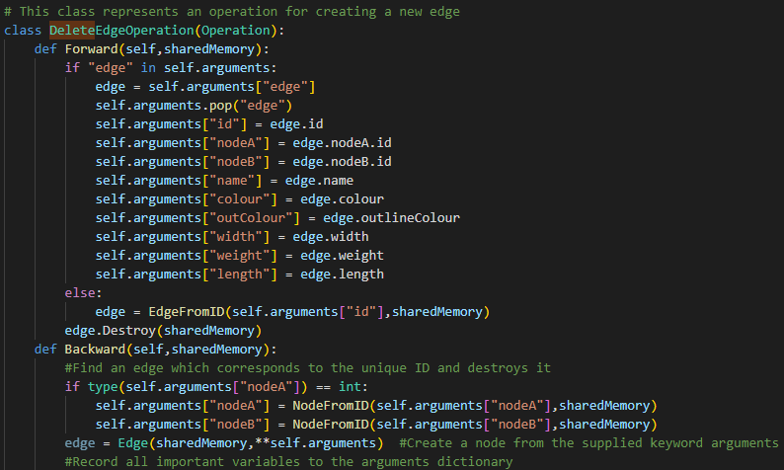

**Testing this with the undo/redo functions produced the following output:**

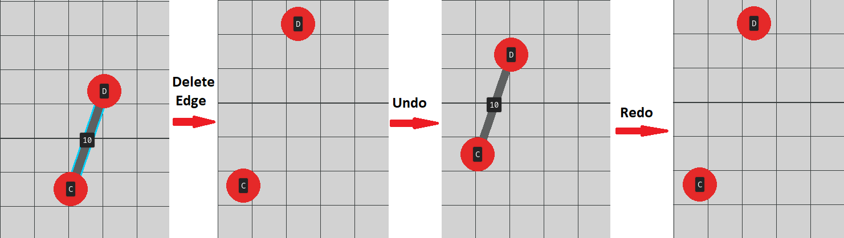

#### Delete Node Operation

This final operation for graph editing will be the most complex of the four. This is because for the forward operation, all deleted nodes and edges associated with the node have to be recreated. This will require storing information about the node and all connected edges. The backward action will then involve removing the node and all associated edges as prior.

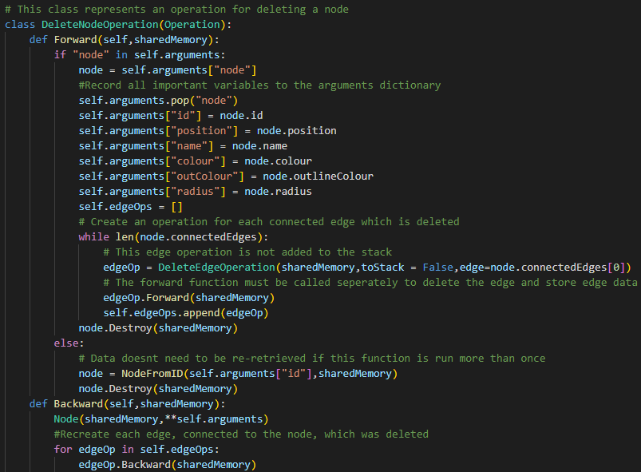

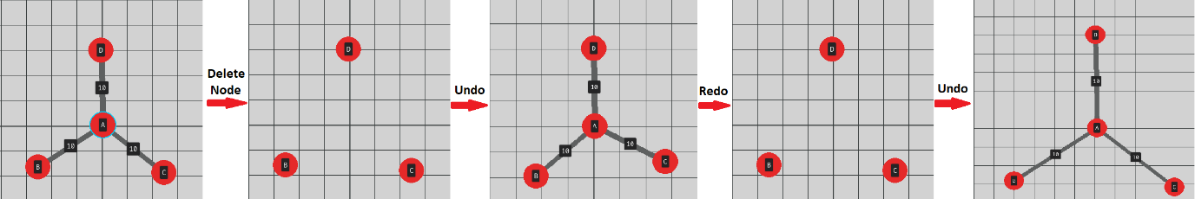This was achieved by having an array of operations for each edge which would be removed alongside the edge. This insured that all information about the node and its connected edges was retained.

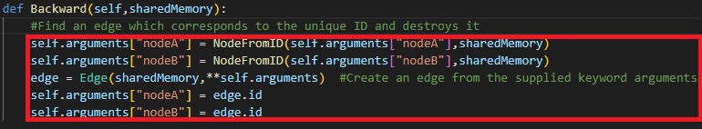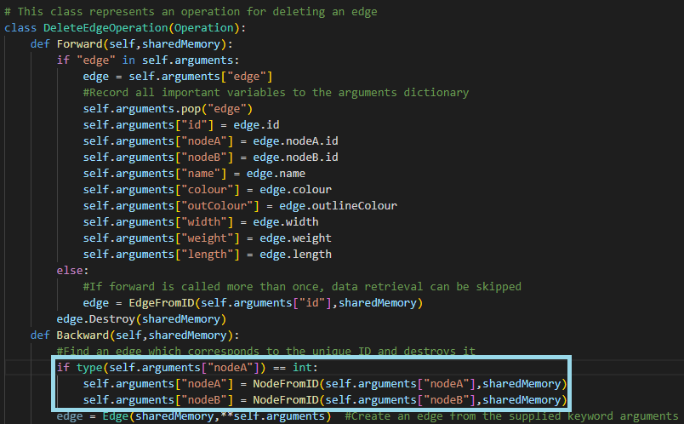While testing this in the solution, the program was able to correctly undo and redo changes for the first time. However, if the user tried to undo, redo, and undo the same operation, the adjustment of nodes was incorrect as shown in the 5th graph in the image above. This was due to a bug in the backward action of the DeleteEdgeOperation, where the edges would be created to node instances which did not exist. Through debugging, the issue was identified in the area highlighted in blue below. The bug is now resolved with the code highlighted in red.

### Stage 3 Review

#### Overview

In this stage, the solution is now fully capable at accepting user input to modify graphs. The guidelines for what was required for creating and editing graphs was specified in the 6th, 7th, 8th, 9th and 11th success criteria. This consisted of having a toolbar where the user would be able to select different tools to interact in different way as well as to create/delete edges and nodes. The solution would also need to correctly record each change which is made to the graph so that operations could be undone/redone.

#### Met Criteria

|  |  |  |
| --- | --- | --- |
| Criterion # | How this area of the success criteria has been met | Level of Completion |
| 6 | The toolbar was partially completed in stage 1. During stage 2 and 3 all functionality for the toolbar has now been added. In stage 3, this included the select and create tool which will be discussed later in more detail. Functionality for all undo and redo buttons were added. The drag tool was combined into the select tool so that moving and selecting nodes and edges became smoother and more intuitive for the users. | Complete |
| 7 | Nodes can now be created in any empty space the user clicks on with the create tool selected. Edges can be created in the solution by clicking one node and dragging it to a different node. An edge is then created between these nodes and information about both connected nodes is updated. Nodes and edges can be deleted simply by selecting them and pressing the delete key/button. When a node is removed, so is all of its associated edges. | Complete |
| 8 | Whenever a user makes a change to their graph, such as creating a node, it is recorded into an undo stack. If the user presses the undo button or Ctrl-Z, the node will be removed from the environment. Likewise, if they press the redo button or Ctrl-Y, the node will be recreated into the environment with the same original properties. A key consideration when doing this was to ensure that when rebuilding nodes and edges, they reform all connections to edges and nodes. | Complete |
| 9 | This was an additional feature designed to support the automatic adjustment of nodes so that the user could move nodes to make the graph easier to interpret. When the user selects a node with the select tool and holds their cursor on it, the node will move towards the cursor position until the user releases the button. | Complete |
| 11 | This criterion was integral to several of the aforementioned success criteria because it is important that the solution is able to correctly identify if a node or edge intersects a coordinate. This was simple to do when checking for nodes as the distance from the point to any node can be calculated. If one of these distances was less than the radius of a node, then the algorithm could conclude intersection occurred. To check for intersection of edges, a rotational matrix was applied to a point and it was localised to the centre of the edge. Then the solution could easily check if the local point was within the rectangular edge boundary.  Adjusting properties about nodes and edges will be added at a later stage. | Partial |

#### Testing completed

A significant amount of this section required a lot of visual testing since it was all graphical manipulation being applied to the graph. When initially testing node/edge selection, different nodes and edges were selected/not selected at different points in the environment to see if the selection algorithm would correctly determine if the mouse position intersected any objects.

When creating/deleting the nodes and edges, the visual nature of the testing was most evident. A combination of test tables, illustrating how different inputs would choose between making a node/edge, and screenshots of graphs in the environment were used to demonstrate the correct operation of different features for editing graphs.

Similarly for the undo/redo actions, these were tested by taking screenshots of the graphical output displayed when the user enters certain inputs. For example, what the graph looks like before and after pressing Ctrl+V.

#### Remedial action taken during development

Several areas of this stage required some remedial action. Initially an issue with selecting edges arose in the program which was because the size of edge’s rectangle in which selection was true was fixed. However, I forgot to consider edges which would be stretched/squeezed and wouldn’t be their desired length. This was adapted by allowing the size of the edge’s hitbox to adjust to the actual length of the edge.

When setting out to develop the tool for moving nodes in the environment, it was considered to be quite clunky and would reduce the effectiveness at which users could interact with their graphs. To improve this, it was combined into the select tool to enable much easier interaction with nodes in the environment because they would not need to switch between tools each time. This, therefore, involved modifying the toolbar so it no longer displayed the move node tool.

Remedial action was also taken when creating the undo/redo tools. It was noticed in the Delete Node/Edge Operations that repeatedly undoing and redoing delete operations on edges would cause rebuilt edges to incorrectly connect back to its nodes. This was due to an older, deleted instance of a node being referenced in the creation of new edges. This was updated so that every operation would ensure that it was referencing only the most recent, existing

## Stage 4 – Additional UI functionality and stakeholder feedback

In stage 4, the solution is now at a sufficient stage when it would be useful to gain stakeholder feedback on using the software so that I can improve the solution to better fulfil their needs and the success criteria. Getting feedback and providing remedial action on this will be the initial component of this stage.

This will then be followed by adding functionality to the additional subsections of UI including the help section, file options, properties, and SPA properties pages in order to fulfil the 3rd, 2nd, 11th and 13th success points respectively.

### Stakeholder feedback so far

The current point in the development process is now at a stage where it would make sense to gain stakeholder feedback on the current solution to gauge how easy the solution is to use and understand what is going on. By completing this additional feedback, I will be able to apply additional remedial action to ensure that the solution best meets the success criteria and needs of the stakeholders.

I started by sending the program to several stakeholders, along with instructions of how to use the program and several basic tasks the stakeholders should try and complete:

**“Hello testers,**

**I have attached a set of files as well as instructions to correctly run the program I would like you to test. The program will currently allow you to create and manipulate graphs in the program’s 2D environment. To begin, try moving around in the environment by pressing the middle mouse button or left mouse button and dragging your cursor. You can zoom in and out with the scroll wheel or with the scroll buttons at the bottom of the toolbar on the left of the screen. Select the “create” tool from the toolbar. Nodes can be created by clicking on the screen. To create an edge, select a starting node and drag to another edge. Nodes and edges can be deleted by selecting them and pressing the delete button or delete key. If you make a change you’d like to undo, press Ctrl-Z or the undo button on screen.**

**Now have a go doing the following in the program:**

* **Create a central node with 10 nodes connected to it.**
* **Create a ring of nodes all connected together**
* **Create a tree graph with 7 nodes (A tree is a graph with no cycles/loops)**
* **Create a graph of your choice. Bigger is better.**
* **Try and see if you can break the program or get unexpected results**

**After testing the program sufficiently, please reply to this email with any feedback you have to improve the software.**

**Thank you and have fun testing,**

**- Alex”**

#### Getting Lost

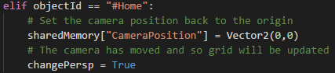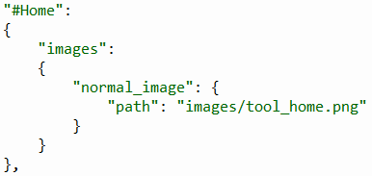One user mentioned how when moving around in the environment, if they were to move extremely far away from the origin, they would struggle finding their way back to their graph in the centre of the screen. This problem could be remedied by creating a button on the toolbar which would return the user’s camera back to its original position.

This was implemented by adding some additional data to the themes.json file directing to the new “Home” image to be used as well as adding this button to both instances of the toolbar. A condition to the UI_BUTTON_PRESSED event could then be added to update the camera position.

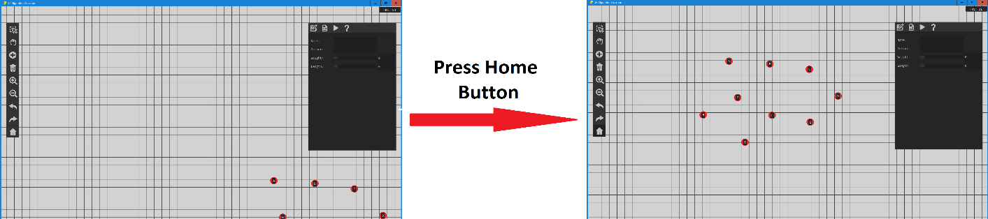

#### Selecting nodes in the create tool

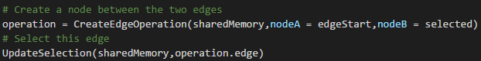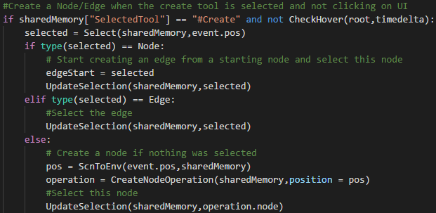Another user mentioned some difficulty when trying to delete nodes and edges. This was because selecting them required the user to navigate to the select tool, back to the node and then back to the create tool. This could be streamlined by adjusting the creation algorithm to also incorporate selection under certain conditions. The logic for creating nodes and edges will be adjusted slightly. If when the “Create” tool is selected and the user clicks an edge, the edge will be selected rather than creating a node. When the user clicks on a node, it will become selected. If the user clicks on a node and creates an edge, the new edge is selected. If the user clicks on empty space, a node will be created and selected.

|  |  |  |  |
| --- | --- | --- | --- |
| Input | Expected Output | Output | Successful |
| Click on empty area | Create node and select it | Node created and selected | Yes |
| Click on node | Select node | Node selected | Yes |
| Click on edge | Select edge | Edge selected | Yes |
| Click on node and drag to another node | Select node and create edge. Select edge | Node created, edge created and edge selected | Yes |

#### Difficulty selecting edges and nodes

Due to the very narrow width of edges in the environment, they can be difficult to select. When zoomed out this can be especially difficult for both nodes and edges. This will be reduced by increasing the bounds around where objects can be selected beyond their displayed size. These bigger hitboxes should make it easier for the user to select objects.

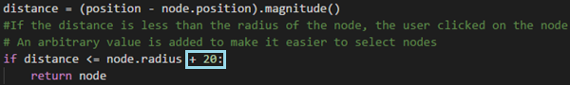This was done by simply adding a constant onto the following conditions. This made it noticeably easier to select edges and nodes.

### File Options

#### Saving Files

To satisfy the 2nd success criteria, functionality must be added to the file options section of the main window so that users can easily save and load graphs from files. This will be achieved by creating file dialogue boxes using Tkinter and saving files efficiently with the pickle library.

The following function was created for the Save and Save As buttons.

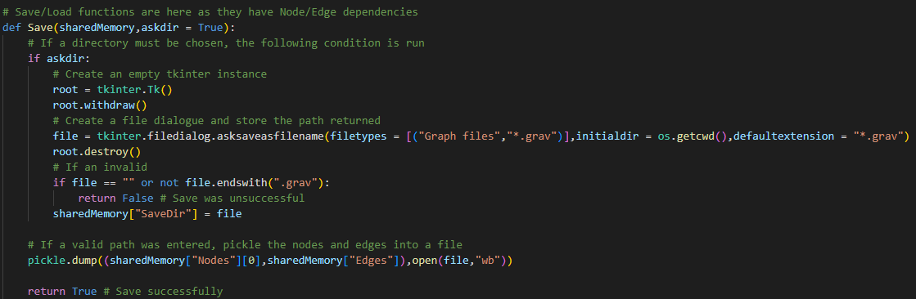

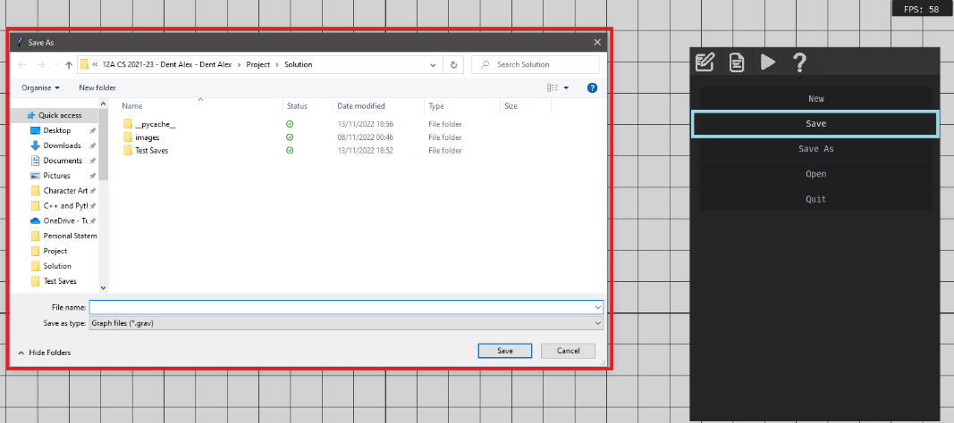Pressing the Save/Save As buttons causes this function to execute which will create a file dialogue window where the user can specify a file location to save their file to. By using Tkinter to display the file dialogue box, it can be assumed to be robust.

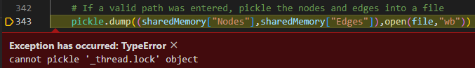However, when the function attempts to save the list of nodes and edges to the file the following error is produced:

This indicates that the pickle library will not allow node and edge instances to be saved. To overcome this problem, I will create a method in each class which will compile an array of all values about each object. These values will then be stored in a 3D array and used to rebuild edges and nodes when the file is opened. Rebuilding nodes in this way is most likely better practice since reinstantiating objects which depend on other objects would be prone to error.

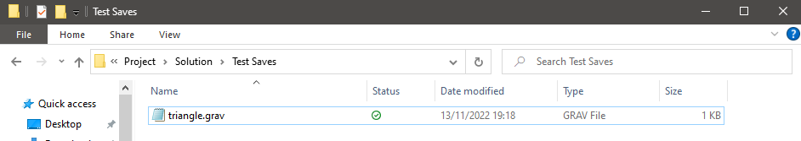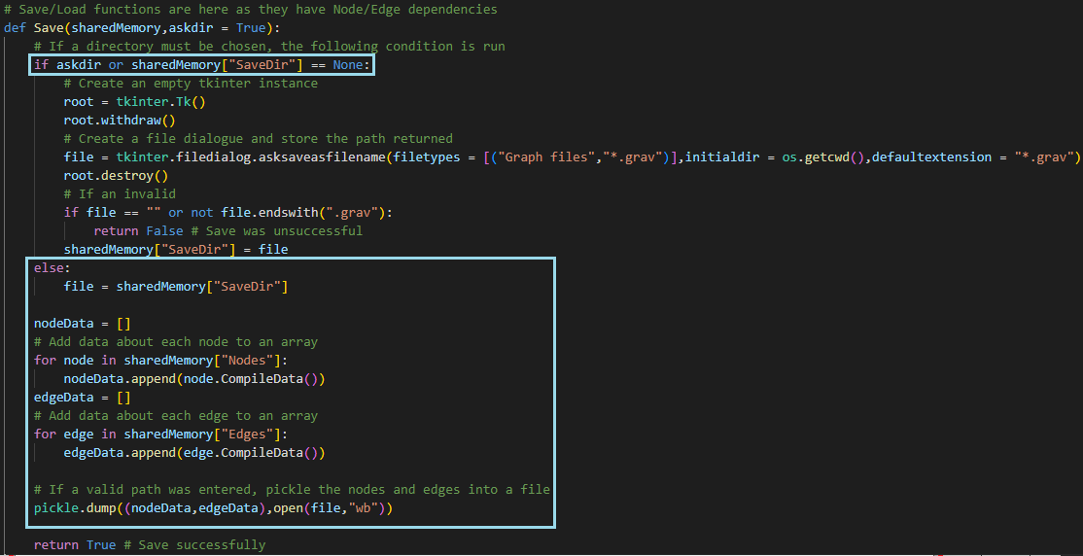Adding these methods to the Save function and making these following adaptions allows files to store all information corresponding to a graph’s edges and nodes.

**Test Table for interacting with the Save/Save as buttons**

|  |  |  |  |
| --- | --- | --- | --- |
| **Input** | **Expected Output** | **Output** | **Success?** |
| Press the “save” button where save directory is not set | File dialogue is displayed | File dialogue is displayed | Yes |
| Press “save” button with save directory set | File is automatically saved | File is automatically saved | Yes |
| Press the “save as” button where save directory is not set | File dialogue is displayed | File dialogue is displayed | Yes |
| Press the “save as” button with save directory is set | File dialogue is displayed | File dialogue is displayed | Yes |
| Close the window without entering a directory | The file is not saved | The file does not change | Yes |
| Press save without entering a filename | The file is not saved | The file does not change | Yes |
| Press save, entering a valid filename | The file is saved | File is saved with the given filename | Yes |

#### Quitting

It is also important to suggest the user saves their work before completing certain actions, such as closing the program, loading a new graph or creating a new graph. Therefore, a dialogue box should be displayed, asking if the user would like to save their graph in these following instances.

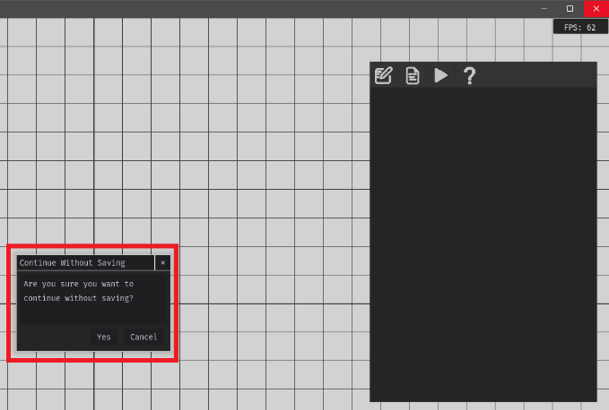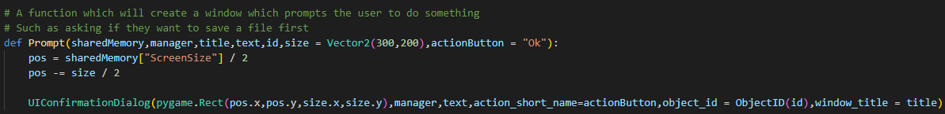This simple code was introduced which will display a dialogue box on screen when called. Below, it is being used to ask the user if they would like to save their file before quitting.

#### New graphs

A similar process was then repeated for the “New” button which creates a new graph after prompting the user if they would like to save their current one:

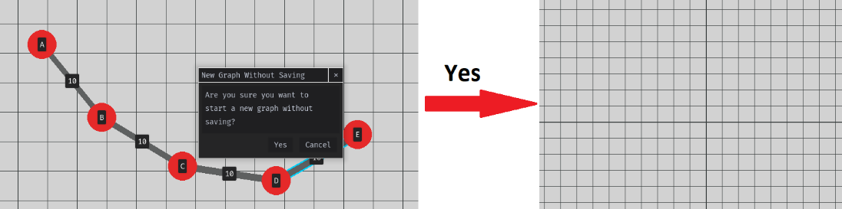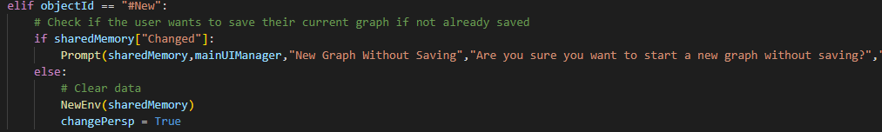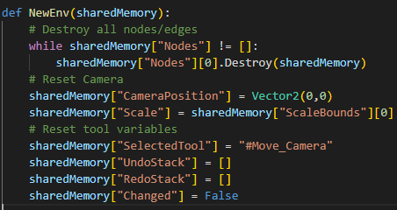The diagram below demonstrates how choosing to create a new environment will remove all changes made in the program once the user selects yes on the displayed dialogue.

#### Opening Files

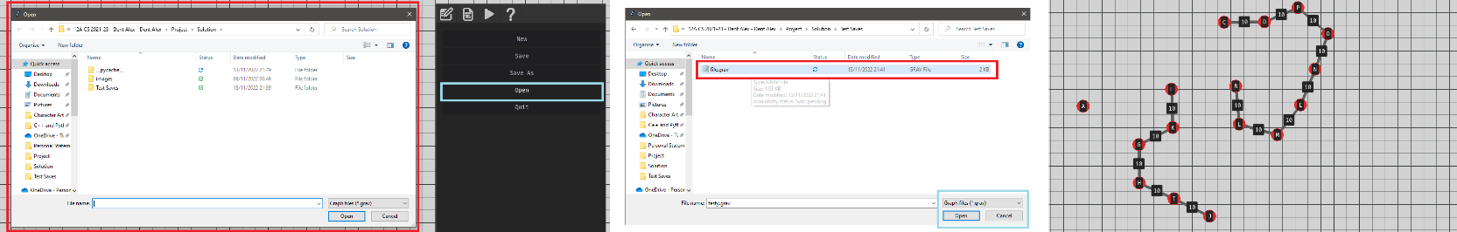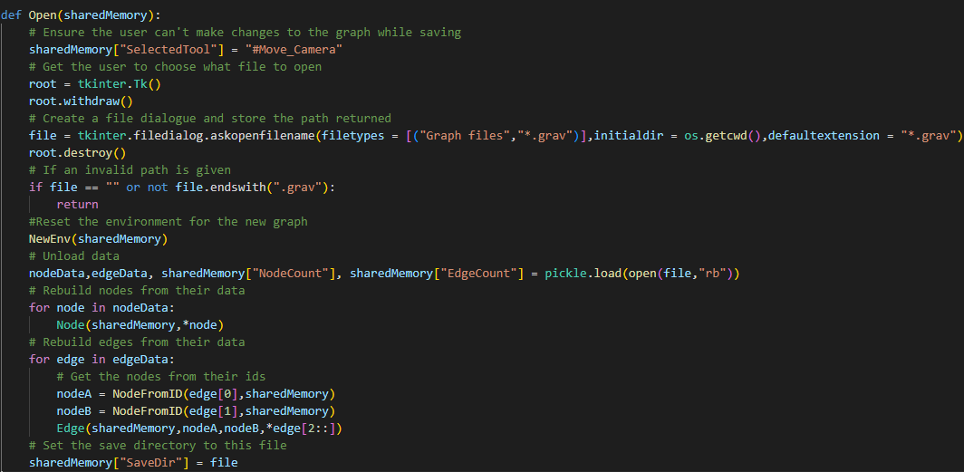The final part of this section was to create the function responsible for opening a new file. After prompting the user if they are sure they want to open a file, this window is function is executed which displays a file dialogue where they can choose a valid file. It will then reset the environment with the previously created NewEnv function, ready for new nodes and edges to be created.

This diagram shows an example of the file dialogue being created, selecting a valid file and the output this had on the environment.

### UI Properties

Currently, certain attributes about the graph such as the names of nodes and the weights of edges have been stuck to their default values. The UI properties panel will allow the user to selectively adjust and view settings about individual nodes and edges. This will be achieved to fulfil the 11th success criterion. It will be utilising the existing UI as well as the UpdateSelection function which will need to correctly display an object’s properties and allow them to be changed. Any changes in the UI will be reflected in the graph.

#### Updating properties onto the UI

To begin, a new method called UpdatePropertiesUI was created so that the UI displayed in the properties panel would reflect the currently selected node:

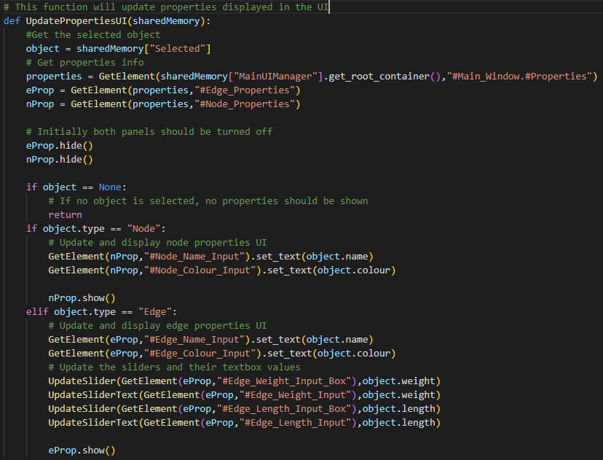

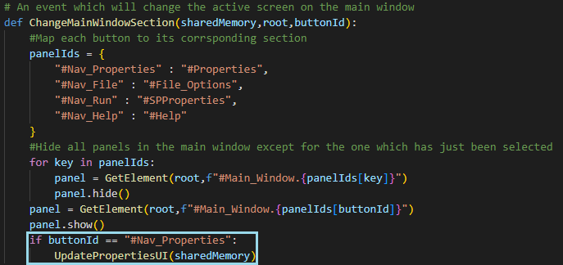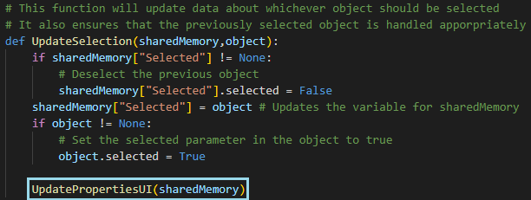This function will show the appropriate properties depending on what the user has selected. Along with showing the correct settings, it is important that all values area relevant and updated for each node/edge. This function is then run whenever a new node/edge is selected or the user navigates to the properties panel.

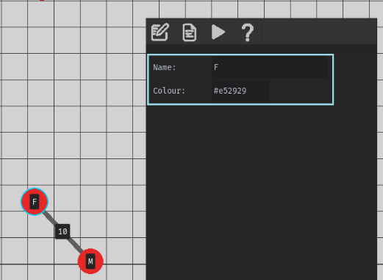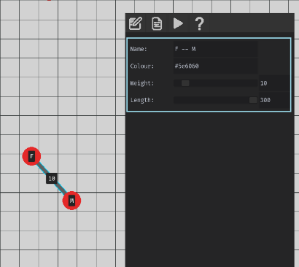E.g Node Properties E.g Edge Properties

**Testing**

|  |  |  |  |
| --- | --- | --- | --- |
| **Condition** | **Expected Output** | **Output** | **Success?** |
| Select node with properties panel open | Properties of node displayed | Properties of node displayed | Yes |
| Select edge with properties panel open | Properties of edge displayed | Properties of edge displayed | Yes |
| Create node with properties panel open | Properties of node displayed | Properties of node displayed | Yes |
| Create edge with properties panel open | Properties of edge displayed | Properties of edge displayed | Yes |
| Delete edge with properties panel open | No properties are displayed | No properties are displayed | Yes |
| Delete node with properties panel open | No properties are displayed | No properties are displayed | Yes |
| Undo edge creation with properties panel open while selecting edge | No properties are displayed | No properties are displayed | Yes |
| Undo edge creation with properties panel open while selecting a different edge | No change to properties | No change to properties | Yes |
| Undo node creation with properties panel open, while selecting edge | No properties are displayed | No properties are displayed | Yes |
| Undo node creation with properties panel open while selecting a different node | No change to properties | No change to properties | Yes |
| Select node with properties panel closed and then navigate to panel | Properties of the node are displayed when opening panel | Properties are drawn over other UI panel | No |
| Select edge with properties panel open and then navigate to panel | Properties of the edge are displayed when opening panel | Properties are drawn over other UI panel | No |

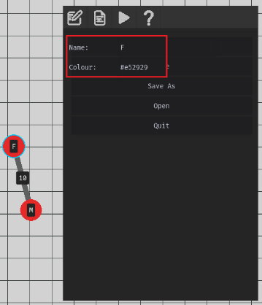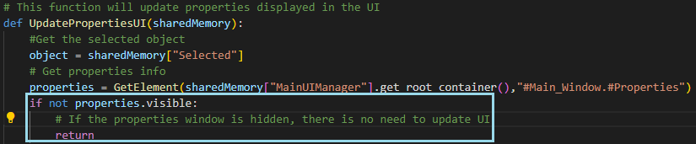The testing conlcuded that the new function was able to correctly display settings. However, it did not check whether those settings should actually be displayed. For example, if the user has the file options setting open and selected a node, that node’s properties would be incorrectly displayed over the top of the file options section:

This was remedied by checking if the properties panel was visible before updating the UI. The UI properties panel will then be updated once the user decides to navigate onto that section.

#### Updating Properties onto the graph

When the user inputs a new value into the properties panel, that value should be validated and applied to the selected node/edge in the graph.

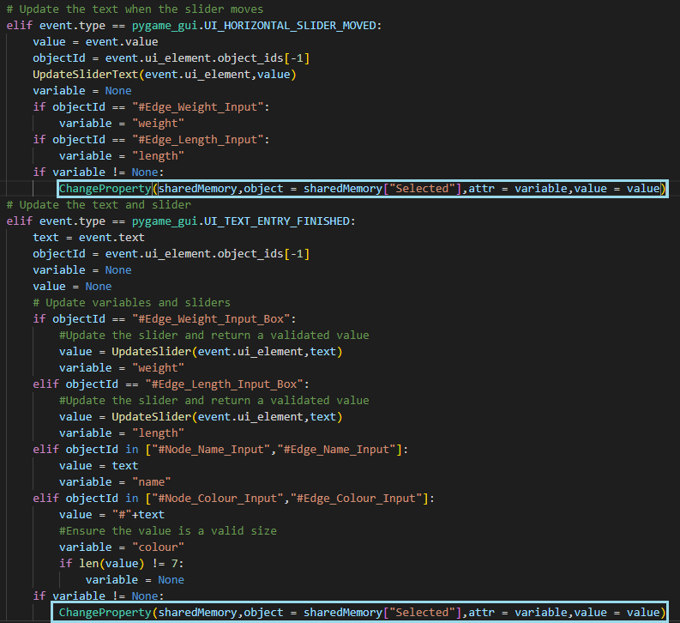The method of application will make use of previously introduced operations. This will mean that if the user makes a change to a property and would like to reverse this, they will be able to utilise the undo/redo functionality.

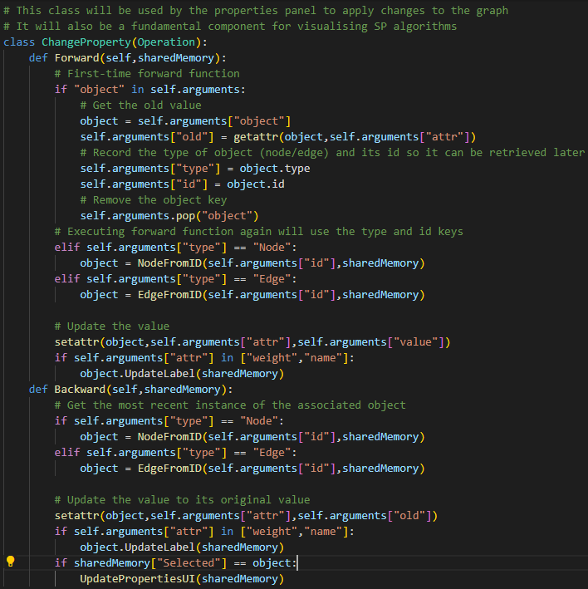A new ChangeProperty operation was created as shown above on the right. Its forward action would update a given attribute about the edge or node and the backward node would undo this change. It would also make sure if the attribute was connected to a label such as a node’s name or edge’s weight, that would also be updated.

This class was then added into the main file in the event loop. If an event was fired regarding the change of a text box or slider, the value and the UI element that fired the event are validated and where necessary, the Change Property class is used. It should be noted that the majority of validation is already handled and discussed when designing the UI in stage 1. However, an additonal check is required when changing the colour properties to ensure that the value’s length is the correct size (E.g #FF00FF would be valid whereas #FF00F would not despite containing the correct characters).

The following diagrams illustrate the testing performed to demonstrate the functionality of changing properties and how they interlink to the undo/redo operations as well as how the graph is displayed:

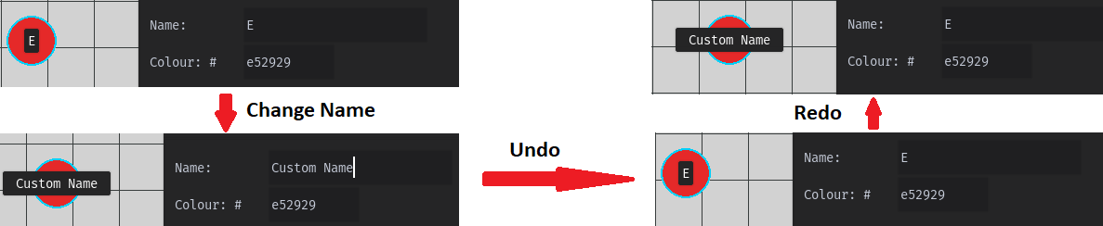**Node Name Property**

This diagram correctly shows how changing a node’s name will update the node’s label. This can be undone and redone and the label will change appropriately.

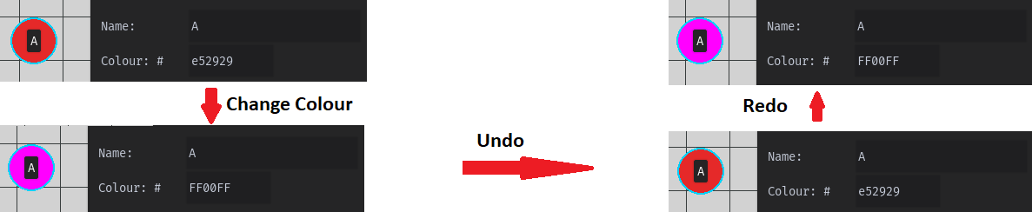**Node Colour Property**

Changing the colour property will correctly change the rendered colour of this node in the graph.

**Edge Name Property**

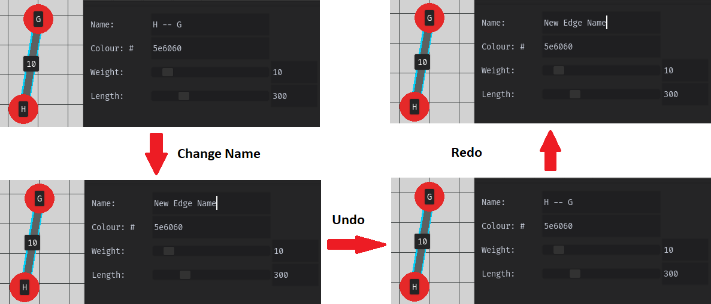The name property of edges will not impact how graphs are displayed however, undoing and redoing this property is still demonstrated.

**Edge Colour Property**

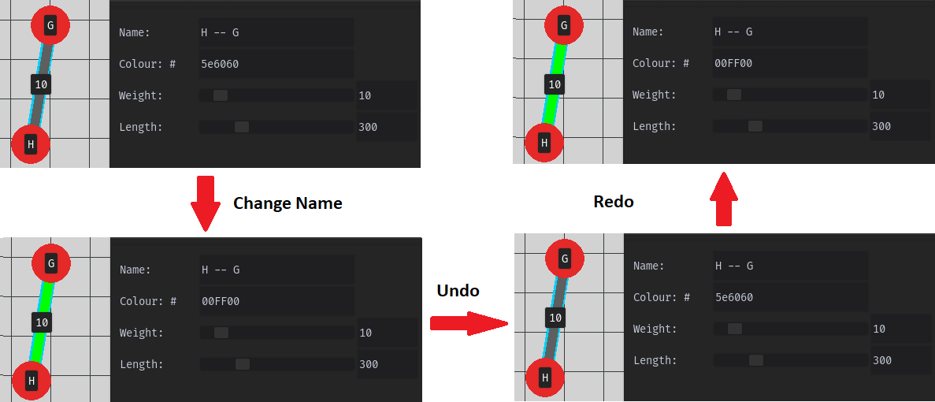

Similarly to nodes, changing the colour will update the colour of this edge on the graph.

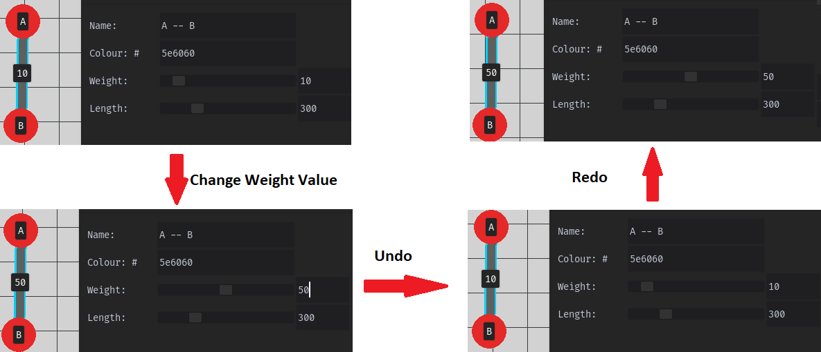**Change Weight Property With Text Box**

Using the text box to adjust these value worked correctly, adjusting the value displayed on the edge’s label as well.

**Adjust Weight Property With Slider**

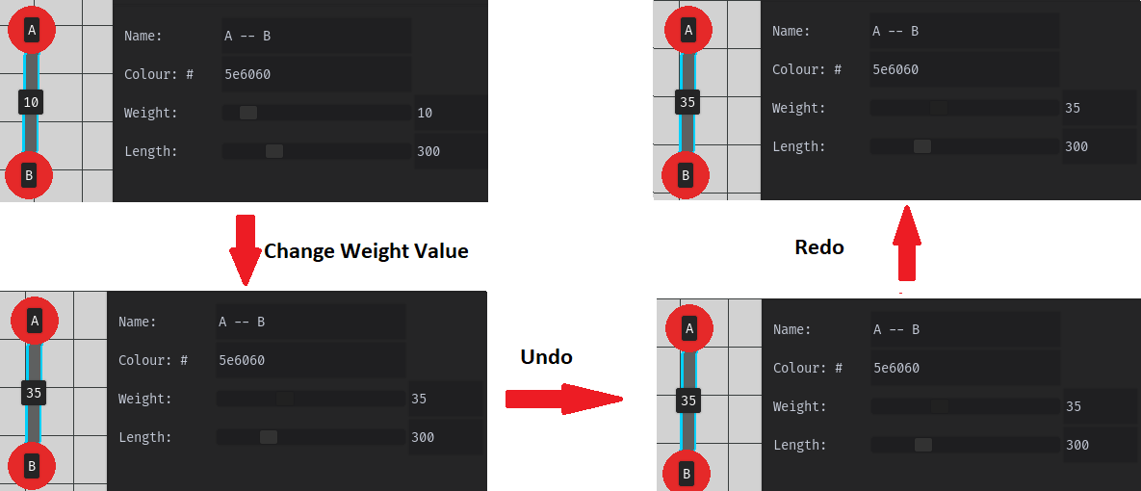

Again the weight is correctly changed when using the slider, however, the solution fails to undo changes made using this method. This is because every frame the user has the slider selected, a new operation is added to the undo stack. This means repeatedly pressing the undo button will eventually return the graph to its previous state however this is very frustrating.

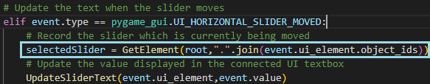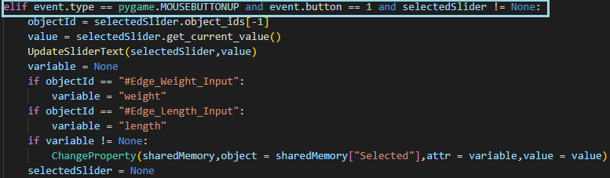This was remedied by recording when a slider is moved and then when the user releases their left click (indicating they have finished moving the slider), a change property operation is applied to the graph.

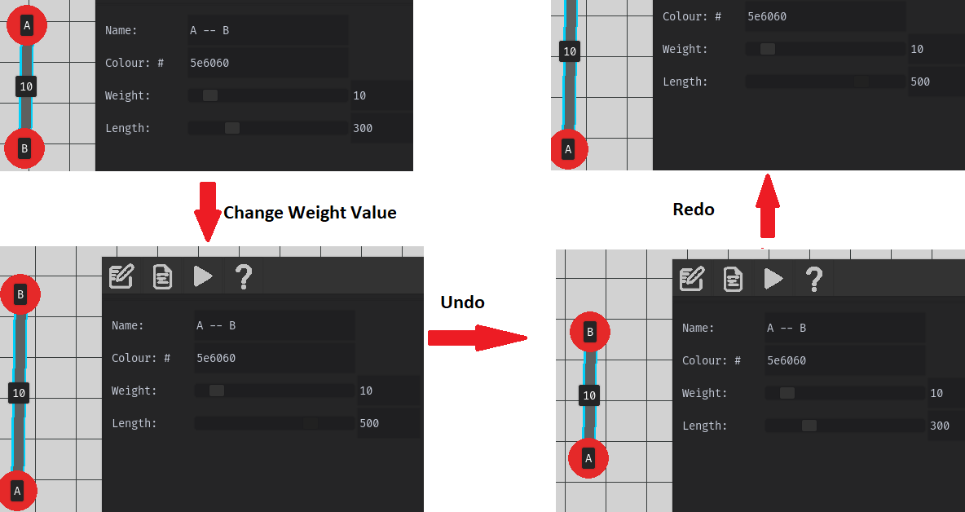**Adjust Length Property with Slider/Text Box**

This final diagram shows how the length of an edge can be dynamically changed in the properties window. It also demonstrates the remedial action previously added where slider adjustment will only be applied once the user releases their mouse button.

### Help Section

To complete the 3rd success criteria, a help section needs to be able to effectively teach and aid the user when using the program. This will be done by creating a set of pages of information and diagrams the user can follow along with. A new file called help.json was created which will store the file directories of all images and their associated text.

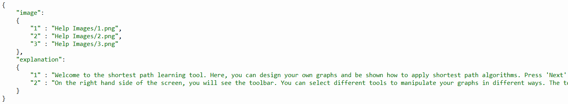

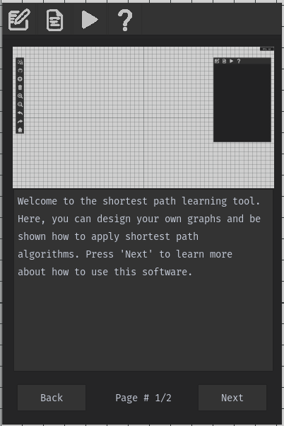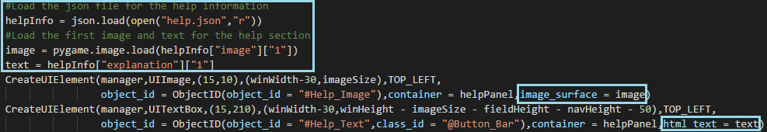This design model will ensure that the help section can be easily maintained and adjusted, all through editing fields in this file. This file can then easily be imported and referenced into the solution as highlighted below. The result onscreen can then be seen on the right, where the custom image and text are correctly displayed. I also decided to add a page number to the bottom of the section so that user’s can easily reference pages.

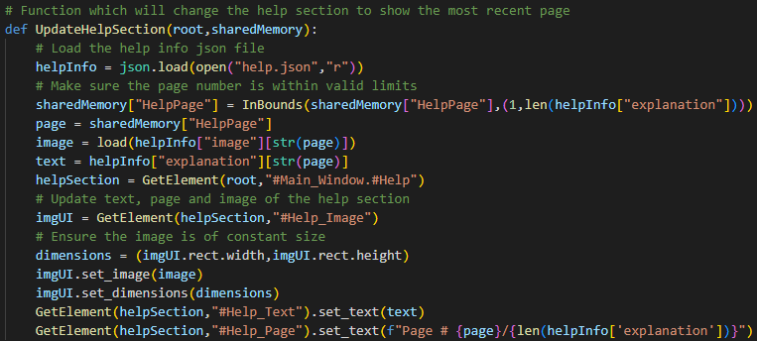A function can then be executed to update the help page each time the back and next buttons are pressed. When doing this, the program should make sure that the page number is within valid bounds. For example, the page number must be no less than 1 and no greater than the number of pages in the help.json file.

|  |  |  |  |
| --- | --- | --- | --- |
| Input | Expected Output | Output | Success |
| Press back on page # 1/3 | No change | No change | Yes |
| Press back on page #2/3 | Page 1 is displayed | Page 1 is displayed | Yes |
| Press next on page # 1/3 | Page 2 is displayed | Page 2 is displayed | Yes |
| Press next on page # 3/3 | No change | No change | Yes |

### Shortest Path Algorithm Properties

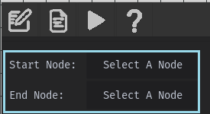The final part of stage 4 will involve adding the functionality to the SPA properties section of the main window. This is specified by the 13th success criterion and will enable the user to select either Dijkstra’s or A* pathfinding algorithm, a starting/end node and a button to perform these algorithms.

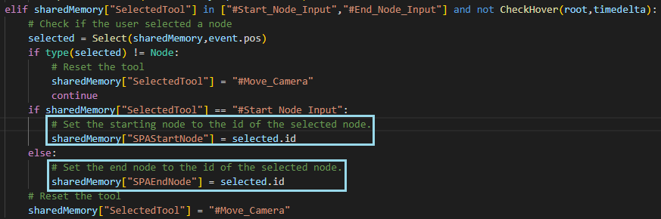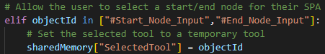 To allow the user’s to easily choose nodes, pressing the start/end node selection buttons will select two new tools.

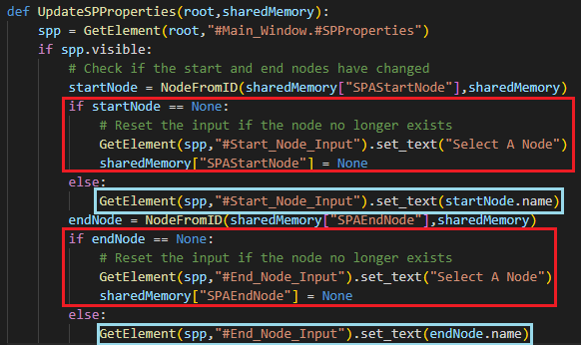 When the user clicks on a node after pressing these buttons, two keys are updated in the sharedMemory dictionary. These contain the node ids of the selected nodes. These nodes can then be retrieved by another function to update the input buttons in the UI. It will additionally handle if the names of nodes change or a node is deleted.

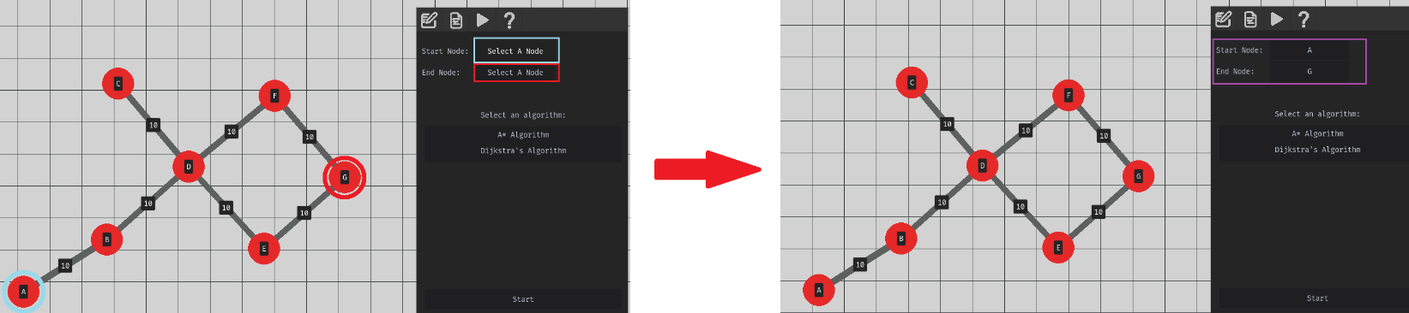The diagram below demonstrates the process of pressing the “Select A Node” buttons, pressing nodes A and B and having them displayed in the UI respectively.

### Stage 4 Review

#### Overview

This stage began by gaining some stakeholder feedback on the solution so far which was then used to make some adjustments to the solution. This included making selection of nodes possible within the creation tool, a new button on the toolbar which would recentre the camera in case the user got lost, as well as making it easier to select nodes and edges.

The stage then focused on adding the remaining UI functionality. This included implementing a system that allows graph properties to be adjusted through the UI. These changes were then connected to the undo/redo system. Then file options were added allowing users to save and load files into the solution. Then finally, functionality was added to the help section and SPA properties section which will lead into Stage 5 development.

#### Met Criteria

|  |  |  |
| --- | --- | --- |
| Criterion # | How this area of the success criteria has been met | Level of Completion |
| 2 | This point of the criteria has been met by demonstrating through screenshots the processes which allow the user to save and load files. This was completed by using tkinter to display a file explorer dialogue which would allow the user to enter file paths. An option to create a new graph has also been added if the user wishes to start over. It was an important consideration to prompt the user to save their file before quitting/opening a file/creating a new graph to make sure the user would not accidentally lose their work. | Complete |
| 3 | The help section was also introduced. This section allows the user to view text and images explaining different parts of the software. They can move between different pages of text using the forward and backward buttons as shown in diagrams in its related section of this stage. | Complete |
| 11 | This success criterion has finally been completed by adding UI functionality which allows the user to adjust settings about nodes and edges. Changes made in the UI will be applied to the graph. For example, renaming a node will change the name of the node displayed in the graph. When a change is made to a property, the system has been designed so that the user can choose to undo/redo these actions. | Complete |
| 13 | In this final section of the main window’s UI, the user is able to select starting and end nodes which will be used as parameters in a shortest path algorithm. This is done by pressing on one of the associated buttons and then clicking on a node. This method was chosen since it does not require a keyboard to enter the name of a node and so will make adjusting these properties feasible on a smart board. The user is then able to select one of two buttons corresponding to the A* Algorithm and Dijkstra’s Algorithm. | Complete |

#### Testing Completed

This stage incorporated several methods of testing. The first involved using stakeholders to destructively test different elements of the program by getting them to experiment using the program. As done in previous methods, there was a large amount of visual testing with the UI involving screenshots of functionality working correctly. Particularly in the UI properties section, to test how adjusting each setting would affect the graph as well as the file options showing how navigation would work. This was combined with test tables to thoroughly to ensure that only valid sequences of operations would produce the correct output; Such as not asking the user for a save directory if one had already been provided.

#### Remedial Action taken during development

From stakeholder feedback, several adjustments were made to the program which included making it easier to select nodes and a button which would recentre the user if they got lost. I made it easier to select nodes by increasing the radius and width of the hitboxes of nodes and edges and made it possible to select them within the creation tool so that users would not have to switch between the creation and selection tools each time.

When getting the program to display the properties of a selected node and edge, test tables showed that selecting a new node/edge when the properties window should be closed caused it to be drawn over another section of the main window. This problem was resolved by ensuring the properties are only updated when the user has navigated to the properties section. A problem also arose when adjusting sliders because the solution would adjust the variables associated with these sliders for every frame the user held down their mouse on one. This meant that when trying to undo these changes, it would only undo to the value the variable was in the last frame instead of when they started moving the slider. This was remedied by only recording slider changes once the user releases their mouse.

When designing the file options setting and the algorithm for saving files, it was inititally considered to just save the node and edge objects using the pickle library. However when implementing this, an error was encountered due to the interdependency between nodes and edges (connectedNodes and connectedEdges array variables). Instead, I saved all the significant variables about each node and edge which could be used to rebuild them when the file is opened again.

## Stage 5 – Shortest Path Algorithm Implementation

Finally, after 5 stages the program is ready to carry out its main purpose, to visualise and explain A* and Dijkstra’s Algorithm. This stage will focus on implementing the remaining 14th, 15th and 16th points of the success criteria. To complete these criterions, the solution will need to be able to calculate the shortest path between two nodes as well as a set of explained, visualised steps to reach work it out. Each step will be visualised in the environment and the user will be able to move between steps.

### Dijkstra’s Algorithm

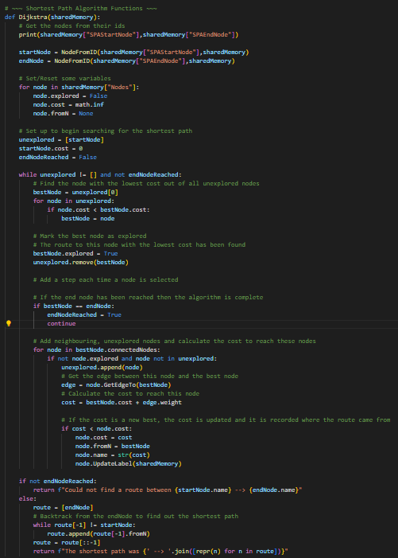Before visualising the graph, I want to begin by implementing the Dijkstra’s algorithm correctly into the solution. This will not produce the set of steps which the later algorithm will produce but will instead just print a series of nodes in the order they are traversed. The focus for this initial step will be getting the algorithm to interpret the graph’s data correctly.

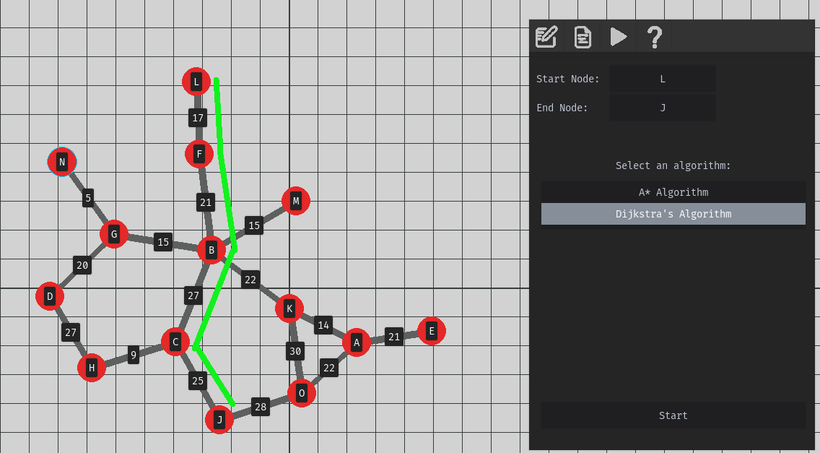Here is an example of a randomly generated graph which I want to traverse using Dijkstra’s Algorithm. By setting the start and end nodes to L and J respectively, the following output is displayed:

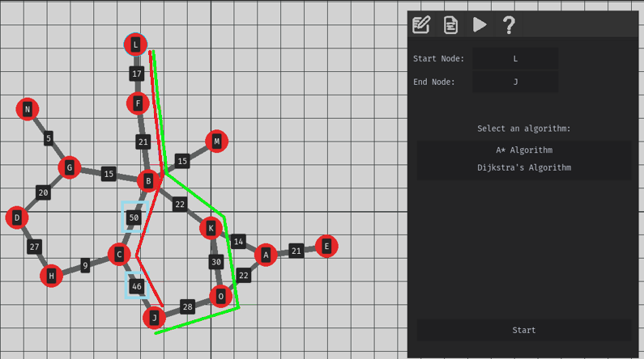This has correctly found the shortest path between these two nodes.

The weights between edges can also be adjusted to compare how the algorithm adapts its output of the shortest path.

By changing the weights of the highlighted nodes in the image above, this should cause the shortest path to change to:

L -- > F -- > B -- > K -- > O -- > J

However, the output is the same:



The image above shows the incorrect route which the algorithm produced in red and the expected shortest route in green.

By inspecting the code, I found a flaw in the algorithm which would prevent it from considering alternative pathways to get to any particular node. Such as in the above diagram, the algorithm found the first route highlighted in green but did not continue to consider other possible routes. Some of these routes were in fact better routes such as the one highlighted in red.

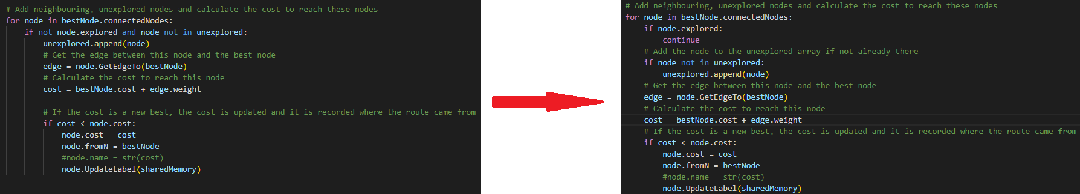

This adaption will ensure that the costs to nodes is recalculated every time that node is encountered to ensure only the lowest costs are found.

Running the code again produced the correct output of:



The algorithm will also correctly output when a path could not be found such as:

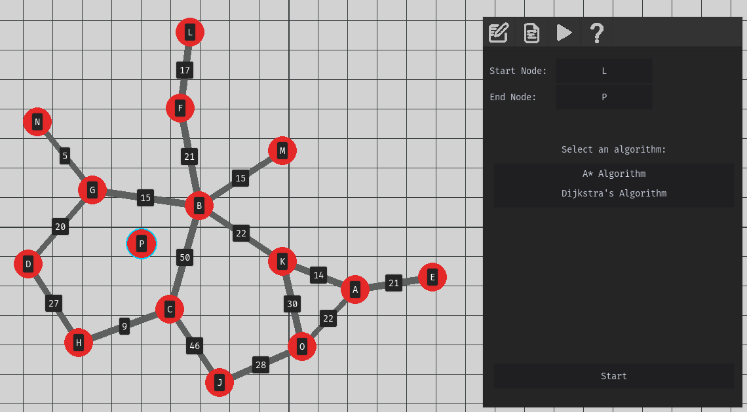

Clearly by inspecting the graph there is no route from L to P and so the algorithm returns:



### Generating Steps for Dijkstra’s

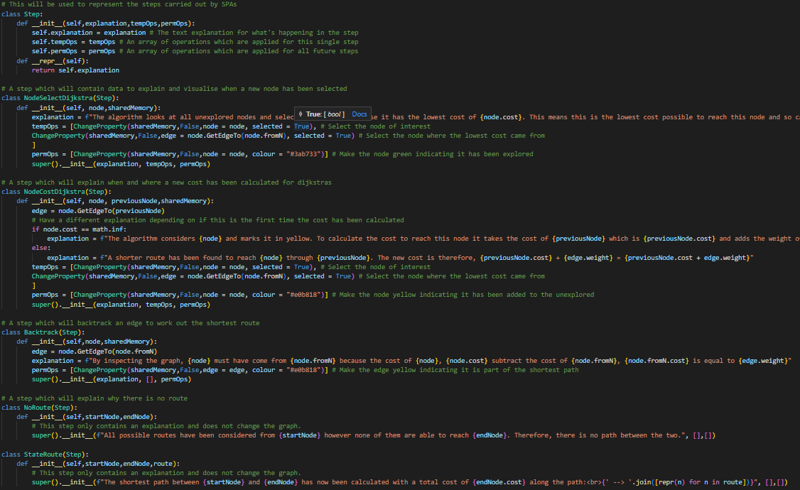So that the user can follow along with how the algorithm determines the shortest paths, a set of steps should be devised explaining what is happening at each section. Each step will also need to apply several visual changes to the graph to aid with the explanation. Each step will therefore need a set of permanent and temporary changes it will make to the graph. Permanent changes will include changing the weight of variables and temporary changes may include changing the colour of nodes to highlight their significance in a particular step.

In this section of code the Step class is created along with several subclasses for different types of steps. These types of steps include:

* Selecting a node
* Calculating the cost of a node
* Stating no route could be found
* Backtracking to work out the shortest route
* Saying what the shortest route is

In each subclass, arrays of operations are also specified indicating how the program should manipulate different areas of the graph.

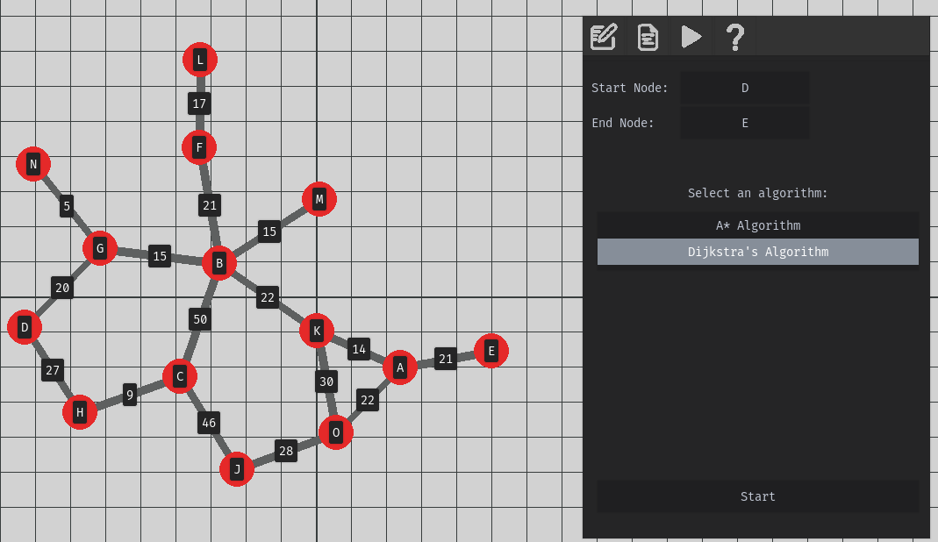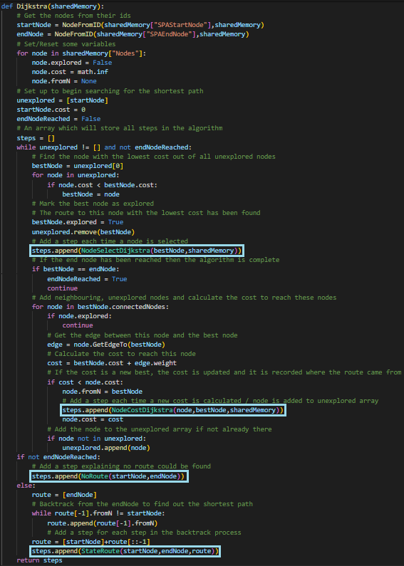These steps could then be added into Dijkstra’s Algorithm where needed. To test that these steps were being added correctly I performed the algorithm on the following graph and printed the explanations of each step. It should be noted that changes to the graph will be added at a later stage.

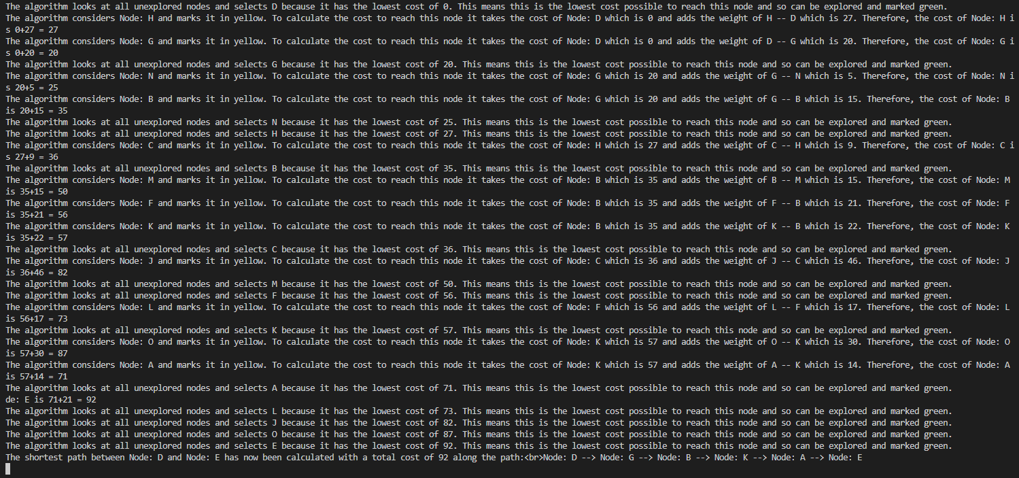

This output was as expected, and a similar output was obtained when testing it where a route could not be found. From this testing and remedial action, I can conclude that the Dijkstra’s algorithm is able to correctly produce a set of steps required to find the shortest path between two nodes.

### Setting up for visualisation

Now that the algorithm can correctly produce a set of steps for Dijkstra’s algorithm. I will now need to display these steps onto the graph. This process began by adding an additional section of code to the top of the Dijkstra function which would swap the toolbars, display the algorithm explanation window and ensure the user cannot edit their graph during visualisation.

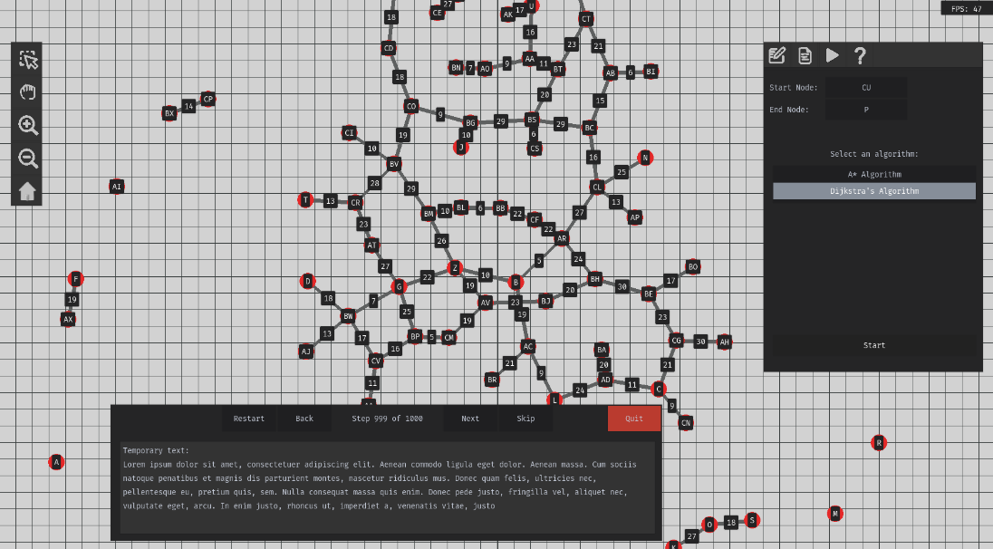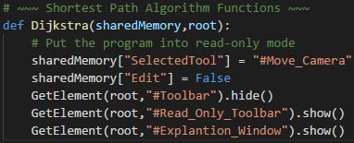

It will be important that the user cannot edit or save their graphs while they are in this mode to prevent the graphs becoming corrupted. I have created the following test tables to ensure all possibilities for saving/editing files are prevented whilst the software is visualising these algorithms. Part of this potential risk has already been reduced by changing tool bars and changing the currently selected tool to #Move_Camera so that the user cannot edit the graph.

|  |  |  |  |
| --- | --- | --- | --- |
| Input | Expected Output | Output | Success? |
| Navigate to properties section | No properties are displayed | No properties are displayed | Yes |
| Enter read-only mode with the create tool equipped. | Tool will be changed to #Move_Camera | The #Move_Camera tool is equipped | Yes |
| Attempt to delete a node | No change | No change | Yes |
| Pressing undo | No change to graph | No change | Yes |
| Pressing redo | No change to graph | No change | Yes |
| Attempt to save file | Not allowed | No prompt indicating I could not save. | No |
| Attempt to save as | Not allowed | Not allowed | Yes |
| Attempt to open file | Not allowed | Not allowed | Yes |
| Attempt to create new file | Not allowed | Not allowed | Yes |
| Attempt to quit | Should just quit as file should be saved upon entry | Program quits | Yes |

From this test table I was able to conclude that the program was able to correctly prevent the user from making any changes to the graph. The only exception to this was when trying to save a graph, a window would not be shown indicating they couldn’t save at this time. Therefore, I had to adjust the code accordingly:



Now when the user attempts to save the graph when they are in read-only mode, the following prompt is displayed:

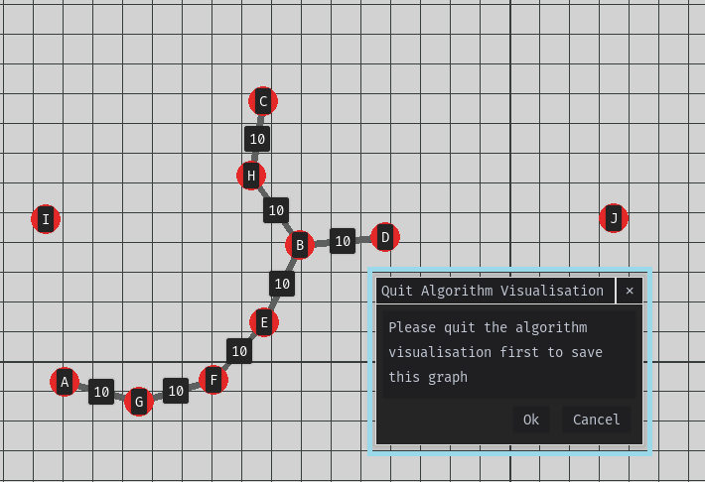

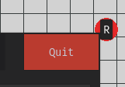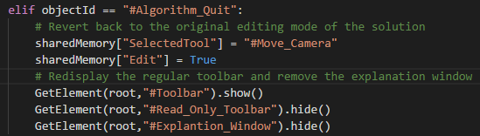Likewise, when pressing the quit button on the algorithm explanation UI, the program will revert back to edit mode where all changes can be made to the graph again.

### Dijkstra’s Visualisation

The algorithm can now be visualised onto the graph using the set of steps designed in the previous section. In this function, the step counter is incremented/decremented and is ensured to be within the bounds. If the user tries to go to the previous step when on the first step or go to the next step when on the last, clearly no change needs to be made in this case. When incrementing, the previous step’s temporary operations should be removed, and the next steps permanent operations should be applied. Then when decrementing, the permanent and temporary operations of the last step are undone, and the temporary operations of the previous step are reapplied.

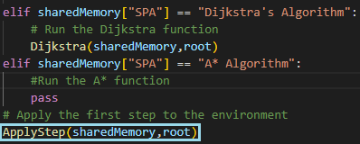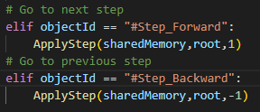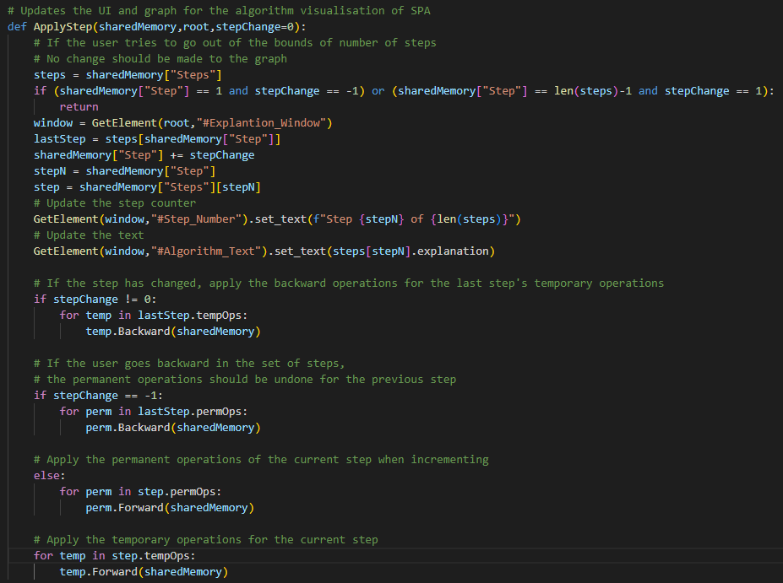This function can be cleanly entered after running the pathfinding algorithm to display the first step of the algorithm. Likewise, this same function can be applied for the next and back buttons which will allow the user to explore the different steps of the algorithm.

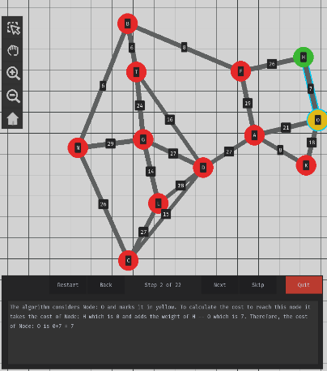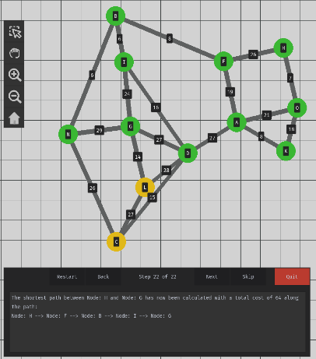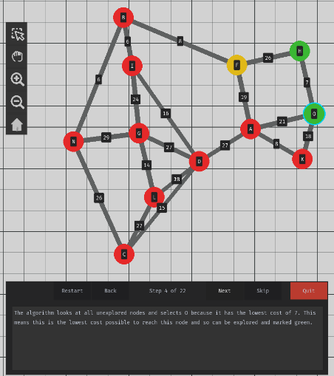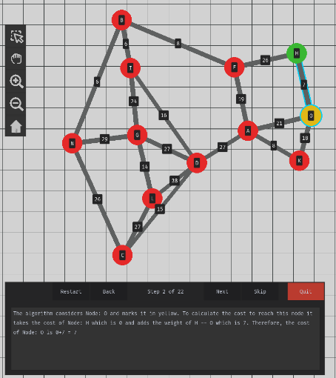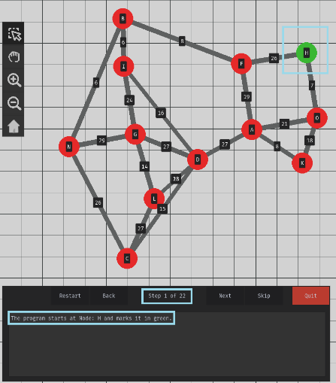I began testing by running the program and asking to perform a Dijkstra’s pathfinding algorithm from node H to G. When doing so, the program correctly changed the explanation window to reflect the current step I was on as well as an explanation of what is happening on the graph. In this instance it has selected the starting node by turning it green. When pressing next, the explanation and graph displayed accordingly to show it inspecting neighbouring nodes, marking them in yellow. The third image demonstrated the algorithm correctly choosing which node to explore, marking it in green and explaining why.

After iterating over the remaining steps, the algorithm correctly identified the shorted path. However, the steps which should illustrate the backtracking process in which this is found was not done.

It was also found when testing that while the ApplyStep could correctly go back and forth between steps, it was stuck at step 2 and could not return back to the first step.

Visually, the solution is able to represent very clearly what it is doing in the graph at any one time. However, myself and other testers concluded that it was difficult keeping track of the costs to reach each node as this was only referred to in the explanation and not on the graph.

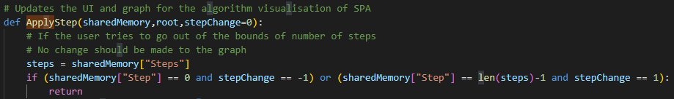The first remedial action taken was very simple by slightly adjusting the logic in the ApplyStep function so that the program could go back to the first step.

By making this change, the solution is correctly able to go back to the first step.

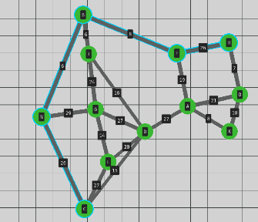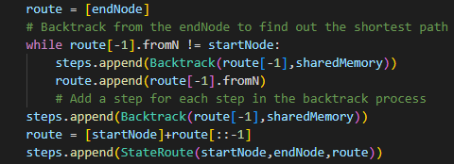Backtracking was also remedied by including the step class into the function as shown below:

This means that when a shortest path is found, it will be displayed onto the graph.

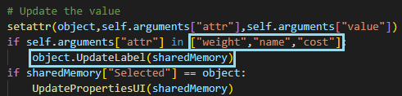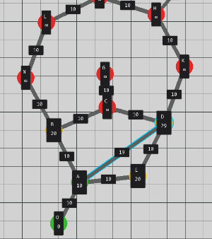It is also important the weight costs to reach each node are displayed to visually show the process of exploring new nodes. In the example below, iterating over the steps will adjust the weight costs displayed on the graph. This was done by updating the label’s of nodes when there is a change to a cost value. The label will also display a different label while running the Dijkstra’s algorithm to show all relevant information.

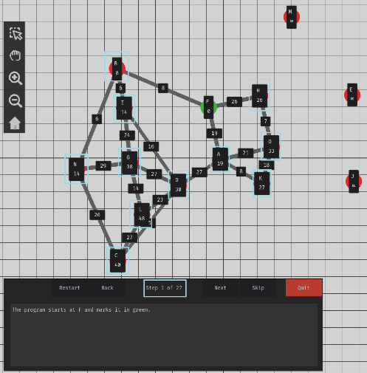The lengths will be adjusted to show their current lowest length. It should also be noted that nodes which haven’t had their costs calculated have a default cost of infinity represented by the ‘∞’ symbol. However, while testing this feature with the back buttons, it was noticed that the costs would not be unapplied to the graph and would be stuck with their assigned values. The image below highlights this as while all other graph properties have returned to their previous state, the node costs have remained fixed.

This issue is caused because the Dijkstra’s algorithm will update the node cost of all nodes when performing the algorithm. However, the initial costs of nodes are not recorded until after this algorithm has been performed. This means that the incorrect node costs are recorded. To remedy this, I have created a condition within the ChangeProperty operation which will allow the original value to be assigned while performing the algorithm rather than after.

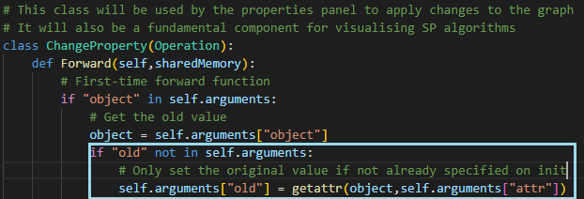

The original cost argument can then be specified in the Dijkstra algorithm so that the correct value is recorded. The diagram below demonstrates this feature now working correctly where the node cost of node A will update and revert its value accordingly as the user navigates between steps.

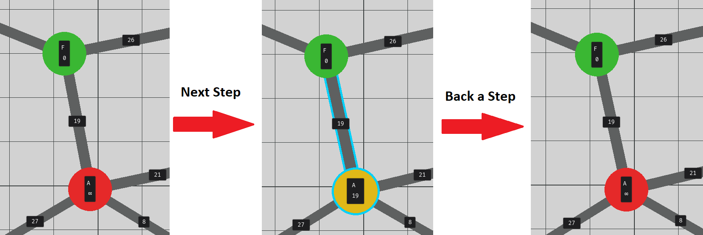

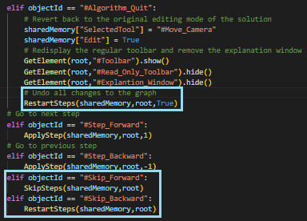Some of these algorithms may be very long and if the user just wants to see the final shortest route, functionality will be needed to skip right to the end. Likewise, functionality should also be included for returning back to the first step. This will be an important process as all steps will need to be unapplied before safely returning to the edit mode.

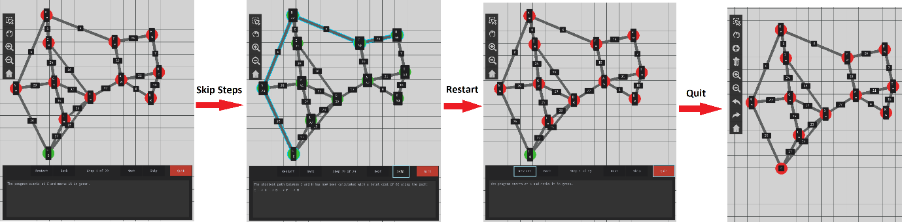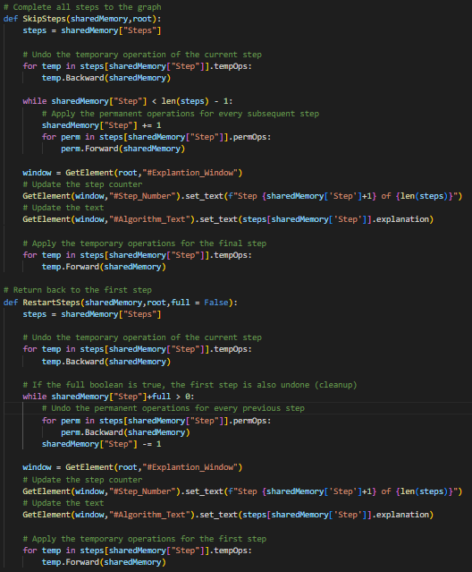Two functions were created which would undo the current temporary operation for the step they were on and either apply or undo all permanent actions until they got to either the start or end of the set of steps. These algorithms were then linked to the three remaining UI buttons and their effect on the graph can be seen below.

When exiting out of the visualisation mode, the explanation window is hidden again, and the toolbar is removed. All changes to the graph are undone and the UI labels on each node have been reverted to their previous form. The user can now make additional adjustments to their graph if they choose to do.

### A* Visualisation

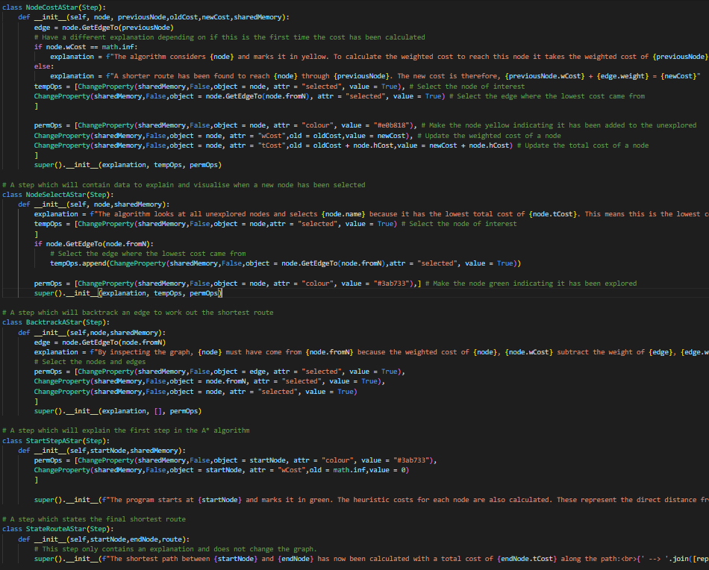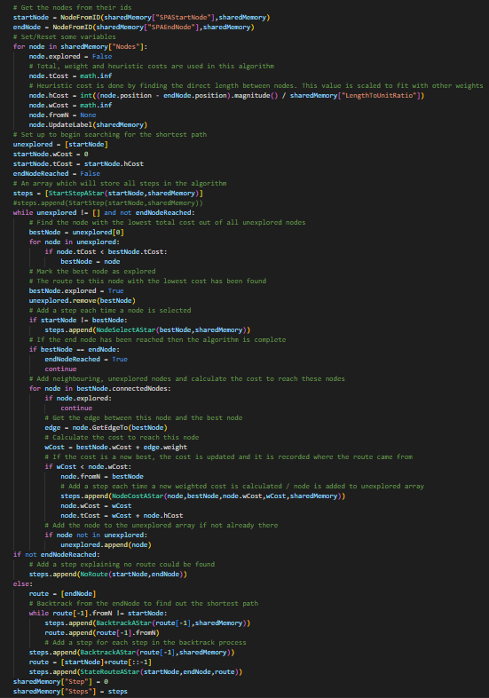The algorithm for generating steps for the A* pathfinding will be very similar to that of Dijkstra’s however it will need to consider three cost variables associated with each node rather than one. This is for the heuristic, weighted and total costs. The program will therefore need to consider these when explaining how the A* algorithm operates. Additionally, there will be some slight adjustments to what information is displayed. A function was created for the A* algorithm which would also produce a list of steps the program could interpret. This additionally involved creating a new set of steps for A* which would explain and visualise the process effectively.

The A* function (on the left) will then be executed when the user selects the A* Algorithm and presses Start on the Algorithm Visualisation section of the main window. The function will generate a list of steps using predefined Step subclasses shown on the top right. An additional change was made to the UpdateLabel function in node objects so that if the A* algorithm is chosen, it will display all three types of costs associated with the node.

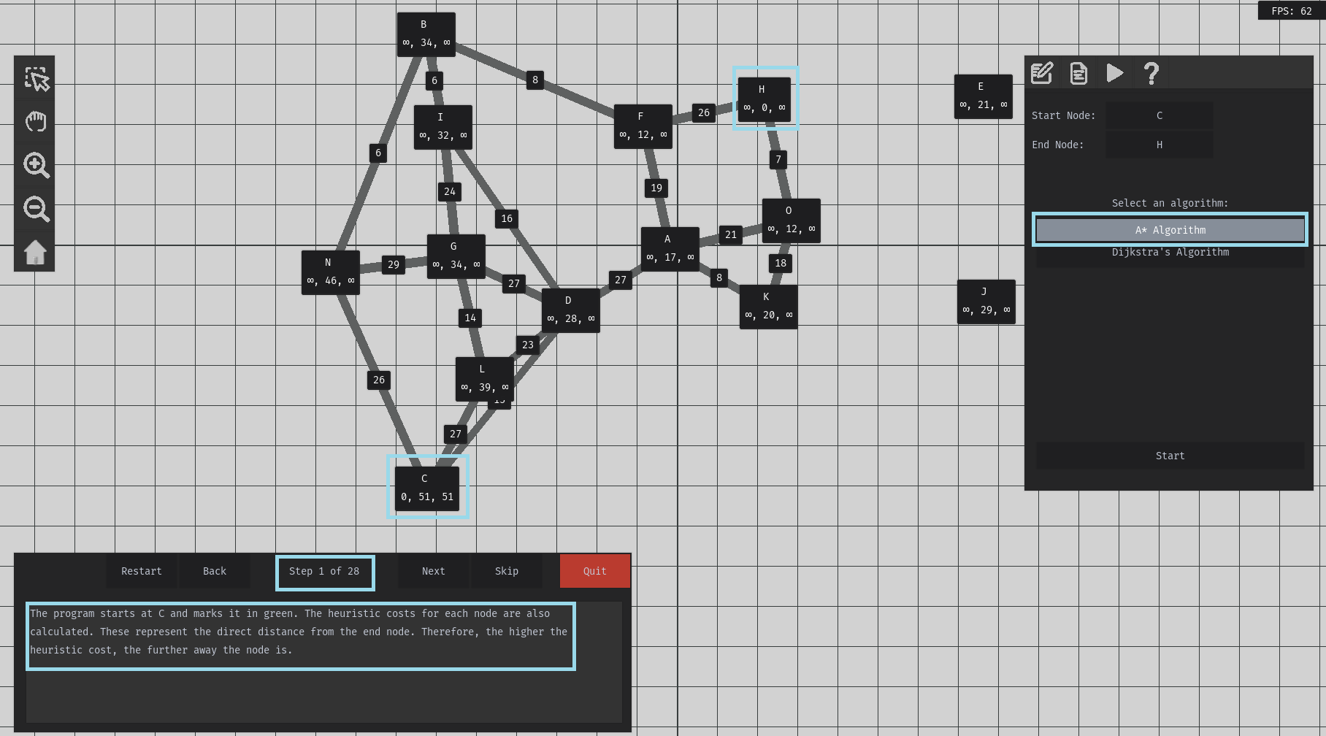To test this new algorithm, I selected the nodes C and H as the respective start and end nodes and selected the A* Algorithm. This entered the software into the read-only mode and would not allow me to edit the graph. The program then updated the labels on the nodes to additionally display the three different costs for weighted, heuristic, and total costs. It should be noted that the heuristic costs were all effectively assigned so that the start node had the highest heuristic cost as it was furthest from the end node. A list of steps was also created since the step counter on the explanation window was updated indicating there were 28 steps. The explanation discussed selecting the start nodes as well as explaining the introduction of heuristic costs.

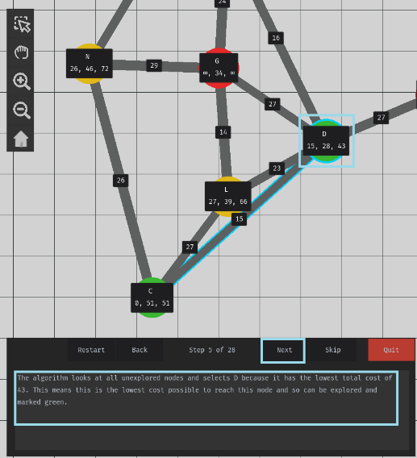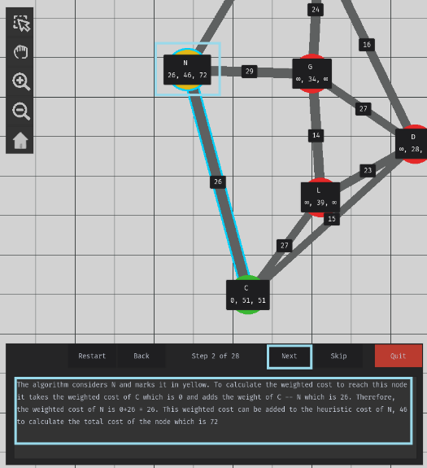Pressing the ‘Next’ button will then update the graph and explanation correctly. The explanation correctly explained how to calculate the weighted and total costs for the node which was also demonstrated on the graph. After iterating through several more steps, the next image correctly showed how the algorithm was able to explore another node by choosing the one with the lowest total cost.

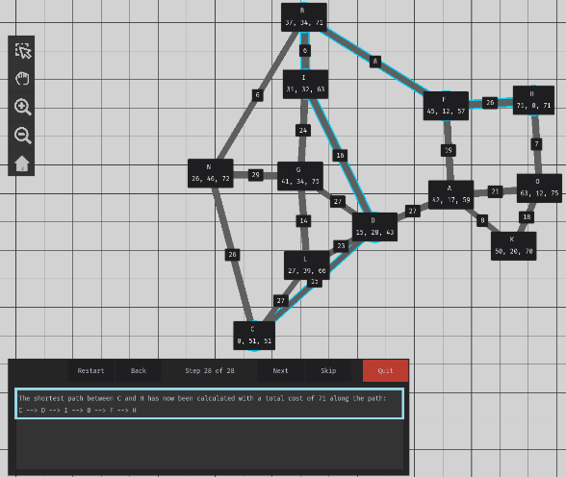Finally, the algorithm was able to correctly identify the shortest path between the two nodes with a written explanation and the edges highlighted in blue.

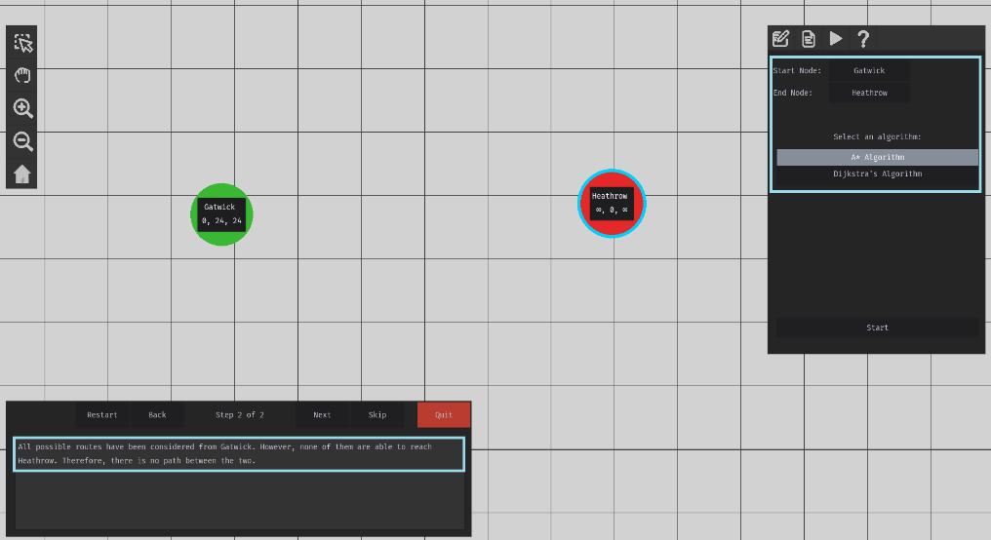On a different graph I tried to find the shortest distance between two nodes which were unconnected. Therefore, the graph should be able to explain and identify when a shortest route is not possible:

The simple example above correctly identified that a route between the two nodes was not possible. The algorithm explained why this was the case as it has examined all possible routes from the starting node.

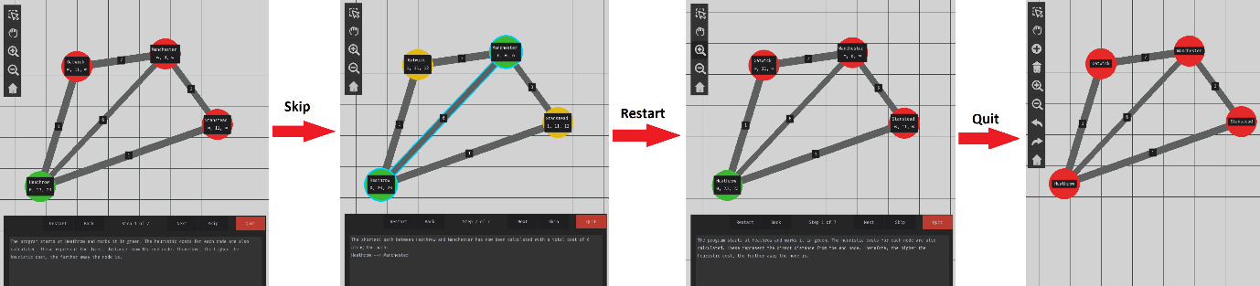This diagram shows the testing to demonstrate the skip/restart/quit buttons working appropriately. The explanation and graph visualisation adjust accordingly, and quitting will return the graph to an editable version.

An error was encountered when I attempted to compare the A* and Dijkstra algorithms to complete the same route and encountered the following error:

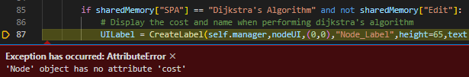

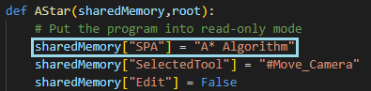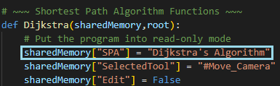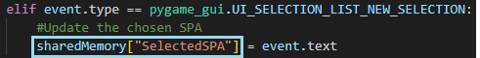This was because selecting the Dijkstra’s Algorithm from the SPA Properties section in the main UI updated the ‘SPA’ key in shared memory. Since the visualised environment has been created for A* pathfinding, it will not contain the correct variables for Dijkstra’s.

To fix this issue, I created a new key to represent the currently selected algorithm in the UI which operates separately to the key representing the algorithm currently being visualised. This new key is assigned when selecting an algorithm from the UI. The ‘SPA’ key is set when an algorithm is run.

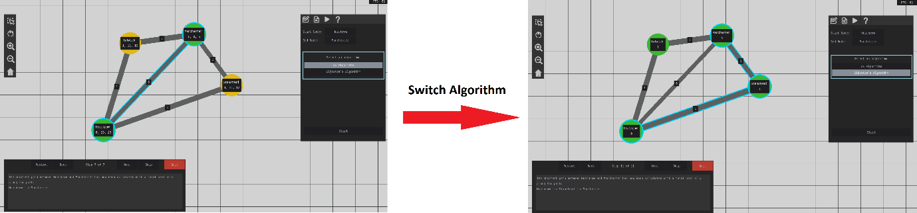The diagram above shows how this issue has now been resolved as the user can switch between A* and Dijkstra’s algorithm and vice versa while visualising them.

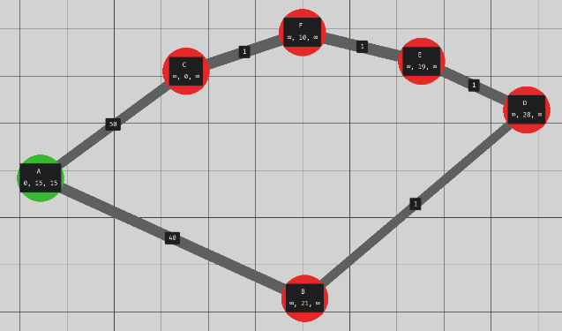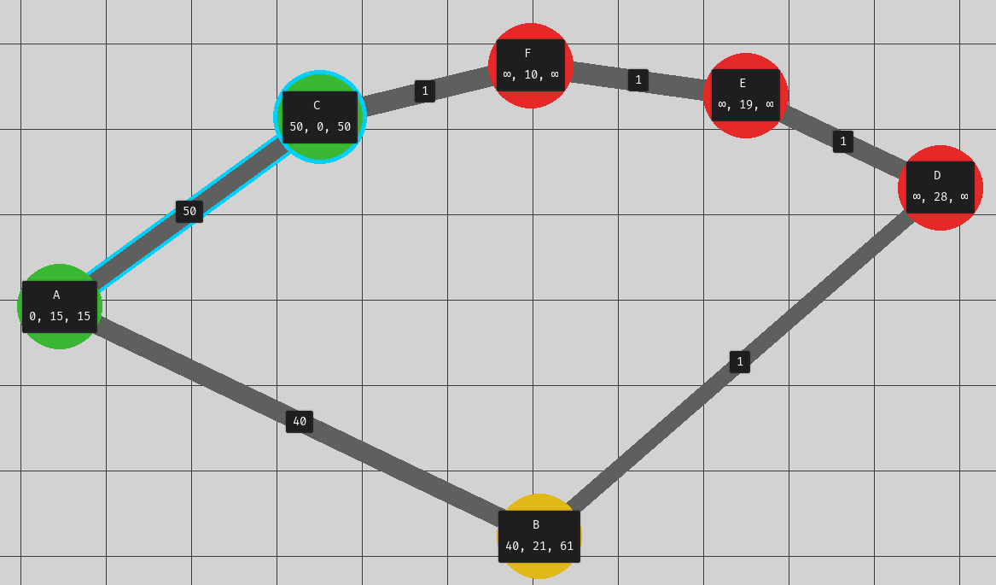During testing of the A* algorithm, I considered the following graph and asked the algorithm to calculate the shortest route from A -- > C.

The correct result should have been A -- > B -- > D -- > E -- > F -- > C with a total cost of 44 however the algorithm returned A -- > C with a total cost of 50 as its answer.

This result was initially hard to identify as the algorithm is correct in finding the shortest route of most graphs. However, when the heuristic cost outweighs the weight cost, issues can arise. For example, the heuristic cost of B is considerably higher than that of C. Therefore, despite A -- > B having a lower weighted cost, A -- > C is selected for a lower total cost. Node C then has the lowest total cost of 50 and so is incorrectly marked as explored.

Further research into A* pathfinding uncovered an overlooked condition in regard to heuristic calculations. This condition required that for the optimal path to always be contained, the heuristic costs cannot overestimate the actual required weight cost to reach the end node. In the example below, the heuristic to B is not admissible as it overestimates the total cost to reach node C. This issue has arisen because the weighting of nodes is independent from the distance between them, and their distance is considered to calculate their heuristic costs. This introduces the risk that a heuristic cost is overestimated. Therefore to resolve the issue, a new method is required to calculate the heuristic cost.

This problem does not have a solution which can ensure heuristics are always admissible, however, the likelihood of this issue being encountered can be mitigated by calculating smaller heuristic costs. The drawback to lower heuristic costs means that they have a weaker effect on the trend in exploration of nodes, which could lead to greater inefficiency.

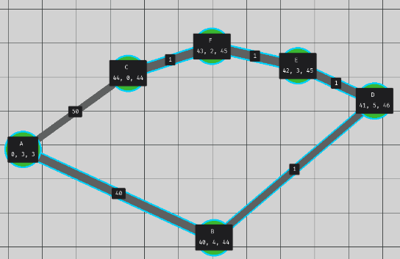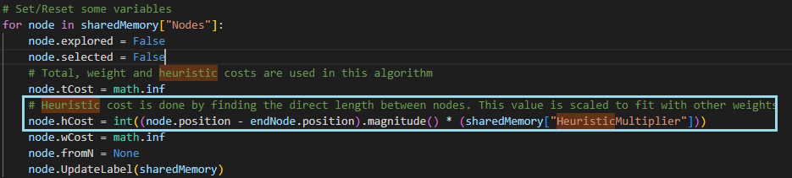The shortest path can now be calculated correctly with the lower heuristic costs.

### Stage 5 Review

#### Overview

During the final stage of feedback, the focus was on adding the functionality which would explain how A* and Dijkstra pathfinding algorithms could be applied to different user-generated graphs. This involved creating a set of steps for both of these algorithms which the solution could interpret. These steps would be displayed visually onto the graph as well as having a written explanation of what the program was performing. UI would also be displayed and updated to show the current weight/heuristic/total costs associated with each node.

#### Met Criteria

|  |  |  |
| --- | --- | --- |
| Criterion # | How this area of the success criteria has been met | Level of Completion |
| 14 | This success criterion was met by applying a high level of visual guidance to the shortest pathfinding algorithms. This was achieved by labelling each node and displaying their costs as well as highlighting which nodes and edges are currently being looked at. A sense of progression through the graph was also created by colouring nodes differently depending on their state of exploration. Upon finding a path, the program would highlight this shortest route on the display. All of these features were sufficiently demonstrated through annotated screenshots. | Complete |
| 15 | Media controls were introduced so that the user could navigate between different steps at their own pace. The ‘back’ button would allow the user to revisit steps they would like to look back over in more detail in addition to the ‘restart’ button which would take the user back to step 1. If a user just wanted to view the final shortest path, they could do so by pressing the skip button. During the graph visualisation, editing is not possible and so the ‘quit’ button allowed the user to leave the pathfinding visualisation so that they could make adjustments to their graph. | Complete |
| 16 | In addition to the aforementioned criterion’s UI, the UI should also display written guidance about what the algorithm is doing. These explanations could be in regard to the calculation of heuristic cost; selecting a new node to explore; finding a new, shorter path; reaching the end node; etc.  This additional help would assist teachers/students in a classroom setting by giving reason behind what is happening in the algorithm. | Complete |

#### Testing Completed

This section involved the implementation of a new mode in the program in which the user is unable to make changes to the graph. Therefore, testing was performed using a test table to ensure that the user could not make any changes to their graph as well as loading/saving/creating new files which could cause corruption in the program and the user’s graphs. To successfully meet the test, the program would have to produce a relevant prompt explaining why the user could not complete a given action.

The majority of testing in this section involved visual testing of different graphs to test the robustness of the shortest pathfinding algorithms. I tested the initial output of steps the Dijkstra’s Algorithm generated to check it aligned with expected results. This involved considering graphs with multiple possible routes to a particular node as well as ones where no shortest path is possible. After further development, I tested the visual output created in the program and how this interacted with the UI interface to check that combinations of button presses interacted correctly with the graph visualisation.

When creating the A* algorithm, more visual testing was performed to demonstrate how the solution considered different types of graphs, how different UI elements were displayed, such as the additional costs being displayed on labels, and how the solution processed UI button input on the graph.

#### Remedial Action taken during development

When designing the Dijkstra’s algorithm, it was found during testing that the algorithm would not necessarily find the shortest route and would instead assume the first route it finds to the end node as optimal. This issue arose because when inspecting neighbouring nodes, costs would not be updated if a shorter path to a node was found. This was resolved by adjusting the algorithm to always update a node’s cost if a lower value is found.

During development of the visualisation section for Dijkstra’s Algorithm, it was noted by testers that it was difficult keeping track of the costs associated with each node. This was remedied by displaying the cost of each node in their labels, helping to show the numerical progression of the algorithm for users. Although, these labels were initially problematic as updated cost values would not be reverted back to their previous values when the user pressed the ‘back’ button. This was eventually fixed by making sure that the correct old and new values for nodes were correctly stored so that the program could correctly move between them.

Due to the similiarities between the A* and Dijkstra algorithms, implementing A* was much easier as the majority of the foundations were then already in place. However, when testing an extreme case input, the algorithm was not able to find the optimal solution. Researching into the implementation of A* uncovered a condition that heuristic costs must not overestimate the actual cost (unadmissable) of the shortest path. Ensuring this condition is always true cannot be guaranteed in my solution’s implementation, however the risk of a cost being unadmissable was reduced by lowering the calculated heuristic costs.

# Evaluation

## Success Criteria Review

|  |  |  |  |
| --- | --- | --- | --- |
| **Criterion #** | **Criteria** | **Completion** | **Evidence in development** |
|  | A simple and intuitive UI which allows the software to work effectively across different devices, some without access to keyboard input. | Full | Stage 1 – P60 – P65  Stage 2 – P69 – P71  Stage 3 – P82  Stage 4 – P90 – P103  Stage 5 - P111 – P121 |
|  | An option for the user to create a new graph or load/save an existing one from/to an external file. | Full | Stage 1 – P61  Stage 4 – P91 – P95 |
|  | Provide help information about how to use the software, how to create graphs and what different parts of the UI do. | Full | Stage 1 – P62  Stage 4 – P102 |
|  | The software should be able to display graphs in a virtual environment. This will display any graphs the user creates. | Full | Stage 2 – P71 – P72 |
|  | The user should be able to move around in the environment and zoom in and out using keyboard and mouse input. | Full | Stage 2 – P69 |
|  | A toolbar widget should also be included to provide functionality where keyboard input isn’t an option. | Full | Stage 1 – P62, P65  Stage 2 – P69 – P72  Stage 3 – P79 – 86 |
|  | The user being able to create/delete nodes and edges to form their own unique graphs. | Full | Stage 3 – P80 – P81 |
|  | The user should be able to undo/redo changes they make to their graph. | Full | Stage 3 – P82 – P86 |
|  | The user should be able to drag nodes to different positions. | Full | Stage 3 – P82 |
|  | Nodes will automatically try and space themselves to avoid overlapping. | Full | Stage 2 – P72 – P74 |
|  | Allowing the user to select nodes/edges and view/edit their properties from a UI element. | Full | Stage 1 – P60 – P61  Stage 4 – P96 – P101 |
|  | Software should be effectively multithreaded so that it runs smoothly on different devices | Not Completed | Stage 2 – P76 |
|  | A set of parameters the user can choose from to perform a given shortest path algorithm. | Full | Stage 1 – P62  Stage 4 – P103 |
|  | The graph updating in the environment as the user’s selected pathfinding algorithm is performed. | Full | Stage 5 – P113 – P122 |
|  | Media controls for step, skip, exit buttons to go through the algorithms. | Full | Stage 1 – P63  Stage 5 – P112 – P117 |
|  | A UI window which will explain each step the algorithm performs. | Full | Stage 1 – P63  Stage 5 – P110 – P114, P119 – P120 |
|  | A navigation bar which allows the user to easily navigate between the properties, file options, help and algorithm parameters sections of the main window. | Full | Stage 1 – P64 |

### Success Criteria and Usability Testing

#### #1

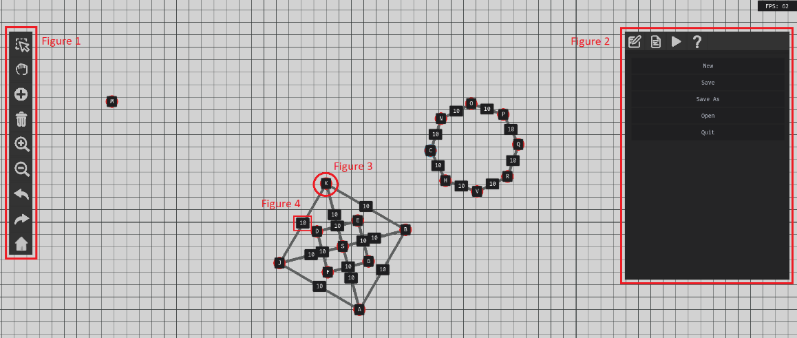

The screenshot above demonstrates the effective completion of the first success criteria. Figure 1 is the toolbar UI which has large, image-buttons so that the user can quickly and easily understand what each button does. The use of buttons for all main features of the UI also ensure that the software can be used effectively on a smart board, since no keyboard input is required. Figure 2 shows the main UI window. Having a central location for all of the UI ensures the user does not get lost navigating through it. The user is able to move between different sections of the main UI by pressing the navigation buttons at the top of the window.

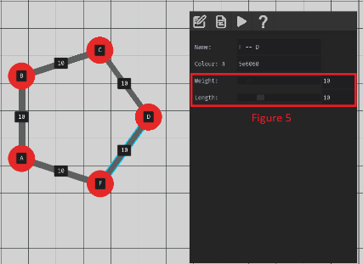Figure 3 and 4 are examples of UI labels being displayed over the top of nodes and edges. Figure 3 shows the name of each node while figure 4 shows the weight of each edge. Adding these labels to the graph provides an easier understanding of the context of each graph.

In figure 5, the implementation of sliders has been introduced to allow the user to adjust values in the program. This was implemented with stakeholders in mind so that when presenting to the class, a teacher is able to make adjustments to the program more interactively without the need for a keyboard.

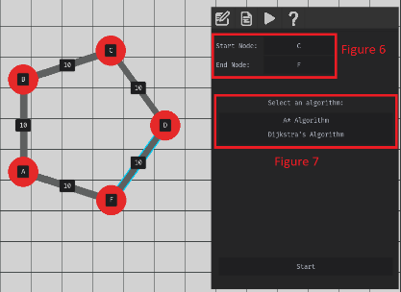Figure 6 shows a unique type of button which operates in a similar way to a colour picker in other programs. When the user presses one of these buttons, the next node that they select will be assigned as the start/end node. This was to reduce the complexity for the user, having to manually enter the name of a node and for the solution, which would have to perform more checks for validity to ensure valid node names were entered. Figure 7 shows a selection list where the user can choose which algorithm they want to perform.

This help section is easily and always accessible to users 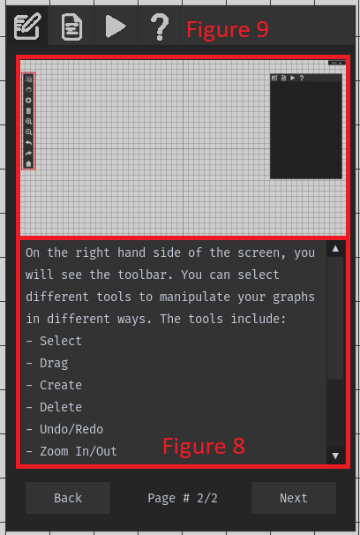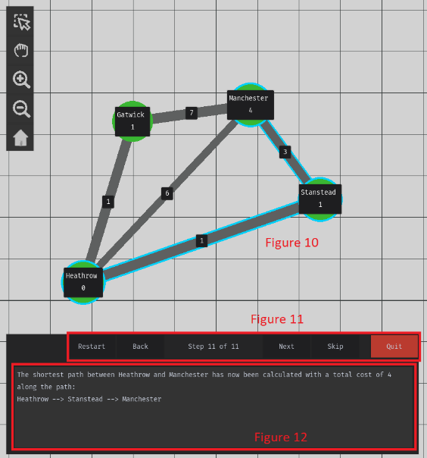by simply clicking the question mark icon on the toolbar. Figure 8 is a textbox which will explain different areas of software to the program. The pygame-gui library allows for html formatting in these textboxes and will automatically create a scrollbar, when necessary, which allows for a great degree of flexibility of the information that can be displayed. Figure 9, provides a visual aid for users to help make the software interface easier to understand. Highlighting different sections on the images can encourage the user to explore the software further.

Figure 10 shows the highlighted visualisation in the UI which helps to improve the readability and interpretation of the shortest path algorithms which was designed to make it easy to follow along and engage with. Different parts of these visualisations could be interacted with by simply pressing the buttons outlined in figure 11. These were all large and clearly marked so the user very easily understands their purpose. The large textbox in figure 12, like the one mentioned in figure 8, demonstrates how written assistance is also used to aid learning. This way if a student was to use the software independently, they can still learn how these algorithms work using these explanations.

From the following evidence, I can conclude that the first success criteria have been met fully. All UI elements are large and clearly shown with either text or images so that the user can easily interpret what different parts of the program do. The prominent use of different UI elements has ensured that all important functionality can be achieved without the use of a keyboard. Simply by using a touch input or mouse, the user can interact with all aspects of the program and therefore teachers can effectively use this software in a classroom setting on a smartboard. By keeping the UI simple, students can likewise use the software effectively.

#### #2

The ‘new’ button in the main UI will simply clear all nodes from the environment. However, it was important to note during development, that when making irreversible changes to the user’s graph, a “safety net” should be in place. This was introduced in a similar manner to other programs which will double check with the user that they wish to make this change without first saving their current graph. Adding this check will help reduce the risk of a user accidentally deleting their work.

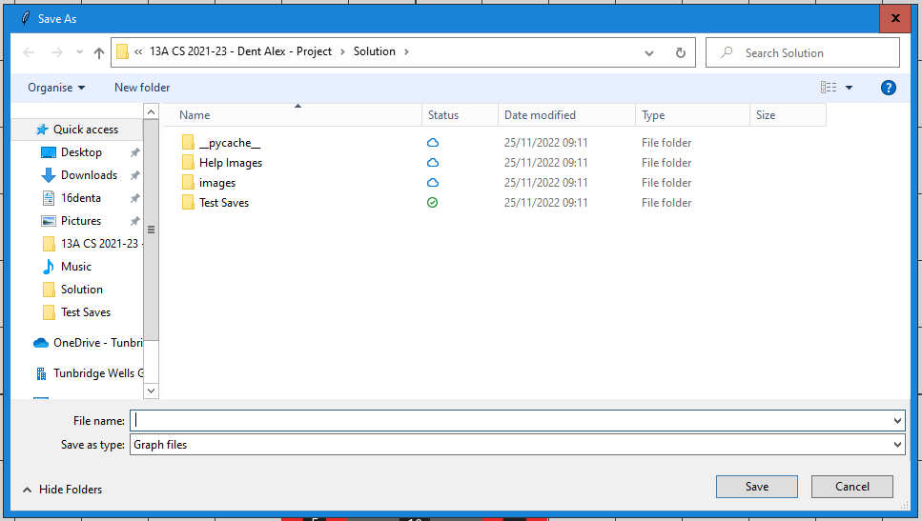Saving files incorporates the file explorer interface users will already be used to interacting with. Using this helped to reduce the amount of validation required as the window would ensure that a valid file extension and path are selected. If the user had already saved their file, pressing the save button or Ctrl+S on their keyboard will automatically save their file to the graph’s directory without the user having to select it themselves. This helped to make saving a faster and easier process, enabling users to frequently update their file. A consideration for future development would be to provide feedback to the user when they save a file automatically. This is because there is no indication of a successful besides the updated file which could create confusion for the user due to this ambiguity.

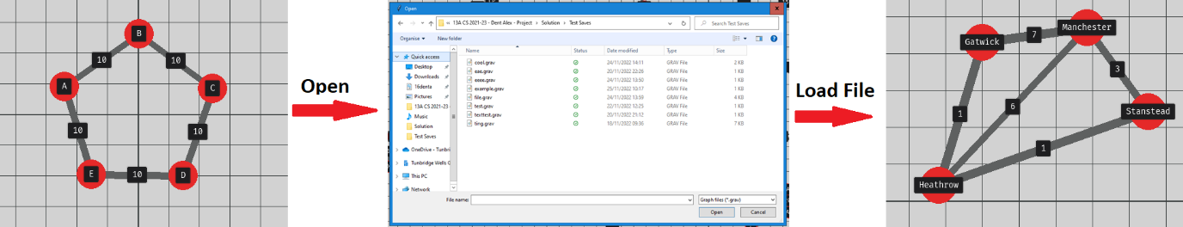

Opening files utilises the same interface and will only allow valid files with the ‘.grav’ extension to be loaded. When a valid file is selected, all required variables are updated, the previous graph is removed and the new graph is loaded into the environment. This very simple process could be ideal for a teacher since they could very easily switch between different premade files to demonstrate different concepts in their lessons.

From the following evidence, I can conclude that the second success criterion has been fully met. The solution is able to effectively open/save/create files using UI buttons in the program and a familiar file selection dialogue. Keyboard shortcuts have also been introduced to make saving files easier and faster for the user. It was also an important consideration when creating new files or opening existing ones to check that the user wants to proceed to reduce the risk of users losing their existing work.

#### #3

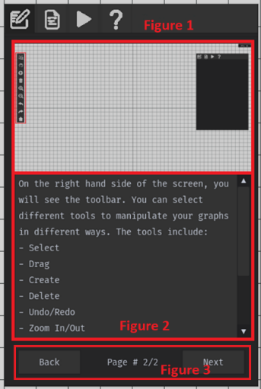The third success criterion was to create a help section which would help inexperienced users interact with the software. Figure 1 shows an image which would be used to display a particular element of the program. Figure 2 is a html-formatted textbox which will explain what is happening in each image. This help section is then split into pages where the user can move between different pages using the ‘next’ and ‘back’ buttons highlighted in figure 3. Each page is predefined in a json file which will contain the text and image path associated with each page. An addition in future development would be to make use of hyperlinks in these textboxes. These hyperlinks could be used to navigate to pages more easily in the help section as well as links to websites for further information.

From the evidence shown above, the 3rd success criterion has been met successfully. A combination of visuals and explanation have been incorporated to ensure the user can easily understand how particular elements work. Additional functionality could be introduced in further development to make navigation within the help section easier than just the ‘next’/’back’ buttons.

#### #4

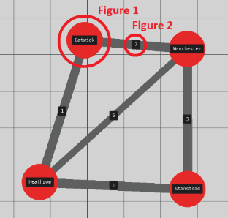Completing the 4th success point involved displaying nodes and edges in an interactive environment. From the diagram to the right, Figure 1 demonstrates how customisable nodes can be created in different positions with unique names. These names are displayed on the graph to allow for greater contextual clarity so that they can be easily interpreted by users. The nodes themselves are large and brightly coloured to help them stand out. Figure 2 shows how these nodes can be connected together by edges of varying weight to form a graph. These weights are also displayed in the environment so that the user can visualise the costs between nodes.

From this evidence, I can conclude that the 4th success criteria have been met successfully since nodes and edges can be easily displayed in the environment. They have been abstracted appropriately so that only important information is displayed which ensures that they can be easily interpreted by others.

#### #5

This criterion was met by allowing the user to move around and scale the environment using a variety of sources to ensure the program was accessible and easy to use across a multitude of different devices. By selecting either the ‘Move Camera’ or ‘Select’ tools, the user is able to move around the environment by holding the left mouse button and dragging the cursor which allows the user to focus their attention in different areas of the graph as well as increasing the size of graphs they can interact with. To view larger graphs, the user is also able to zoom in/out using either the respective buttons in the toolbar or using the scroll wheel.

In conclusion, the 5th success point has been effectively met since interacting with the environment has been made accessible for both smartboards and standard computer devices. A combination of UI and mouse input have been utilised for simple movement in the environment.

#### #6

The 6th criterion has been achieved by using UI elements to form a toolbar which users can use to select different “tools”. These tools enable the user to interact with the software in numerous different ways including: selection; camera movement; creation; deletion; zoom in/out; undo/redo; recentre. These following tools will be discussed in more detail in their more specific and applicable criteria. However, it should be noted that the UI toolbar can be used across all devices since interacting with it only requires the user to click on one of its several icons.

Therefore, the 6th success criterion has been met successfully since the user is able to select several different tools that they can use to interact with the environment and graphs.

#### #7

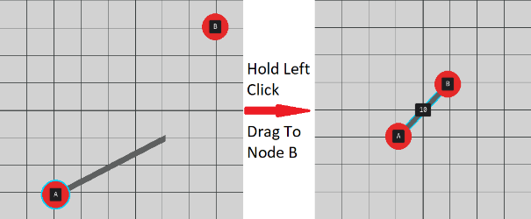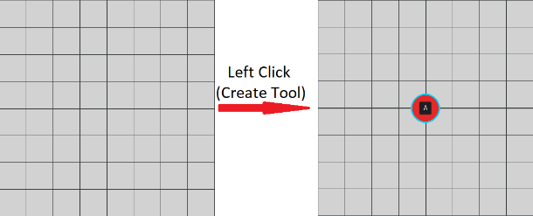Graphs can be created in the environment through the single use of the create tool. This tool allows the user to create either a node or edge depending on set conditions. If when the user presses their left mouse button on empty space, a node is created. If the user presses and holds their left mouse button on a node and then drags their cursor to another node, an edge is created between the two. These operations can be visualised by the images above which demonstrate how nodes and edges can be created. It can also be noted that when creating an edge, a line is drawn to the cursor as a visual cue that an edge is being created. Also helps show the user where the edge is going to come from.

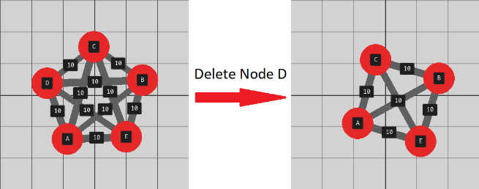If the user makes a mistake when creating their graph or wishes to make an alteration, they can delete edges and nodes using the ‘Delete’ tool in the toolbar or ‘delete’ button on a keyboard after selecting the node/edge they want to remove. Removing a node will also remove all edges that are connected to it.

From this, it has been demonstrated that the 7th success criteria have been met since the user is able to easily and quickly create/delete nodes/edges by simply clicking and dragging the cursor. The simplicity of this allows graphs to be created on a variety of devices including smartboards where only touch input is possible.

#### #8

The 8th success criteria have been implemented to effectively allow the user to undo/redo changes to their graph using Ctrl-Z / Ctrl-Y as well as redo/undo buttons on the toolbar UI. When the user makes any of the following changes to the graph, it is recorded:

* Create edge/ node
* Delete edge/ node
* Change to an edge/ node property

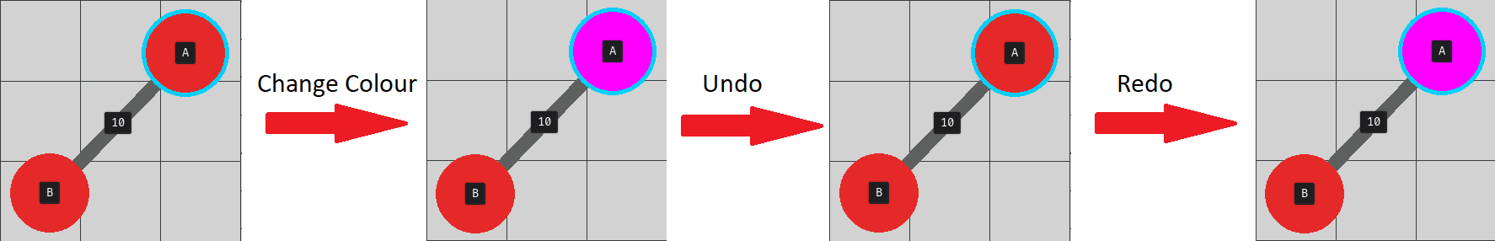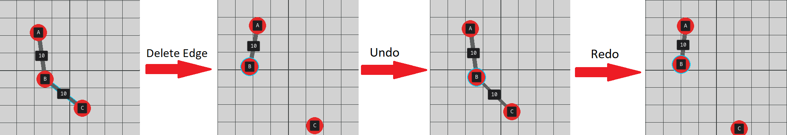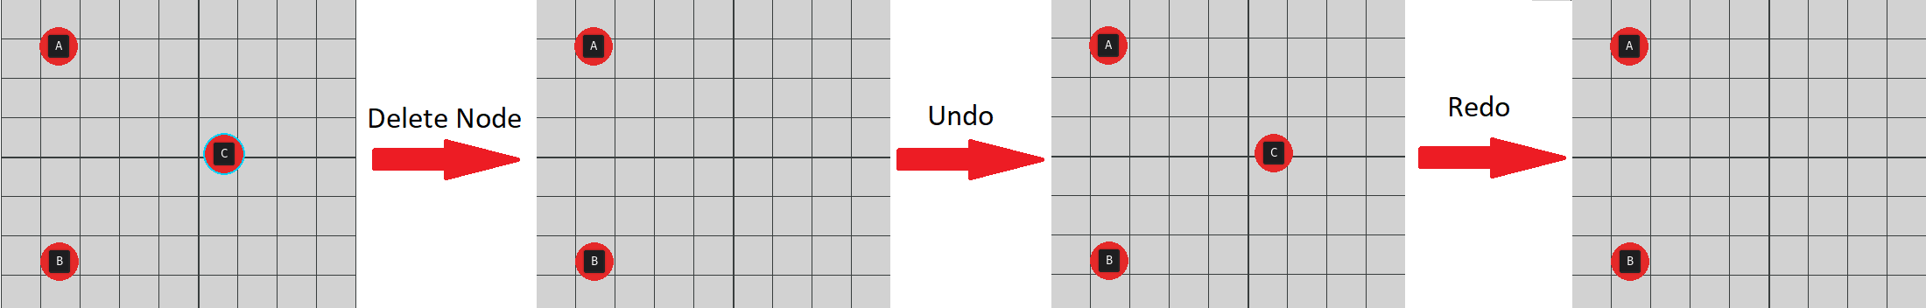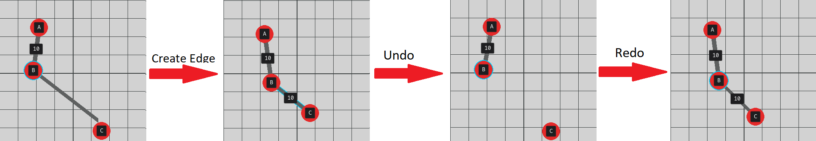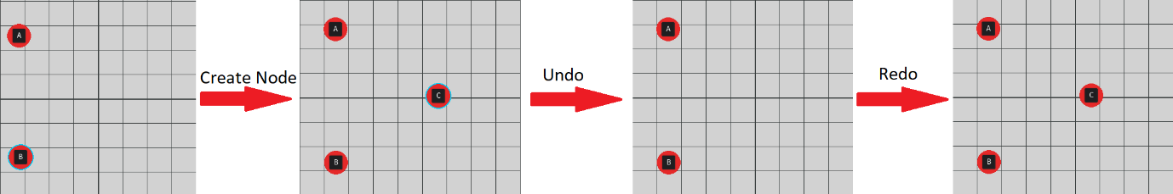Any recorded change can then be undone and redone to the graph using the aforementioned buttons. This was retested below:

Adjusting properties will also be reflected in the properties UI and be updated accordingly as demonstrated below:

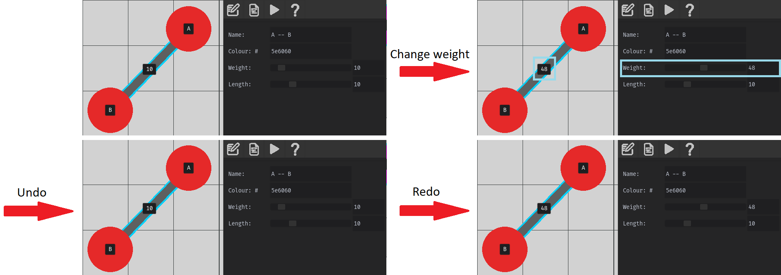

From these tests, I conclude that the 8th success criterion has been met fully. The solution is able to effectively undo and redo a variety of different operations to the user’s graphs with several different input methods. Keyboard input (Ctrl-Z/Ctrl-Y) is available to users which can utilise it however if a keyboard is unavailable, the UI buttons are still accessible to users as well. This system correctly integrates itself into the properties UI as well as making correct adjustments to the displayed graph.

#### #9

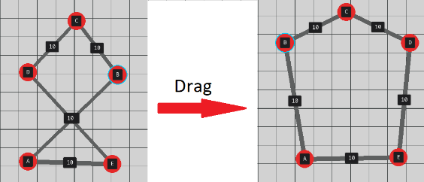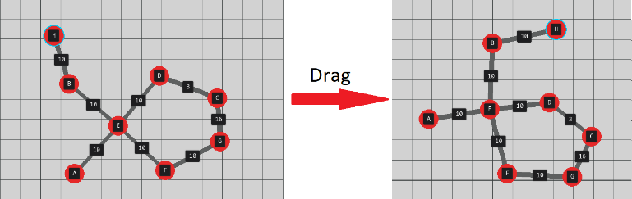To allow the user to manually adjust nodes to different positions, the 9th success criterion was completed. By selecting a node and holding the left mouse button, the node is moved in the direction of the cursor. Allowing the user to easily manoeuvre specific nodes enables the user to view isomorphic versions of their graph which may be easier to interpret (as demonstrated by the graph on the right which has been made planar).

Therefore, this evidence has indicated that the 9th success criteria has been implemented correctly since the user is able to easily move nodes in the environment using mouse/touch input. This allows the user to interact with and more easily interpret their graph.

#### #10

Additionally, to the 9th success criterion, the 10th required nodes to automatically distance themselves from one another. If nodes were within a given distance from each other, a repulsive force should be applied and if two nodes connected by an edge where beyond an arbitrary length, attractive forces would be applied to suspend the nodes a fixed distance from one another.

**Interactions between nodes connected by an edge.**

Forces were initially modelled by tanh ((distance - length) / slope). This caused jittery motion while nodes tried to settle at their desired length and was altered to tanh ((distance - length) ** 3 / slope) after remedial testing.

|  |  |  |
| --- | --- | --- |
| Distance < Length | Distance == Length | Distance > Length |
|  |  |  |
| Repulsion | No Change | Attraction |

**Interactions between unconnected nodes.**

These forces were modelled by a cosine function from the interval 0 <= force <= optimalDistance with equation -cos((π/2) * (distance /optimalDistance))

|  |  |  |
| --- | --- | --- |
| Distance < Optimal Distance | Distance == Optimal Distance | Distance > Optimal Distance |
|  |  |  |
| Repulsion | No Change | No Change |

From this evidence, I can conclude the 10th success criteria has been met fully since nodes will automatically adjust their positions depending on several equations which calculate forces relative to the distances between nodes. This ensures that nodes do not overlap one another and that edges form at a fixed distance from each other. This ensures that all graphs look consistent and easy to interpret since overlapping is prevented. However, a limitation to this implementation is that edges may still overlap and while it is attempted, the solution is not always capable of moving nodes into a planar configuration, hindering graph readability.

#### #11

The 11th success criteria have been met by adding the ability to select nodes and edges in the environment and adjust their properties in the UI. In the example below, this feature was tested by correcting a spelling mistake of one of the node names. When the new name is entered into the UI, it is updated onto the graph. This feature is also implemented with the operation recording system and so the user can undo and redo changes they make to the graph.

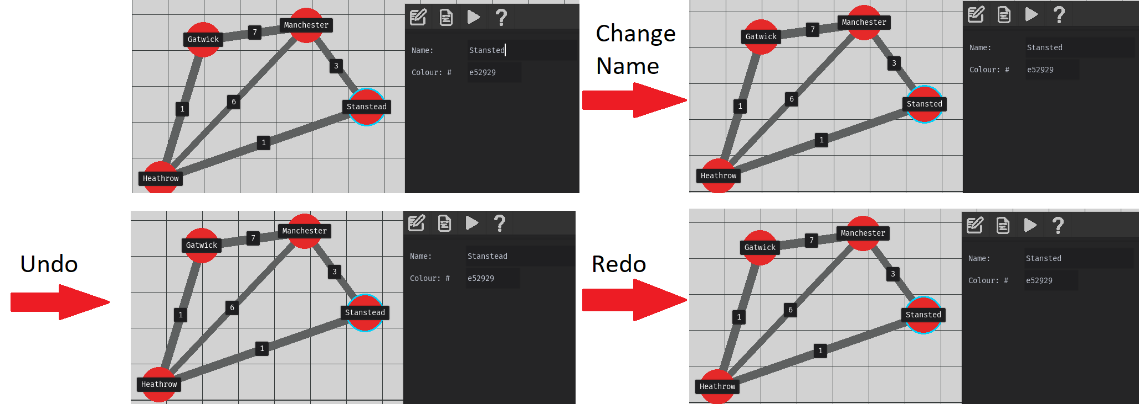

This feature also applies to property adjustments for edges. Numerical input such as weight and length parameters can be inputted with a keyboard or a slider. This makes the most essential parameter, edge weights, accessible to users on a smartboard. This is ideal for a learning environment since the teacher can easily adjust specific edge weights to visualise how the algorithm adapts its shortest path.

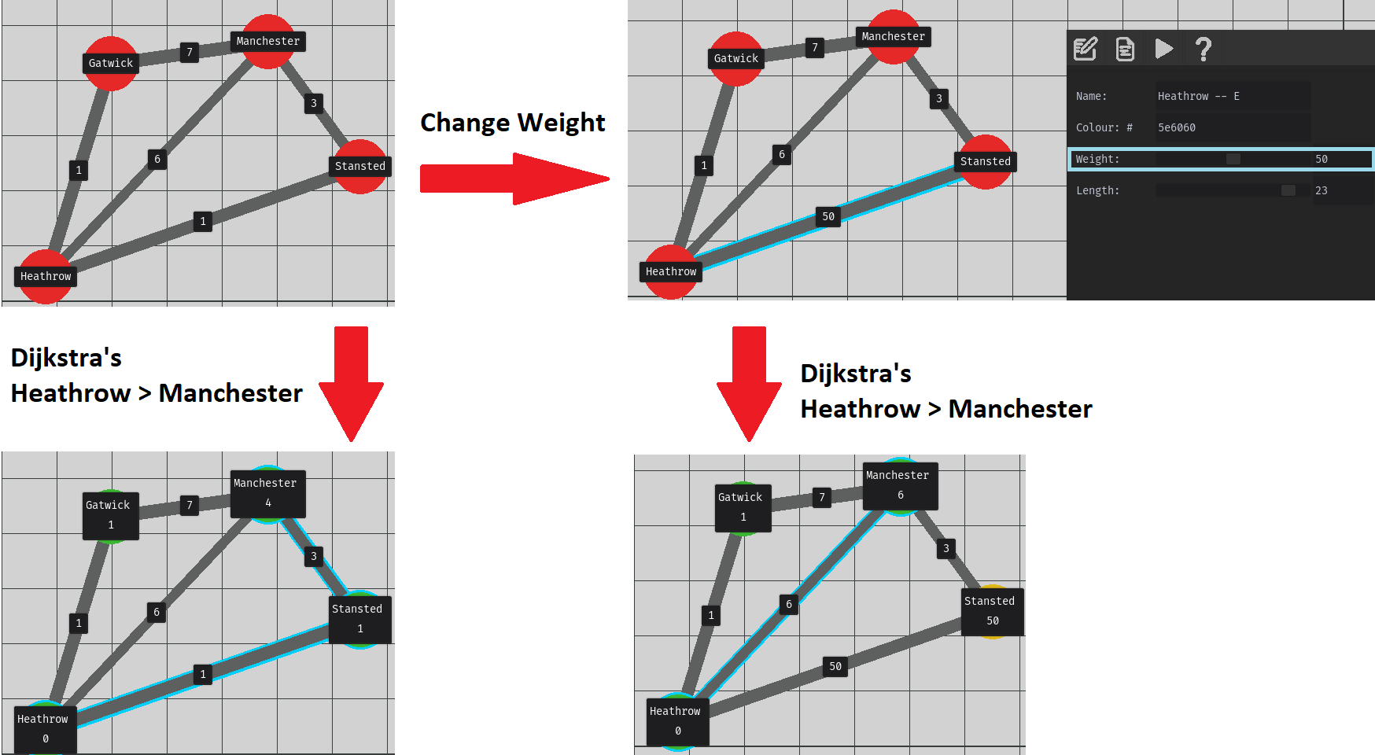

The limitation of the properties UI is that it would not allow text-based properties to be changed without a keyboard. However, these properties are all non-essential features that simply help to improve the design of graphs.

#### #12

The 12th success criterion was not implemented. This was because when testing the solution running across two threads, a significant reduction of performance was recorded. This was not the expected outcome I had initially considered since the addition of multithreading was to assist performance so that the software was more accessible to lower end hardware. Since multithreading could no longer fulfil this purpose and the solution was able to consistently perform significantly above 60 FPS, multithreading was not implemented.

Test data was gathered comparing framerates with graphs of increasing complexity. A Kn Complete graph is a graph which contains n nodes and each node has n-1 edges. Performance dropped linearly with increasing complexity. The K25 graph was the largest graph which provided acceptable performance (24 FPS). This graph contains 25 nodes and 300 edges indicating that despite some limitations, the user still has a very large degree of freedom in the graphs they decide to create.

While multithreading has not been implemented, performance optimisation was a priority during development to ensure the solution is accessible to all students and teachers. A limitation of the solution is that performance does reduce with larger graphs as shown above and so the solution could benefit in the future from an effective implementation of multiprocessing which would allow the software to utilise multiple cores.

To conclude, whilst multithreading has not been implemented, the principle behind multithreading to ensure strong performance across devices has been met effectively. The user is able to have a large degree of freedom in the graph’s they create while the solution performs at acceptable levels.

#### #13

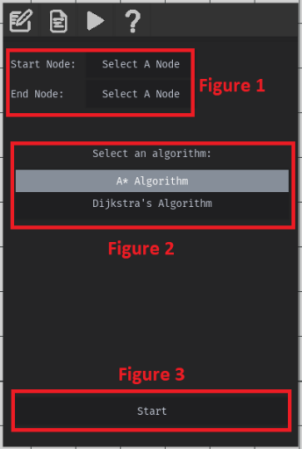The 13th success criteria were fully completed by allowing the user to enter the parameters the solution would use to perform shortest path algorithms. The user would need to select an algorithm, select start and end nodes and a ‘start’ button.

The start/end node parameters have been highlighted in figure 1 and consists of two respective buttons. When the user presses one of these buttons, the next node they select will be set for the parameter:

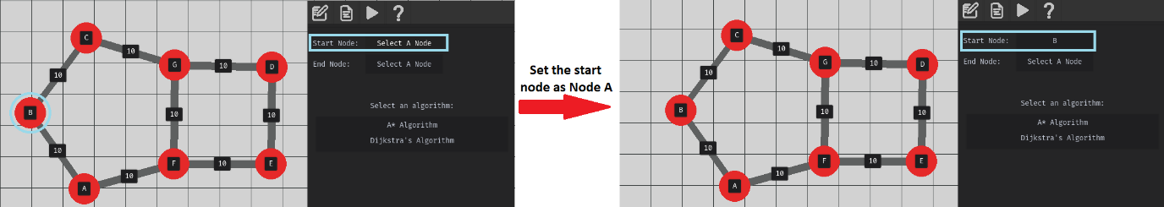

As shown in the diagram, the start node is set to be Node A and the parameters are updated to reflect this. It should be noted that changing the name of the node or removing it will be updated to the UI as well to ensure that only up to date and valid nodes are set as the parameters. A limitation of this functionality is that there is no visual indication of what the start and end nodes except from what is specified in the UI which could be slightly confusing for users. In future development, selected start and end nodes could have their own unique outline to visually highlight their significance.

In figure 2, the user is able to select between two buttons representing each of the implemented shortest path algorithms. When selected they are highlighted so that the user can clearly see which option they have chosen.

The ‘start’ button will be explored in more detail as it is heavily connected with the preceding success criteria however it should be noted that when clicked, the program will enter a read-only mode in which the user is unable to edit their graphs and additional UI is displayed:

From this evidence, I can conclude that the 13th success criteria point has been met fully. The user is able to easily select start and end node parameters and has been designed so that these parameters can be inputted without the use of a keyboard so that it works effectively on touch screens. The user is also able to select from a list of algorithms which they can perform.

#### #14

The 14th success criterion specifies that the software must clearly visualise each step in the pathfinding processes so that the user can easily follow along. This feature must be uniquely designed for both the Dijkstra’s and A* Algorithm.

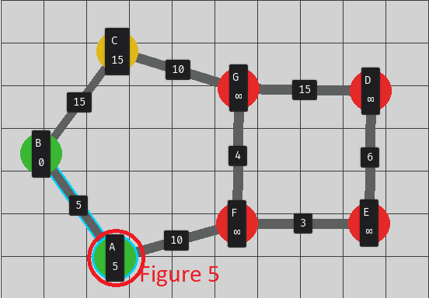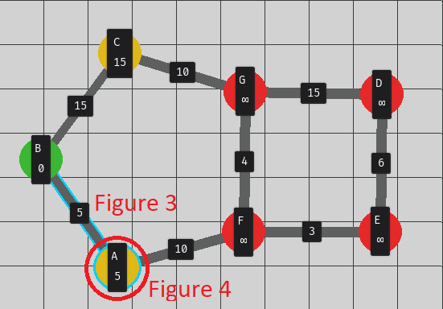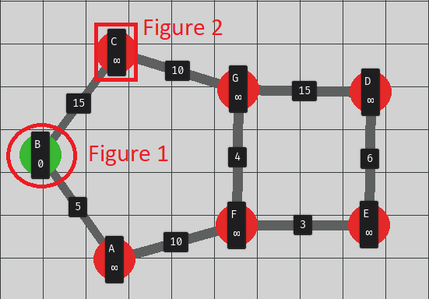In Dijkstra’s, the visualisation begins by highlighting the start node in green to mark it as “explored” as demonstrated in figure 1. Colour coding these nodes means that users can very quickly identify the state of each node during the algorithm’s progression. The program also updates the labels on each node to show the current lowest cost to reach each node. This information will be used to justify exploration of new nodes.

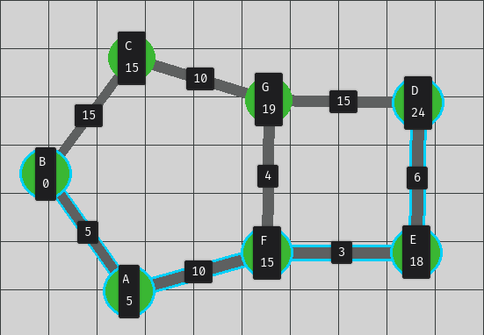Figure 3 shows how the node and connecting edge are highlighted in blue to show which nodes are currently being looked at and the direction this inspection came from. In Figure 4. the new lowest cost is then displayed onto the node’s UI and the node itself is coloured in yellow to show that it has been inspected.Figure 5 again shows that nodes are coloured in green when they have been explored. The change in colour as the algorithm progresses through the graph is a useful indicator for users to easily process what is happening.

Once the end node is reached, the solution will then visualise the backtracking process, highlighting each edge/node that is part of the shortest route. On the graph the user is then able to very easily view the shortest route they would need to travel between nodes.

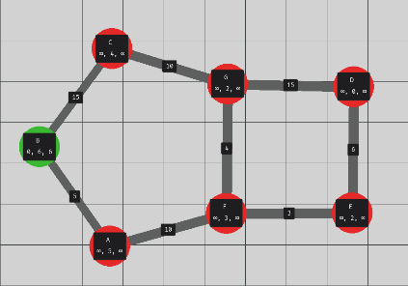In the A* algorithm, additional information is displayed to the user so that they can track the current total, heuristic and weight costs associated with each node. While all of this information is required to help explain the A* algorithm, it can cause the graph to look a bit crowded and harder to read. As shown in the diagram to the right, nodes are significantly less visible. A potential imporvement to this in future would be to see if it is possible to render opaque UI in the program so that the user is still able to see the nodes/edges beneath the labels.

To conclude, all of these visualisation aids greatly help to enhance the explanation abilities at teaching A* and Dijkstra’s Algorithms to users. All relevant information is displayed on the graph and colour-coding of nodes is utilised.

#### #15

The 15th success criterion requires that the user can navigate between the steps of the shortest path algorithms by using a set of different buttons on a new UI element. This UI should also allow the user to quit the visualisation and return the solution to its previous state.

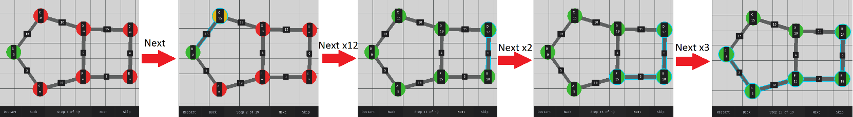This image shows the several different buttons the user can use to increment/decrement the step the algorithm is performing as well as the ability to skip to the final step/restart. The current step is also displayed and updated in the UI.

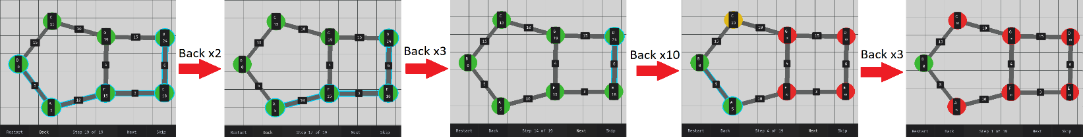Successive inputs to the next button produced the following output as shown above. This diagram highlights the different visualisation processes highlighted in the previous success criterion: calculating new costs for neighbouring nodes; exploring other nodes; backtracking process; displaying shortest route. The UI was also tested for the back buttons which should be able to return the graph from the final step to the first step:

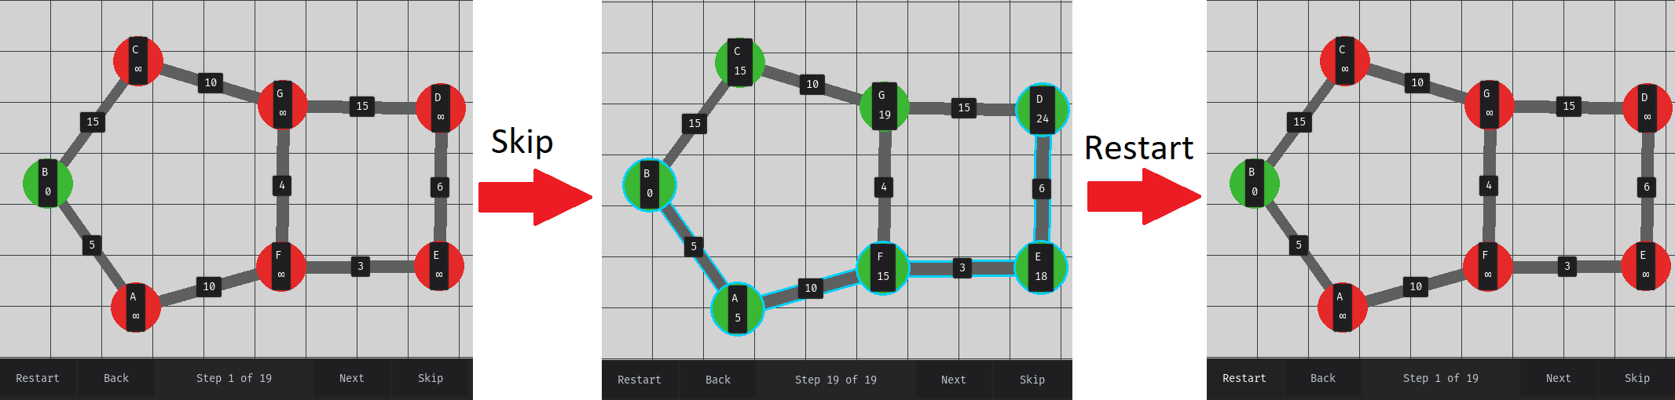These processes allow for greater accuracy navigating between steps with the disadvantage of the cost that the user has to click through them all. To speed up the navigation process, skip and restart buttons can be used as shown below:

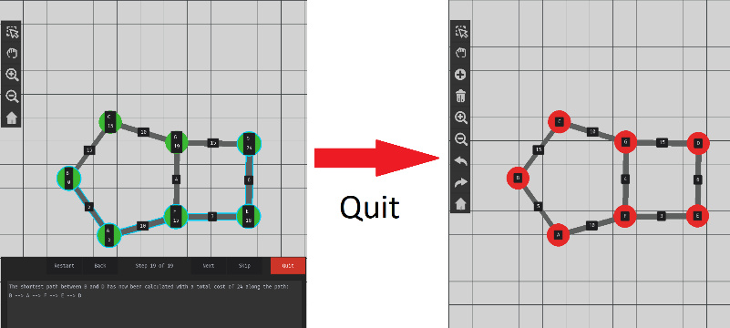Once the user has completed the visualisation process, the user should be able to press the quit button to return the program to its previous state which allows the user to edit their graphs again. This will include removing the visualisation UI, removing all visualisation changes made to the graph and changing the available toolbar tools. The diagram below highlights all of these features in the solution being reverted back to their previous state.

From this evidence I can conclude that the 15th success criterion has been fully met since the user is able to view each step in the shortest path algorithms. The visualisation applied to the graph dynamically updates to these changes. The user is able to leave this visualisation environment by pressing the ‘quit’ button which will revert the environment to its original graph so that the user can edit their graphs again.

#### #16

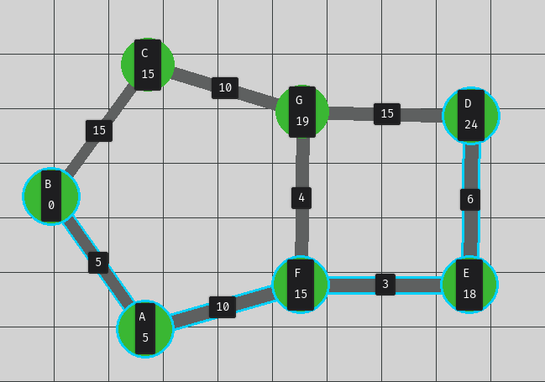In addition to visual aids when exploring the shortest path of a graph, the solution should generate unique and relevant text to apply context and greater understanding to what the algorithm is performing in each stage of the pathfinding so that the solution fulfils the 16th success point.

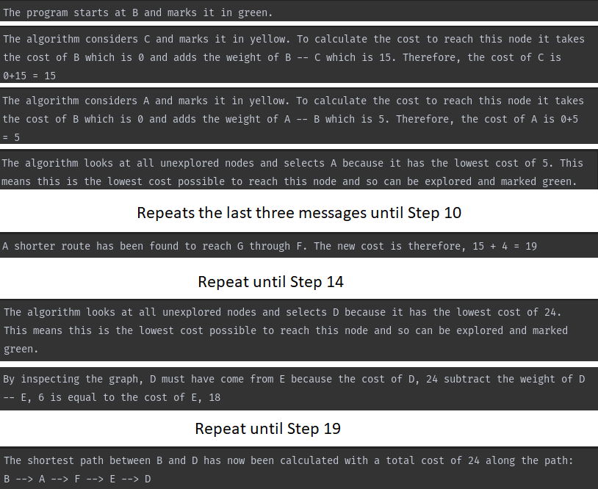The Dijkstra’s algorithm was tested on the following graph from node B to D to test if the outputted text explanations were relevant and correct.

This demonstrates that the solution can generate a set of steps which are relevant and concise to what is occurring in each step. The algorithm provides justification when selecting nodes to explore by referring to specific costs, weights, and nodes. The algorithm will also explain the backtracking process as well as the final shortest path and its cost.

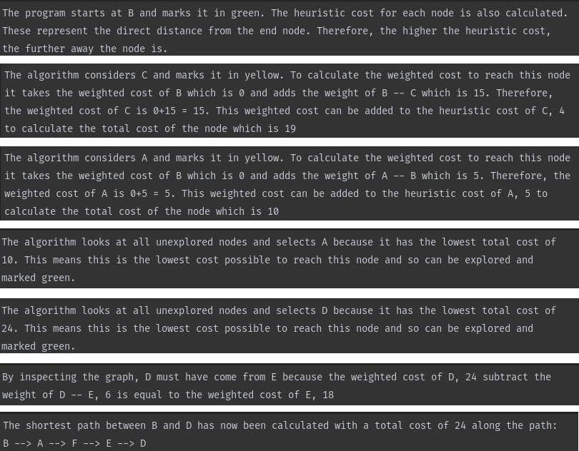This was tested again on the A* algorithm to test the set of steps this algorithm generates. The same graph and start and end nodes were used.

The output of key steps is very similar to that of dijkstra. However, additional information is provided in the justifification of exploring nodes as well as an explanation of how the heuristic costs are calculated.

In conclusion, the solution is able to correctly produce a set of written steps to explain how shortest paths are found. These messages are customised to represent the unique attributes of the user’s graph.

## Post Development Testing

Now that the development section is complete, I shall refer back to the test tables that were devised at the end of the design section and check to see if the solution is able to correctly meet the criteria set out in these tests.

### UI

#### Slider-Value Inputs

**Slider Test**

|  |  |  |  |  |  |
| --- | --- | --- | --- | --- | --- |
| **Test Definition** | **Set slider to its lowest value** | **Set slider below its lowest value** | **Set slider to a value around the middle** | **Set slide to its maximum value** | **Set slider beyond its maximum value** |
| **Test Type** | Boundary | Invalid | Valid | Boundary | Invalid |
| **Expected Output** | The slider is set to its minimum value. The text box is updated to show the minimum value. | The slider is set to its minimum value. The text box is updated to show the minimum value. | The slider moves to the middle value. And the text box updates to show this. | The slider is set to its maximum value. The text box is updated to show the maximum value. | The slider is set to its maximum value. The text box is updated to show the maximum value. |
| **Output** | Slider was moved to the far left and the value in the text box was updated to 0. | I could not move the slider below the minimum value. | I set the slider to 55 and the value in the text box displayed this. | The slider was maximised to 100. | I could not move the slider beyond the far right. |
| **Success?** | Yes | Yes | Yes | Yes | Yes |

**Text-Box Test**

These were tested with the length property as an example. This property can except values from 5-25.

|  |  |  |  |
| --- | --- | --- | --- |
| **Test Definition** | **Enter the lowest allowed value** | **Enter a value below the lowest value** | **Enter a valid value within the given range** |
| **Test Type** | Boundary | Invalid | Valid |
| **Expected Output** | The slider is set to its minimum value. The text box displays the minimum value. | The slider is set to its minimum value. The text box displays the minimum value. | The slider moves to the middle value. And the text box updates to show this. |
| **Output** | Typed in 5 and the slider moved to the left | I typed in 3 and the value was changed to 5. The slider moved to the left to the minimum value. | I typed in 15 and the slider moved to around the middle. The text box displayed the value 15. |
| **Success?** | Yes | Yes | Yes |
| **Test Definition** | Enter non-numerical characters | Enter the highest allowed value | Enter a value above the highest allowed value |
| **Test Type** | Invalid | Boundary | Invalid |
| **Expected Output** | The user should not be allowed to type non-numerical characters in this textbox | The slider is set to its maximum value. The text box displays the maximum value. | The slider is set to its maximum value. The text box displays the maximum value. |
| **Output** | I could type in any characters except for 1-9 | I entered 25 and then slider moved to the right as far as possible. | I entered 100. The slider moved as far to the right as possible but the value in the textbox was changed to 25. |
| **Success?** | Yes | Yes | Yes |

#### Colour Inputs

The default colour of a node is shown below. This colour is displayed when the colour property has not been changed.

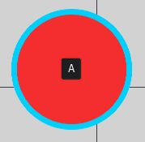

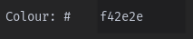

|  |  |  |  |
| --- | --- | --- | --- |
| **Test Definition** | **#123456** | **#789ABC** | **#def123** |
| **Test Type** | Valid | Valid | Valid |
| **Expected Output** | Colour is set | Colour is set | Colour is set |
| **Output** |  |  |  |
| **Success?** | Yes | Yes | Yes |
| **Test Definition** | #12345 | #1234567 | #ghijkl |
| **Test Type** | Invalid | Invalid | Invalid |
| **Expected Output** | The input must consist of exactly 6 characters | The input must consist of exactly 6 characters | The textbox should not allow invalid characters to be typed |
| **Output?** |  |  |  |
| **Success?** | Yes | Yes | Yes |

#### Text Boxes

The textboxes have a 15 character, character limit on them.

|  |  |  |  |
| --- | --- | --- | --- |
| **Test Definition** | **Enter text below the character limit** | **Enter text until the character limit is reached** | **Attempt to add more characters beyond the limit** |
| **Test Type** | Valid | Boundary | Invalid |
| **Expected Output** | The text is allowed to be entered | The text is allowed to be entered | No more characters are allowed to be entered |
| **Output** | I entered “Hello world” which is 11 characters and so the text box allowed me to type this. | I typed “123456789ABCDEF” (15 characters) and was allowed to do so. | I attempted to type “Hello world my name is Alex.” However, the text box only allowed me to type: |
| **Success?** | Yes | Yes | Yes |

#### Buttons

**Toolbar Buttons**

|  |  |  |  |  |  |
| --- | --- | --- | --- | --- | --- |
| **Test Definition** | **Press “select tool”** | **Press “drag tool”** | **Press “create tool”** | **Press “delete tool”** | **Press “zoom in tool”** |
| **Expected Output** | “#Select” | “#Move_Camera” | “#Create” | “#Delete” | “#Zoom_In” |
| **Output** |  |  |  |  |  |
| **Success?** | Yes | Yes | Yes | Yes | Yes |
| **Test Definition** | **Press “zoom out tool”** | **Press “undo tool”** | **Press “press redo tool”** | **Press “home tool”** | **Don’t press anything** |
| **Expected Output** | “#Zoom_Out” | “#Undo” | “#Redo” | “#Home” | Nothing should happen |
| **Output** |  |  |  |  |  |
| **Success?** | Yes | Yes | Yes | Yes | Yes |

**Main Window UI Navigation**

|  |  |  |  |
| --- | --- | --- | --- |
| **Test Definition** | **Click on “Properties” with nothing selected** | **Click on “Properties” with a node selected** | **Click on “Properties” with an edge selected** |
| **Expected Output** | Properties are empty | Display node properties | Display edge properties |
| **Output** |  |  |  |
| **Success?** | Yes | Yes | Yes |
| **Test Definition** | **Click on “File Options”** | **Click on “Help”** | **Press “Visualisation”** |
| **Expected Output** | Display all the buttons for file options | All Help UI is displayed. | Display all UI relating to visualisation |
| **Output** |  |  |  |
| **Success?** | Yes | Yes | Yes |

**File Options Buttons**

|  |  |  |  |
| --- | --- | --- | --- |
| **Test Definition** | **Press “New” when graph changes are unsaved** | **Press “New” when graph changes are saved** | **Press “New” while visualising a graph** |
| **Test Type** | Invalid | Valid | Invalid |
| **Expected Output** | Prompt the user if they would like to save their file first | Open a new empty environment | Be prompted to first close the visualisation. |
| **Output** |  | A new environment is opened successfully. |  |
| **Success?** | Yes | Yes | Yes |
| **Test Definition** | **Press “Save” when the graph has not been saved before** | **Press “Save” when the graph has been saved before** | **Press “Save ” while visualising a graph** |
| **Test Type** | Valid | Valid | Invalid |
| **Expected Output** | Open a file dialog box which allows the user to specify a file location | Automatically save the file. It should not open a file dialog. | Be prompted to first close the visualisation. |
| **Output** |  | The graph was saved and did not prompt the file dialog. |  |
| **Success?** | Yes | Yes | Yes |
| **Test Definition** | **Press “Save As” when the graph has not been saved before** | **Press “Save As” when the graph has been saved before** | **Press “Save As” while visualising a graph** |
| **Test Type** | Valid | Valid | Invalid |
| **Expected Output** | Open a file dialog box which allows the user to specify a file location | Open a file dialog box which allows the user to specify a file location | Be prompted to first close the visualisation. |
| **Output** |  |  |  |
| **Success?** | Yes | Yes | Yes |
| **Test Definition** | **Press “Open” when the graph has unsaved changes** | **Press “Open” when the graph has been saved** | **Press “Open ” while visualising a graph** |
| **Test Type** | Invalid | Valid | Invalid |
| **Expected Output** | Prompt the user if they would like to save their file first | Open a file dialog box which allows the user to specify a file to open | Be prompted to first close the visualisation. |
| **Output** |  |  |  |
| **Success?** | Yes | Yes | Yes |
| **Test Definition** | **Press “Quit” when graph changes are unsaved.** | **Press “Quit” when graph changes are saved** | **Press “Quit” while visualising a graph** |
| **Test Type** | Invalid | Valid | Valid |
| **Expected Output** | Prompt the user if they would like to save their file first | Quit the application | Quit the application |
| **Output** |  | The application closes | The application closes |
| **Success?** | Yes | Yes | Yes |

**Help UI**

|  |  |  |  |
| --- | --- | --- | --- |
| **Test Definition** | **Press “next” on the first page** | **Press “next” on the second to last page** | **Press “next” on the last page** |
| **Test Type** | Valid | Boundary | Invalid |
| **Expected Output** | Display the second page | Display the last page | Remain on the last page |
| **Output** |  |  |  |
| **Success?** | Yes | Yes | Yes |
| **Test Definition** | **Press “back” on the last page** | **Press “back” on the second page** | **Press “back” on the first page** |
| **Test Type** | Valid | Boundary | Invalid |
| **Expected Output** | Display the second to last page | Display the first page | Remain on the first page |
| **Output** |  |  |  |
| **Success?** | Yes | Yes | Yes |

**Visualisation Parameters**

|  |  |  |  |  |
| --- | --- | --- | --- | --- |
| **Test Definition** | **Select “Dijkstra’s Algorithm”** | **Select “A* Algorithm”** | **Press “Select Start Node”** | **Press “Select End Node”** |
| **Expected Output** | "Dijkstra's Algorithm" | "A* Algorithm" | "#Start_Node_Input” | "#End_Node_Input" |
| **Output** |  |  |  |  |
| **Success?** | Yes | Yes | Yes | Yes |

**Visualisation Start Button**

|  |  |  |  |
| --- | --- | --- | --- |
| **Test Definition** | **Press Start with no start node selected** | **Press Start with no end node selected** | **Press Start with start and end nodes but an algorithm has not been selected** |
| **Test Type** | Invalid | Invalid | Invalid |
| **Expected Output** | Prompt the user to select start/end node | Prompt the user to select start/end node | Prompt the user to select an algorithm |
| **Output** |  |  |  |
| **Success?** | Yes | Yes | Yes |
| **Test Definition** | **Press Start with start and end nodes selected and Dijkstra’s algorithm selected.** | **Press Start with start and end nodes selected and A* algorithm selected.** | **Press Start where the start and end nodes are the same.** |
| **Test Type** | Valid | Valid | Invalid |
| **Expected Output** | Open the algorithm visualisation UI | Open the algorithm visualisation UI | Prompt the user to select unique start and end nodes. |
| **Output** |  |  |  |
| **Success?** | Yes | Yes | Yes |

**Visualisation UI**

|  |  |  |  |
| --- | --- | --- | --- |
| **Test Definition** | **Press “next” on the first step** | **Press “next” on the second to last step** | **Press “next” on the last step** |
| **Test Type** | Valid | Boundary | Invalid |
| **Expected Output** | Display the second step | Display the last step | Remain on the last step |
| **Output** |  |  |  |
| **Success?** | Yes | Yes | Yes |
| **Test Definition** | **Press “back” on the last step** | **Press “back” on the second step** | **Press “back” on the first step** |
| **Test Type** | Valid | Boundary | Invalid |
| **Expected Output** | Display the second to last step | Display the first step | Remain on the first step |
| **Output** |  |  |  |
| **Success?** | Yes | Yes | Yes |
| **Test Definition** | **Press “skip” on the first step** | **Press “skip” on the second step** | **Press “skip” on the last step** |
| **Test Type** | Valid | Valid | Invalid |
| **Expected Output** | Display the last step | Display the last step | Remain on the last step |
| **Output** |  |  |  |
| **Success?** | Yes | Yes | Yes |
| **Test Definition** | **Press “restart” on the last step** | **Press “restart” on the second to last step** | **Press “skip” on the first step** |
| **Test Type** | Valid | Valid | Invalid |
| **Expected Output** | Display the first step | Display the first step | Remain on the first step |
| **Output** |  |  |  |
| **Success?** | Yes | Yes | Yes |
| **Test Definition** | **Press “Quit” in the Visualisation UI** |
| **Test Type** | Valid |
| **Expected Output** | Close the visualisation UI. |
| **Output** |  |
| **Success?** | Yes |

### Environment Interactions

#### Camera Movement

|  |  |  |  |  |
| --- | --- | --- | --- | --- |
| **Test Definition** | **Click and drag the cursor upwards with the drag tool selected** | **Click and drag the cursor to the right with the drag tool selected** | **Click and drag the cursor to the left with the drag tool selected** | **Click and drag the cursor downwards with the drag tool selected** |
| **Test Type** | Valid | Valid | Valid | Valid |
| **Expected Output** | The camera should move downwards. | The camera should move to the left. | The camera should move to the right. | The camera should move upwards. |
| **Output** | The camera moves downwards | The camera moves to the right | The camera moves to the left | The camera moves to the right |
| **Success?** | Yes | Yes | Yes | Yes |
| **Test Definition** | **Zoom in within the bounds** | **Zoom in when the maximum zoom has been reached** | **Zoom out within the bounds** | **Zoom out when the maximum zoom has been reached** |
| **Test Type** | Valid | Boundary | Valid | Boundary |
| **Expected Output** | The camera should zoom in slightly | The camera should not zoom in any further. | The camera should zoom out slightly | The camera should not zoom out any further. |
| **Output** | Then camera slightly zooms inward. | Then camera zoom stays the same. | Then camera slightly zooms outward. | Then camera zoom stays the same. |
| **Success?** | Yes | Yes | Yes | Yes |

#### Selection Tool

**Main Tool**

|  |  |  |  |  |
| --- | --- | --- | --- | --- |
| **Test Definition** | **Select an empty area in the environment with nothing previously selected** | | **Select an empty area in the environment with a node currently selected** | **Select an empty area in the environment with an edge currently selected** |
| **Test Type** | Invalid | | Boundary | Boundary |
| **Expected Output** | Nothing should be selected. | | The currently selected node should remain the same. | The currently selected edge should remain the same. |
| **Output** | Nothing is selected. | | Nothing new is selected. | Nothing new is selected. |
| **Success?** | Yes | | Yes | Yes |
| **Test Definition** | | **Select the edge of a node with properties open** | **Select the centre of a node with properties open** | **Select the centre of a node with properties closed** |
| **Test Type** | | Boundary | Valid | Valid |
| **Expected Output** | | The node should be selected. The properties UI should be updated to show its properties. | The node should be selected. The properties UI should be updated to show its properties. | The node should be selected. The properties should not be displayed. |
| **Output** | | The node is highlighted by a blue border and its properties are displayed in the UI. | The node is highlighted by a blue border and its properties are displayed in the UI. | The node is highlighted by a blue border. |
| **Success?** | | Yes | Yes | Yes |
| **Test Definition** | | **Select the edge of an edge with properties open** | **Select the centre of an edge with properties open** | **Select the centre of an edge with properties closed** |
| **Test Type** | | Boundary | Valid | Valid |
| **Expected Output** | | The edge should be selected. The properties UI should be updated to show its properties. | The edge should be selected. The properties UI should be updated to show its properties. | The edge should be selected. The properties should not be displayed. |
| **Output** | | The edge is highlighted by a blue border and its properties are displayed in the UI. | The edge is highlighted by a blue border and its properties are displayed in the UI. | The edge is highlighted by a blue border. |
| **Success?** | | Yes | Yes | Yes |

**Select Start/End Node**

|  |  |  |  |  |
| --- | --- | --- | --- | --- |
| **Test Definition** | **Select the edge of a node.** | **Select the centre of a node.** | **Select an edge.** | **Select an empty area of the environment.** |
| **Test Type** | Boundary | Valid | Invalid | Invalid |
| **Expected Output** | The node is selected and assigned as the start/end node. The node’s name is displayed in the algorithm visualisation parameters. The selected tool is set to the drag tool. | The node is selected and assigned as the start/end node. The node’s name is displayed in the algorithm visualisation parameters. The selected tool is set to the drag tool. | Nothing should be selected. The selected tool is set to the drag tool. | Nothing should be selected. |
| **Output** | The node’s name is displayed as the start node parameter. | The node’s name is displayed as the start node parameter. | Nothing happens to the parameters. | Nothing happens to the parameters. |
| **Success?** | Yes | Yes | Yes | Yes |

#### Creation Tool

|  |  |  |  |  |
| --- | --- | --- | --- | --- |
| **Test Definition** | **Click on an empty area in the environment** | **Click on an edge in the environment** | **Click on a node** | **Click on part of the UI** |
| **Test Type** | Boundary | Invalid | Invalid | Invalid |
| **Expected Output** | A node should be created. | A node should not be created. | A node should not be created. | A node should not be created. |
| **Output** | A node is created at the cursor | Nothing happens. | The node is selected but no new node is created. | Nothing happens. |
| **Success?** | Yes | Yes | Yes | Yes |
| **Test Definition** | **Press and hold on a node and then release the cursor.** | **Press and hold on a node, drag the cursor to an empty area of the environment and then release the cursor.** | **Press and hold on a node, drag the cursor over another node in the environment and then release the cursor.** | **Press and hold on a node, drag the cursor over a node that already has an edge between the two and then release the cursor.** |
| **Test Type** | Invalid | Invalid | Valid | Invalid |
| **Expected Output** | An edge should not be created where the start and end nodes are the same. | An edge should not be created. A line should be drawn from the start node to the cursor while it is held. | An edge should not be created. A line should be drawn from the start node to the cursor while it is held. | A node should not be created. Only one edge can exist between two nodes. |
| **Output** | No edge is created. | No edge is created. | An edge is created between the two nodes. | No edge is created. |
| **Success?** | Yes | Yes | Yes | Yes |

#### Testing the Creation of Different Graphs

|  |  |  |  |
| --- | --- | --- | --- |
| **Description** | **Design** | **Output** | **Success?** |
| **An empty environment with no nodes** | N/A |  | Yes |
| **A graph consisting of a single node** |  |  | Yes |
| **A graph of 2 connected nodes** |  |  | Yes |
| **A graph consisting of 4 unconnected nodes** |  |  | Yes |
| **The K3 Graph** |  |  | Yes |
| **The K4 Graph** |  |  | Yes |
| **A K4 Graph with a single unconnected node** |  |  | Yes |
| **A graph consisting of 100 nodes** |  |  | Yes |

#### Delete Tool

|  |  |  |  |
| --- | --- | --- | --- |
| **Test Definition** | **Press Delete with nothing selected** | **Press Delete with a node selected** | **Press Delete with an edge selected** |
| **Test Type** | Invalid | Valid | Valid |
| **Expected Output** | Nothing should be deleted. | The node and all of its connected edges should be deleted. | The edge should be deleted. |
| **Output** | Nothing is deleted | The node and all connected edges are removed. | Only the edge is removed. |
| **Success?** | Yes | Yes | Yes |

#### Changing Properties

**Node Properties**

|  |  |  |  |  |
| --- | --- | --- | --- | --- |
| **Test Definition** | **Change the name of a node to a unique name** | **Change the colour of a node from red to green** | **Change the name of a node to have the same name as another node** | **Change the colour of a node from red to orange** |
| **Test Type** | Valid | Valid | Valid | Valid |
| **Expected Output** | The name displayed on the node should be updated to the new name. | The node should change colour to green. | The name displayed on the node should be updated to the new name. The name clash should not affect the graph. | The node should change colour to orange. |
| **Output** |  |  |  |  |
| **Success?** | Yes | Yes | Yes | Yes |

**Edge Properties**

|  |  |  |  |  |
| --- | --- | --- | --- | --- |
| **Test Definition** | **Change the name of an edge to a unique name** | **Change the colour of an edge from red to green** | **Change the name of an edge to have the same name as another edge** | **Change the colour of an edge from red to orange** |
| **Test Type** | Valid | Valid | Valid | Valid |
| **Expected Output** | Edge.name should store the new name. | The edge changes colour to green. | Edge.name should store the new name. | The edge changes colour to orange. |
| **Output** |  |  |  |  |
| **Success?** | Yes | Yes | Yes | Yes |
| **Test Definition** | **Set the weight of a node to 0** | **Set the weight of a node to 100** | **Set the weight of a node to 85** | **Attempt to set the weight of a node to -10** |
| **Test Type** | Boundary | Boundary | Valid | Invalid |
| **Expected Output** | The weight displayed on the edge should be updated to 0. | The weight displayed on the edge should be updated to 100. | The weight displayed on the edge should be updated to 85. | Only an integer from 0-100 should be valid. |
| **Output** |  |  |  |  |
| **Success?** | Yes | Yes | Yes | Yes |
| **Test Definition** | **Set the length of a node to 5** | **Set the weight of a node to 25** | **Set the weight of a node to 15** | **Attempt to set the weight of a node to 0** |
| **Test Type** | Boundary | Boundary | Valid | Invalid |
| **Expected Output** | The length of the edge should decrease to 5 units. | The length of the edge should increase to 25 units. | The length of the edge should increase to 15 units. | Only an integer from 5-25 should be valid. |
| **Output** |  |  |  |  |
| **Success?** | Yes | Yes | Yes | Yes |

#### Undo/Redo

|  |  |  |  |  |
| --- | --- | --- | --- | --- |
| **Test Definition** | **Create a node and then press undo** | **Create two nodes and then press undo twice** | **Create two nodes and then press undo once** | **Press undo when there is nothing left to undo** |
| **Expected Output** | The node should be removed from the environment | Both nodes should be removed from the environment. | Only the most recently created node should be created. | Nothing should be change to the environment. |
| **Output** | The node is removed. | Both nodes are removed. | One of the nodes is removed. | Nothing happens. |
| **Success?** | Yes | Yes | Yes | Yes |
| **Test Definition** | **Create an edge and then press undo** | **Create two nodes and then an edge and press undo twice.** | **Create two edges and then press undo once** | **Create a K4 graph. Press undo once. Create a new node and then press undo twice.** |
| **Expected Output** | The edge should be removed from the environment | The edge and most recently made node should be removed from the environment. | The most recently created edge should be removed | The K4 graph should be missing two edges |
| **Output** | The edge is removed from the environment. | Only one node is left. | The edge is removed. | The graph is missing two edges. |
| **Success?** | Yes | Yes | Yes | Yes |
| **Test Definition** | **Create a K4 graph. Press undo once and then press redo once.** | **Create a K4 graph. Press redo once and then press undo once.** | **Create a K4 graph. Press undo once. Add a new node then press redo once.** | **Create a K4 graph and then press redo.** |
| **Expected Output** | The K4 graph should revert to its original state. | The K4 graph should be missing an edge. | The K4 graph should be missing an edge and there should be a node on its own. | The K4 graph should be missing two edges |
| **Output** | The K4 graph loses an edge and then it is replaced. | An edge is missing | An edge is missing on the K4 graph and there is another node by itself. | The graph is missing two edges. |
| **Success?** | Yes | Yes | Yes | Yes |
| **Test Definition** | **Delete a node with 4 connected edges. Then press undo.** | **Delete an edge and then press undo.** | **Delete all nodes in a K4 graph and then press undo four times to restore the graph.** | **Delete an edge and node and then press undo twice.** |
| **Expected Output** | The node and all 4 connected edges should be restored. | The edge should be restored. | The K4 graph should return to normal. | The node and edge should both be restored. |
| **Output** | The node and all of its edges are recreated. | The edge is restored. | The K4 graph is back to normal. | The node and edge are both restored. |
| **Success?** | Yes | Yes | Yes | Yes |
| **Test Definition** | **Change the name of a node and then press undo and then redo.** | **Change the colour of an edge and then press undo and then redo.** | **Change the colour of a node and then press undo and then redo.** | **Change the weight of an edge and then press undo and then redo.** |
| **Expected Output** | The node’s name should change back to its original name and then change back to its new name. | The edge’s colour should change back to its original colour and then change back to its new colour. | The node’s colour should change back to its original colour and then change back to its new colour. | The node’s weight should revert back to its original weight and then change back to its new weight. |
| **Output** | The node’s new name is displayed. | The edge displays its new colour. | The node displays its new colour. | The edge displays its new weight. |
| **Success?** | Yes | Yes | Yes | Yes |

#### Saving, Opening and Creating New Graphs

The file extension of files shall be given the arbitrary extension “.grav”

|  |  |  |  |  |
| --- | --- | --- | --- | --- |
| **Test Definition** | **Save a K4 graph called “k4.grav”**  **through “save”** | **Save a K4 graph called “k4.grav”**  **through “save as”** | **Save an empty environment to “empty.grav”** | **Open “k4.grav”** |
| **Test Type** | Valid | Valid | Valid | Valid |
| **Expected Output** | An K4 graph should be stored to the file. | An K4 graph should be stored to the file. | An empty graph should be stored to the file. | A K4 graph should be displayed in the environment. |
| **Output** |  |  |  |  |
| **Success?** | Yes | Yes | Yes | Yes |
| **Test Definition** | **Open a corrupted .grav file** | **Create a new environment when the environment is already is empty** | **Create a new environment when there is a saved graph in the environment** | **Create a new environment when there is an unsaved graph in the environment** |
| **Test Type** | Invalid | Valid | Valid | Boundary |
| **Expected Output** | The user should be prompted that the file is corrupted and could not be loaded. | The camera should be repositioned to its original position. Nothing should change to the environment. | The camera should be repositioned to its original position. The environment should be cleared. | The user is prompted if they would like to first save their graph. |
| **Output** | The user is not prompted. The program crashes. | Camera is repositioned and the environment remains empty. | The environment is cleared, and the camera is put in the centre. | The user is prompted if they would like to save their graph. |
| **Success?** | No | Yes | Yes | Yes |

### Shortest Path Visualisations

|  |  |  |
| --- | --- | --- |
| **Graph To Test** | **Shortest Path Output** | **Visualisation Output** |
| Graphical user interface, application, Teams  Description automatically generated  Path from A to B | No path from A to B | A marked as explored.  No other nodes to explore and node B not reached.  Concludes no path |
| Output | No path between the two. |  |
| Success? | Yes | Yes |
| A picture containing icon  Description automatically generated  Path from A to B | A -- B  Total Weight: 10 | A marked as explored.  B is visited and given working weight of 10.  B the visited node with the lowest weight and so is marked as explored.  The destination has been reached with weight 10.  The algorithm backtracks through the graph to determine the route as A -- B. |
| Output |  |  |
| Success? | Yes | Yes |
| Diagram  Description automatically generated  Path from A to C | A -- C | A marked as explored.  B is visited and given working weight of 10.  C is visited and given working weight of 10.  C is the visited node with the lowest weight and so is marked as explored.  The destination has been reached with weight 10.  The algorithm backtracks through the graph to determine the route as A -- C. |
| Output |  |  |
| Success? | Yes | Yes |
| A picture containing diagram  Description automatically generated  Path from A to D | No path from A to D | A, B and C are explored. As no more nodes are left to be visited and since D has not been visited the algorithm concludes there is no path. |
| Output | No path |  |
| Success? | Yes | Yes |
| Diagram  Description automatically generated  Path from A to B | A -- C -- B  Total weight: 20 | A marked as explored.  B is visited and given working weight of 30.  C is visited and given working weight of 10.  C is the visited node with the lowest weight and so is marked as explored.  B is visited again and given a working weight of 20.  B is explored.  The destination has been reached with weight 20.  The algorithm backtracks through the graph to determine the route as A – C -- B. |
| Output |  |  |
| Success? | Yes | Yes |
| Diagram  Description automatically generated  Path from A to E | A -- B -- C -- D --E  Total Weight : 50 | A marked as explored.  B is visited and given working weight of 10.  B is explored.  C is visited and given working weight of 10.  C is explored.  D is visited and given working weight of 10.  D is explored.  E is visited and given working weight of 10.  E is explored. |
| Output |  |  |
| Success? | Yes | Yes |
| Diagram  Description automatically generated with low confidence  Path from A to B | A -- C -- B  Total Weight: 30 | A marked as explored.  C is visited and given working weight of 10.  B is visited and given working weight of 40.  C is visited and given working weight of 10.  C is explored.  D is visited again and given working weight of 20.  B is visited again and given a working weight of 30.  D is explored.  B is explored.  The algorithm backtracks through the graph to find the path. |
| Output |  |  |
| Success? | Yes | Yes |
| Diagram  Description automatically generated  Path from A to D | A -- C -- D or A -- B -- D  Total Weight: 20 | A is explored.  C is visited and given a working weight of 10.  B is visited and given a working weight of 10.  C is explored.  D is given a working weight of 20.  B is explored.  D is explored and the algorithm backtracks to find the shortest path. |
| Output |  |  |
| Success? | Yes | Yes |

By completing the following post development tests, I have been able to effectively ensure the robustness of the program in many different possible permutations of use. This covers all of the UI elements, different methods in which the user will manipulate and interact with the sandbox environment as well as many different possible types of graphs to test its abilities in pathfinding.

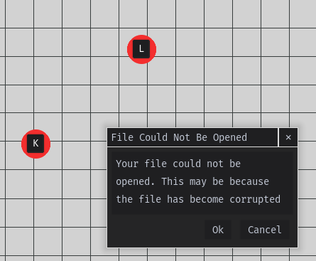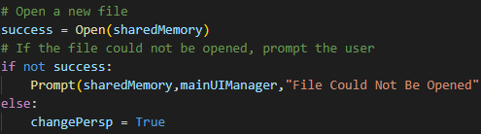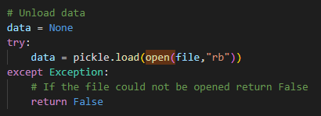From the tests, the only main flaw that was found was that opening corrupted files could cause the program to crash. This issue was resolved by using a try block to catch any exceptions while retrieving the data. If a file is opened unsuccessfully, a prompt is displayed to the user to suggest why. It should also be noted that if a file is opened unsuccessfully, the existing graph shall not be impacted by this.

## Stakeholder Testing

Now that the solution has been developed fully, stakeholders will be given a complete version of the program to ascertain how effective it has been at meeting the success criteria and how easy to use the software is. After allowing the user to explore the software, they were each asked the following questions:

* “How easy was it to navigate the UI window on the right side of the screen?”
* “Were you able to effectively create nodes and edges?”
* “Were you able to save/open your graphs from files?”
* “Was the properties window intuitive to use?”
* “How easy was it to input parameters for the shortest path algorithms?”
* “Were the visualisations and explanations good at guiding you through these algorithms?”

### Teacher Stakeholders

#### Mr Norris

**“How easy was it to navigate the UI window on the right side of the screen?”**

“It was really helpful having all the UI in one place so that I knew where everything would be. Switching between the different panels was fairly straightforward using the icons. However, some of the icons weren’t entirely clear of what they would represent.”

**“Were you able to effectively create nodes and edges?”**

“It was handy being able to create both nodes and edges just by clicking and dragging. The undo and redo buttons additionally made it really fast to correct mistakes and create whatever graphs I want to.”

**“Were you able to save/open your graphs from files?”**

“Saving and opening really was no different from any other program. The additional shortcuts for saving made it a lot easier over having to go to the file panel each time. Although, the file panel was still very easy to find and use.”

**“Was the properties window intuitive to use?”**

“The properties window was helpful when I needed to make a change to an individual node. Although, it was quite slow having to select each individual part of the graph when I wanted to make a change to several.”

**“How easy was it to input parameters for the shortest path algorithms?”**

“Pretty simple as all I had to do was press a button for which algorithm and then just clicked on what I wanted to set as the start and end nodes.”

**“Were the visualisations and explanations good at guiding you through these algorithms?”**

“The use of colour was excellent at highlighting what was happening at each stage. The explanations were concise and not very wordy which would be perfect for students who haven’t encountered much of decision maths.”

#### Miss Baker

**“How easy was it to navigate the UI window on the right side of the screen?”**

“It was pretty easy to move between the different tabs, though I wasn’t sure what some were at first. However, once I was a little used to the program it was really straightforward to interact with.”

**“Were you able to effectively create nodes and edges?”**

“I found it pretty fun creating different graphs. It was really cool as well being able to drag parts of the graph around and seeing how the program automatically tries to find a planar solution. It helped to keep my graphs really easy to read.”

**“Were you able to save/open your graphs from files?”**

“Yes, I was. It was easy to use and I was able to use it to prepare some examples of different types of graphs.”

**“Was the properties window intuitive to use?”**

“Most of the properties were pretty easy to use. The sliders made adjusting weights a lot faster however I found the hexadecimal colour property to be a bit confusing.”

**“How easy was it to input parameters for the shortest path algorithms?”**

“I was really happy with how easy and fast it was to prepare all of the parameters. I was able to quickly look at several different shortest paths with a variety of start and end nodes. It was excellent at demonstrating how different start and end points adjust the shortest path.”

**“Were the visualisations and explanations good at guiding you through these algorithms?”**

“They were really lovely to look at but the labels on the A* Algorithm did take up most of the space on the screen. While you could still easily follow along, I couldn’t see the actual nodes.”

### Student Stakeholders

#### David Bronson

**“How easy was it to navigate the UI window on the right side of the screen?”**

“It was nice to see all of the UI in one place so there was more room to show the graphs. I also always knew where to find help when I needed it. Although, it did take a while to reach the correct help page.”

**“Were you able to effectively create nodes and edges?”**

“I tried copying a graph in an exam question into the program and I had no problems with adding nodes and edges. It took no time at all. However, it did take quite a while to get the weighting of each node right. However, I’m not sure how it could have been made easier.”

**“Were you able to save/open your graphs from files?”**

“Yes, I was and it was really simple. I also noticed that file sizes were really small which is great for students like me who don’t have a lot of storage on school computers.”

**“Was the properties window intuitive to use?”**

“Yes, but it was a little annoying having to use an external colour picker to customise colours. It also took a while as I said before when changing lots of properties. It might be useful to be able to change default values.”

**“How easy was it to input parameters for the shortest path algorithms?”**

“All I had to do was click 4 things and I was able to visualise a pathfinding algorithm of my choice.”

**“Were the visualisations and explanations good at guiding you through these algorithms?”**

“The explanations were nice and short and only told what I needed to know. The changes in colour also made it really easy to see what was happening at each step.”

#### Jenny Watson

**“How easy was it to navigate the UI window on the right side of the screen?”**

“The icons on the buttons made moving between different sections of the UI really simple. Although adding text to the buttons could also be helpful at explaining which one is which.”

**“Were you able to effectively create nodes and edges?”**

“Creating graphs was really straightforward and I tried using it on a smartboard as well and was surprised just how quickly I was able to create graphs.”

**“Were you able to save/open your graphs from files?”**

“Saving and opening files was really useful. The program also asked me if I wanted to save before closing which was very lucky as I would have lost all of my work if it hadn’t.”

**“Was the properties window intuitive to use?”**

“The sliders and textboxes were really easy to use but I didn’t know how to change the colours at first as I didn’t realise it was in hexadecimal.”

**“How easy was it to input parameters for the shortest path algorithms?”**

“It was really quick at letting me enter in parameters. I was also able to easily change them and rerun the algorithm when I wanted to.”

**“Were the visualisations and explanations good at guiding you through these algorithms?”**

“Yes, I found the A* algorithm visualisation really helpful as it helped me to consolidate how the algorithm works.”

### Review

The feedback from the stakeholders showed that the UI was intuitive and easy to navigate, several noting that it was useful having all of the UI in one place. However, while the use of images was helpful, some stakeholders thought text to support these image-buttons would be helpful. The use of hexadecimal colours was also confusing for some and so implementing a colour picker could make choosing colours more intuitive for some users.

The help page was also very useful for new users however, some pointed out that finding the correct page could be made easier. As discussed in the development section, hyperlinks could be added to reference specific pages in the help section. A stakeholder also discussed how they had used the save/open functionality to create learning resources which he could use later in lessons. It was also beneficial that a safety net was incorporated to prevent users losing their work when attempting to close the program.

Users were also very happy with the visualisations of the shortest path finding algorithms and the complementary use of colour and text to explain what is happening in each step. However, a stakeholder did point out that the labels in the A* pathfinding visualisation did take up a large amount of space which could be remedied in the future by making these labels have less wasted space or become opaque.

## Further Development

### Limitations

From stakeholder feedback and by reviewing the solution personally, one of the limitations regarding the usability of the software was the ease of selecting nodes and edges. The solution was designed so that it could only allow individual objects to be selected. However, it was noted that it became very time consuming when the users were forced to select each component of a graph to adjust their properties. Additionally, there was no way to adjust the default properties for nodes and edges which hindered the users speed and ability to easily create the graphs they desired.

This limitation could be overcome by allowing multiple items to be selected at once in which the user is able to change the properties of all selected items. Furthermore, when no object is selected and the create tool is enabled, the properties panel could allow the user to change the default values of nodes and edges when they are created.

It was also noted that the use of hexadecimal colours, while simple to implement was difficult for users who were not familiar with this colour system; implementing a colour picker in future development would help the user more easily see how the colour they are selecting fits the environment. This would help increase the speed at which users are able to create graphs.

While there are already many possibilities for graph creation, only undirected graphs can be created because all edges which are created are bidirectional. Therefore, there may be some occasions when the user is unable to replicate a graph into the program. This limitation could be overcome in future development by allowing the user to adjust the directions of edges they create.

The user is already given a large amount of flexibility in the graphs they create however during evaluative testing for the 12th success criterion, the limit for acceptable performance was the K25 graph (25 nodes, 300 edges). This limitation could be alleviated by implementing multiprocessing so that more CPU cores are used in the program as well as a low processing mode which could disable some non-essential and demanding features of the program such as the node readjustment algorithm.

### Maintenance

A primary focus throughout the development of the software was to ensure that the code was modular. This was to ensure that dependency between different areas of the program were minimised as much as possible and so modifying one area has minimal impact on other areas of the solution. By ensuring modularity, it would be easy for additional features to be implemented into the program. For example, new UI elements can be created into the GenerateUI function in gui.py. All theming is kept consistent across the UI in an external .json file which behaves similarly to a .css file in HTML. This .json file allows for easy future changes to the UI theming. All functionality is wrapped under the pygame.event loop in the main.py file and so new buttons/sliders/etc. can be introduced to this loop simply by adding a new if statement.

Modularity has also been strongly incorporated into the algorithm step generation component of the solution since algorithm visualisations are composed of subclasses of the Step class which are composed of subclasses of the Operation class. Currently, Step/Operation subclasses have only been designed for the A* and Dijkstra’s Algorithm although additional classes could be easily created to represent the steps of different graph theory algorithms. The UI and visualisation components have been designed so that they could receive any array of steps and manipulate graphs appropriately. It should be noted that the implementation of different algorithms may require the user to input different parameters and so could require future modification of the UI section for pathfinding parameters.

By separating code into smaller, manageable, and relevant files, I have helped to make it easier to find functions and classes in the program. By ensuring these files are sufficiently commented and organised should help ensure other people can more easily understand what different areas of the program do as well as how they interact with different files/functions in the program.

All help information was also separated out into its own file. This means that there is complete freedom for help pages as new text and images can be referenced here and automatically be added into the solution. Since the text boxes in the UI support html formatting, a high level of creativity is possible within the help pages as well as hyperlinks which could be used to navigate between pages more easily.

The focus on modularity and the freedom provided to manipulate graphs in any way chosen in the algorithm visualisation section could mean that it would be easy to implement other graph algorithms such as Prim’s and Kruskal’s MST algorithms. Therefore, the scope of this project could be expanded upon just shortest path algorithms and could become a more encompassing learning tool for other areas of graph theory.